OSSE Adult Educator Professionalization Scholarship Application
Academic Year (AY) 2022-23
Closing Date: Friday, July 1, 2022

The paramount role of adult and family education in preparing adult learners (including vulnerable populations) to meet education, skills, and credential requirements for sustainable jobs with career paths, is recognized nationally and by the District of Columbia, and is an overarching premise of the Workforce Innovation and Opportunities Act (WIOA) of 2014. To meet this expanding and growing responsibility, the Office of the State Superintendent of Education, Adult and Family Education (OSSE AFE), in keeping with its accountability for ensuring the adequate preparation, continuing professionalization and support of educators who teach adult learners, forged a collaboration with the University of the District of Columbia (UDC), Adult Education Program, which is specifically designed and aligned to meet the continually evolving needs of its sponsored adult educators. Funds permitting, each year the OSSE AFE/UDC collaboration assists the participation of eligible adult educators, practitioners, and staff with scholarships to a variety of targeted education and training opportunities.

Adult Education Teacher Licensure and Certification Scholarships

OSSE AFE, in collaboration with the UDC Adult Education Program, will offer Adult Education Teacher Licensure and Certification Scholarships to up to 15 eligible adult educators to pursue academic opportunities that culminate in licensure and/or license renewal in Adult Education.

UDC’s Adult Education Program, which is accredited by OSSE, offers a Graduate Certificate (24 credit hours) and a Master of Arts (36 credit hours) in Adult Education. Adult education practitioners, who already hold a baccalaureate or post-baccalaureate degree(s) in their content area(s), can participate in and complete the program to meet professionalization and/or teacher license application or renewal requirements. Each core course of the Graduate Certificate Program curriculum is sub-divided into three 1-credit thematic modules (15 instructional hours for six weeks during the semester the course is offered). UDC permits applicants to take a maximum of 9 credit hours as a Special Student before full registration is required. Specifics on UDC’s graduate program in adult education and admissions requirements are provided at Attachment I.

- Tuition and Fees

OSSE will pay applicable tuition and fees -- at UDC’s graduate resident, or metro rate -- for a set quota of qualifying adult educators who:

- hold an undergraduate degree or higher and are admitted by UDC to the Graduate Certificate program in fall 2022 or spring 2023 to pursue their education at a rate of 6 credit hours of coursework each semester (including summer sessions).

- hold an undergraduate degree or higher and are admitted by UDC to the Graduate Certificate program in fall 2022 or spring 2023 to pursue their education at a rate of 3 credit hours of coursework each semester (including summer sessions) and/or at a rate of one thematic module (1 credit) every six weeks.

- hold an earned master’s degree and the analysis of whose transcript(s) determine that they require some coursework to meet appropriate qualifications for licensure.

- participate in program courses or modules for skills augmentation or accumulation of credits to meet license renewal requirements.

See Attachment II – Schedule of UDC’s Tuition and Fees – Academic Year (AY) 2022-23.

II. Eligibility Criteria

- To be eligible for a scholarship to assist preparation for adult education state licensure, applicants must meet the following criteria:

  - Education:

    - hold an undergraduate degree or better from an accredited university.
    - meet UDC’s admissions requirements for the Graduate Certificate program.
    - adhere to the teacher preparation program requirement of passing scores on Praxis Core (Math, Reading and Writing) to participate in more than nine credit hours of coursework.
    - comply with/exceed the university’s retention standard of a “B” or higher in each course (3.0 GPA or above), to retain a scholarship.

  - Employment:

- For scholarships to credit-bearing Graduate Certificate and/or Professional Development Modules:
  - priority will be given to adult educators employed in key positions in adult education programs funded by OSSE AFE.
  - if space is available, consideration will then be given to adult educators who work in other adult education programs in the District of Columbia.

- For OSSE AFE-sponsored professional development workshops/seminars (non-credit)
  - priority will be given to adult educators, volunteers, tutors and/or staff who work in adult education programs funded by OSSE AFE.
  - if space is available, consideration will then be given to adult educators, volunteers, and tutors and/or staff who work in other adult education programs in the District Columbia.

c. Residency:

- For scholarships to credit-bearing Graduate Certificate/Professional Development Modules:
  - priority will be given to adult educators who reside in the District of Columbia and are employed in key positions in adult education programs funded by OSSE AFE.
  - priority will next be given to adult educators who are employed in key positions in adult education programs funded by OSSE AFE but reside outside of the District of Columbia.
  - if space is available, consideration will then be given to adult educators who reside within or outside of the District of Columbia and who work in other adult education programs in the District of Columbia.

- For OSSE AFE-sponsored professional development workshops/seminars (non-credit):

All adult educators working or volunteering in adult education programs in the District of Columbia are eligible to participate in professional development institutes/workshops/seminars regardless of residency. However,
- priority will be given to adult educators, volunteers, tutors and/or staff who work in adult education programs funded by OSSE AFE.
- consideration will then be given to adult educators, volunteers, tutors and/or staff who work in other adult education programs in the District Columbia.

III. Commitment Agreement

- Recipients of a scholarship to the Graduate Certificate program must commit to:

  - taking the necessary steps to become licensed within six months of successfully completing the necessary academic requirements.
  - working with adult learners in an OSSE AFE funded program or another adult education program in the District of Columbia for no fewer than two years after graduation.
  - providing a copy of their graduate certificate and license to their OSSE AFE program director to be scanned and uploaded in their staff folder in the Literacy, Adult and Community Education System (LACES) by the data manager.

IV. Application and Selection Processes

To apply for a scholarship, eligible candidates must complete an OSSE AFE scholarship application online in Tk20 and submit the required documents – Letters of Recommendation and Employment Verification Form. Please see Attachment III-VI for:

- creating a Tk20 admission account to access the scholarship application.
- completing an OSSE AFE scholarship application.
- the list of documents that must be uploaded with your OSSE AFE scholarship application.

V. Timeline/Critical Dates

- Adult Education Teacher Licensure/Certification scholarships – Opening Date: Apply Now. Closing Date: Friday, July 1, 2022.

- Friday, July 1, 2022: OSSE’s scholarship application process closes at 11 p.m. Please submit your complete scholarship application package on or before that date. Note: Applications will be reviewed in the order received. Application packages that are not fully completed will be relegated a lesser priority. Applicants who have been selected as potential candidates may be interviewed by a Scholarship Selection Committee.

- By July 8, 2022, OSSE AFE/UDC will inform successful candidates of the potential award of a scholarship, predicated on their successful admission to UDC.

- By July 15, 2022, potential scholarship recipients must submit online to UDC a complete admissions application package in order to be admitted to the fall 2022 or spring 2023 cohort. You are encouraged to submit your application to the university well in advance of this date to ensure that you are within the university’s admission schedule.

Note: Applicants may plan ahead by requesting that all colleges they attended send to UDC’s Admissions Office, their official transcript(s) that show all course work, grades, degrees conferred, date(s) of graduation or last date of attendance.

- Non-scholarship recipients who will be paying their own tuition and fees may also follow the schedule above, should they wish to apply to be part of the UDC fall 2022 or spring 2023 cohort. Please refer to Attachment II – UDC Tuition and Fees Schedule. Financial aid is available for the Graduate Certificate and MA programs. (See Attachment I for details about GRE requirements, which are waived for the program.)

ATTACHMENT I thru VI are appended below.

Attachment I UDC Adult Education Graduate Program and Admissions Requirements

Attachment II Schedule of UDC’s Graduate Tuition and Fees – Academic Year (AY) 2022-23

Attachment III Scholarship Application Guidelines

Attachment IV Guidelines for Letters of Recommendation

Attachment V Employment Verification Form

Attachment VI Tips for Completing an OSSE Scholarship Application Online in Tk20

ATTACHMENT I

UNIVERSITY OF THE DISTRICT OF COLUMBIA (UDC)
ADULT EDUCATION GRADUATE PROGRAM AND ADMISSIONS REQUIREMENTS

The University of the District of Columbia (UDC) offers an Adult Education graduate program, with which OSSE AFE collaborates to meet the education, skills and credential requirements inherent in the agency’s responsibility for ensuring the adequate preparation, continuing professionalization and support of educators (academic and vocational) who teach adult learners in the District of Columbia (DC), administrators and staff employed in its sponsored adult education Integrated Education and Training programs.

The UDC Adult Education program is:

- fully accredited by OSSE Division of Teaching and Learning; that ensures programmatic excellence of all educator preparation providers and subject area programs that prepare candidates for educator credentials in the District. It is currently the only program in the District of Columbia, Maryland, and Virginia (DMV) that upon completion, allows candidates to immediately apply for OSSE teacher licensure without having to write a state exam,
- designed to embraces the core Andragogic principles of effective adult learning, which is a paradigm shift from the traditional K-12 pedagogy with which most adult education programs still align,
- versatile, with a curriculum that enables the program to prepare scholar practitioners— irrespective of their specific content area, to effectively plan, design and shape the learning experiences of adults, and
- a viable pathway to a post graduate doctoral program at UDC or other universities.

The UDC Adult Education program offers:

- a Graduate Certificate in Adult Education (24 credit hours)—OSSE AFE offers scholarships for tuition and fees to cover participation in this program to meet DC licensure requirements. This continues to be the only adult education state-approved program for licensure preparation in the DMV.
- The program of study comprises seven 3-credit courses (21 credits) on the foundations and methods of adult learning, and one practicum/reflective seminar (3 credits).
- UDC permits applicants with a graduate degree or higher to transfer in a maximum of 9 credit hours of relevant coursework completed successfully at a prior university.
- Adult educators with a history of relevant experience teaching adult learners may request and be granted a waiver for the 3-credits practicum experience.
- UDC waives the Graduate Record Examination (GRE) requirement for applicants to the Graduate Certificate and the MA programs.
- During the coronavirus (COVID-19) pandemic, all courses were delivered online (synchronously and asynchronously) using the Blackboard Learning Management System, to which all enrollees are granted access. In fall 2022, classes may return to hybrid delivery, one day per week from 6-9 p.m.
- All online courses are built by certified Master Builders, in accordance with Quality Matters Higher Education Specific Review Standards, and all instructors hold Online Teach-Only Certification (OTC).
- Each core course is sub-divided into three thematic modules.
- Students have the option of matriculating through the program at the rate of two courses (6 credit hours); one course (3 credit hours) every semester, including summer, or taking one course module (1 credit hour) of coursework, during a six-week timespan, when the course is offered. Students may enroll in one module during the regular offering of a course during the semester in which it is offered (one day a week from 6–9 p.m.). For instance, for the first 3-credits course, the schedule could be (when course is offered):
  - Module 1: Foundations of Adult Education – Fall (August 2022);
  - Module 2: Orientation to the Adult Learner and Adult Learning – Spring (January 2023); and
  - Module 3: The Role of the Adult Educator as a Leader for Change -- Summer (May 2023).
- Program completers earn a Graduate Certificate, conferred by the university. UDC also allows the transfer of 21 credit hours earned in the Graduate Certificate Program to the MA Adult Education degree, which leaves only 15 credit hours of additional coursework.

- A Master of Arts in Adult Education (36 credit hours).
- Completers of the Graduate Certificate may transfer 21 of the 24 credits earned to matriculate for an MA degree with just 15 additional credit hours of course work.
- The GRE is no longer required for admission to the MA Program.
- MA degree students have the capstone option of a master research thesis or a comprehensive exam.
- OSSE AFE does not offer scholarships for tuition or fees for coursework specific to the MA degree, for which students are eligible for financial aid.

Based on the availability of funds, eligible adult educators may receive an incentive for their achievement of the following:
    - $100 Successful completion of 12 credit hours (persistence)
    - $150 Successful completion of 18 credit hours (milestone)
    - $250 Successful completion of 24 credit hours (milestone)
    - $250 Submission of application for licensure (milestone)
    - $250 Receipt of Licensure in Adult Education (completion)

For admission to the program, graduate candidates must:

- Hold an undergraduate degree from an accredited institution, with a GPA of 2.5 or higher.
- Submit, to the Office of Graduate Admissions, an Application for Graduate Studies, with all required credentials and supporting documents that include:
  - Official college transcripts(s) reflecting all course work, grades, and date of graduation.
  - Payment of the non-refundable $50 application fee.
  - A 500-word personal statement about the applicant’s academic and professional goals, research interests, relevant prior experience, motivation for graduate studies in adult education, and other information in support of program admission.
  - Two letters of recommendation from individuals in a professional capacity who can attest to the applicant’s academic abilities to pursue graduate studies in adult education.
- Applicants who do not already hold a graduate degree must submit official GRE scores (288/4.0) to be admitted to the MA in adult education program. Note:
    - the GRE requirement is waived for students admitted to the Graduate Certificate program but must be met by completers who subsequently transition to the MA program.
    - applicants to the MA program, who do not meet this GRE requirement may be granted Provisional Approval and given the first semester to satisfy this requirement before continuing the program.
- Applicants seeking a teaching credential in the District of Columbia are required to submit combined Praxis Core exam scores (Reading – 156; Writing – 162; Mathematics – 150) and pass a federal background check for OSSE licensure.
- For program admission, the applicant must participate in an advising interview with the academic coordinator.
ATTACHMENT II

SCHEDULE OF UDC’S GRADUATE TUITION AND FEES – Academic Year (AY) 2022-23

Graduate Resident Tuition
Credit Hours | Tuition | Fees ¹ | Total
1 | $513.00 | $430.00 | $943.00
2 | $1,026.00 | $430.00 | $1,456.00
3 | $1,539.00 | $430.00 | $1,969.00
4 | $2,052.00 | $430.00 | $2,482.00
5 | $2,565.00 | $430.00 | $2,995.00
6 | $3,078.00 | $430.00 | $3,508.00
7 | $3,591.00 | $430.00 | $4,021.00
8 | $4,104.00 | $430.00 | $4,534.00
9 or more | $4,617.00 | $430.00 | $5,047.00

Graduate Metro Tuition
Credit Hours | Tuition | Fees ¹ | Total
1 | $580.00 | $430.00 | $1,010.00
2 | $1,160.00 | $430.00 | $1,590.00
3 | $1,740.00 | $430.00 | $2,170.00
4 | $2,320.00 | $430.00 | $2,750.00
5 | $2,900.00 | $430.00 | $3,330.00
6 | $3,480.00 | $430.00 | $3,910.00
7 | $4,060.00 | $430.00 | $4,490.00
8 | $4,640.00 | $430.00 | $5,070.00
9 or more | $5,220.00 | $430.00 | $5,650.00
Graduate Non-Resident Tuition
Credit Hours | Tuition | Fees ¹ | Total
1 | $986.00 | $430.00 | $1,416.00
2 | $1,972.00 | $430.00 | $2,402.00
3 | $2,958.00 | $430.00 | $3,388.00
4 | $3,944.00 | $430.00 | $4,374.00
5 | $54,930.00 | $430.00 | $5,360.00
6 | $5,916.00 | $430.00 | $6,346.00
7 | $6,920.00 | $430.00 | $7,332.00
8 | $7,888.00 | $430.00 | $8,318.00
9 or more | $8,874.00 | $430.00 | $9,304.00
ATTACHMENT III

SCHOLARSHIP APPLICATION GUIDELINES

To apply for a scholarship, eligible candidates must:

A. Complete online on udctK20.com an OSSE AFE 2022-23 Scholarship Application:

To access the OSSE, AFE 2022-23 Scholarship Application, go to udc.tk20.com. website
and follow the guidelines below. If you need assistance, please contact Ayanna Kelley (ayanna.kelley@udc.edu). Also, please see Attachment VI for useful tips for navigating Tk20.
To Create a TK20 Scholarship Admissions Account
- Once on the website, under Helpful Resources (located to the right of the split screen) click on the admissions tab to create your account.
- Create an account by clicking on the blue link at the bottom of the webpage that states “Click here to create your account.” See the blue link highlighted in the sample below.
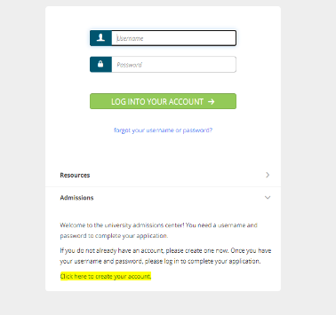
- Complete the required fields (*) Name, Email, Address, Password (which MUST consist of 6-12 letters), and Security Question. Please be sure to save the password, which must be used for all future activities on Tk20. If you do not remember your password, click the Reset button to create a new password, or contact Ayanna.kelley@udc.edu.
- Complete the captcha (fill in the word) as directed; then click on Create My Account.
- Once you have created your account, your username will automatically populate in the field: Enter your password >.
- Click on Login.

To Complete an OSSE AFE 2021-22 Scholarship Application
- Login to udc.tk20.com (using your admission account username and password).
- Click on Admission Application, then click on Create Application.
- Select the Application Type from the dropdown menu, then click on OSSE AE Scholarship Application.
- Click on Continue.
- You will see general information and if applicable, any checklist items that are required. Click on Next to continue to the next page.
- Complete the Application. All fields marked with an asterisk (*) must be filled in before the system will let you submit. Click on Next when ready to proceed to the next page. See Attachment VI for additional tips on navigating Tk20.
- On the last page of the application, you will see > Submit Application Now. Please be sure to upload all required documents (listed under B below).

B. Attach all required documents: The following documents must accompany your completed OSSE AFE Scholarship Application: Note: applications without these documents are classified as “incomplete” and will be considered only when all documents are received:

- A copy of your transcript(s)—for your undergraduate and graduate degree(s). Note: For your UDC Application for Admissions package—WHICH IS SEPARATE AND ADDITIONAL TO YOUR OSSE AFE SCHOLARSHIP APPLICATION PACKAGE— you will need to submit an official transcript from every university you attended—irrespective of whether a degree was awarded or not. To avoid UDC admission delays, we recommend that you request all your official transcripts now.

- An autobiographical and philosophical statement of 500 words or fewer about your academic and professional goals, research interests, relevant prior experience, motivation for graduate study in adult education, and any other information you believe will assist the consideration of your suitability for a scholarship and admission to a graduate program. Note: You may also submit this autobiographical statement as part of your UDC admissions package to satisfy the university’s essay requirement.

- Two letters of recommendation from professionals who can provide candid information relevant to your abilities to pursue graduate study in adult education. Guidelines for the Preparation of Letters of Recommendation are provided as Attachment IV. Note: You may also submit these letters as part of your UDC Application for Admission package.

- A completed Employment Verification Form. See Attachment V - OSSE Employment Verification Form.

- Your current resume.

- Apply to UDC for Admission: The award of an OSSE scholarship is predicated on the candidate’s admission to UDC. Potential scholarship recipients must complete and submit online a UDC admissions application package, per steps detailed in Attachment I.

ATTACHMENT IV

OSSE Adult Education Teacher Licensure and Certification Scholarships
Guidelines for Letters of Recommendation

As part of your scholarship application package, OSSE requires you to provide two Letters of Recommendation from individuals who know you in a professional capacity and who can provide candid information relevant to your abilities to pursue graduate studies in adult education. When you submit your application for an OSSE Adult Educator Scholarship, you are required to upload into Tk20 two Letters of Recommendation.

To be acceptable, Letters of Recommendation must:

- Be typed on the professional/agency’s letterhead of your personal reference provider.

- Include the name of the professional reference provider, his/her title, institution, department address, telephone and email address.

- Reference your name in the caption.

- State how long your references have known you and in what capacity (e.g., supervisor, manager, teacher, etc.)

- Discuss your suitability for graduate studies in Adult Education, addressing specifically the following aspects of your competence:

- Your intellectual potential and ability to meet the high expectations of a rigorous program geared toward the development of scholar practitioners.
- Your ability to stay the course and complete the program within a specified timeframe.
- How they would describe you and your philosophy of adult education.
- How you demonstrate your ability, as an educator, to work with adults with varying learning needs.
- Your level of facility with oral, written and interpersonal communication skills.
- How you have displayed mature judgment.
- Your motivation and capability to engage in self-directed and active learning.
- Your ability to be a positive contributor and change agent in a vibrant cohort of adult educators.

ATTACHMENT V

Adult Education Teacher Licensure and Certification Scholarships
Employment Verification Form

Name: _________________________________________________________________

Mailing Address: _________________________________________________________

City: _________________________ State: ________________ ZIP Code: _______

Phone: ______________________ (work) ___________________ (cell)

Email Address: ___________________________________________________________

Agency/Program Name: ___________________________________________________

Address: ________________________________________________________________

City: ____________________________ State: ________________ ZIP Code: _______

Phone: ______________________ (work) _________________________ (cell)

Current title/position: _______________________________________________

Full-time _____ Part-Time _____ Volunteer _____ OSSE Funded position: Yes ___ No _____

How long have you been working in this position? ____________ (number of years/months)

Have you worked in other positions in the agency? Yes _____ No _____

If yes, please list the other positions that you have held: ________________________________

___________________________________________ _____________________
Employee’s Signature Date

Supervisor’s Name: ______________________________________

Supervisor’s Phone Number: _________________ Email Address: __________________________

___________________________________________ _____________________
Supervisor’s Signature Date
Before signing, be sure to answer every question.
ATTACHMENT VI

TIPS FOR COMPLETING AN OSSE SCHOLARSHIP APPLICATION ONLINE IN Tk20

- Back:takes you to the previous page.

- Save Changes and Exit: allows you to save your work and come back at a later time.

- Submit Application Now: submits your application for review.

- Cancel: deletes any work that had been started.

- If an application has a picture of a lock, it has already been submitted and will need to be recalled or re-opened for editing by an administrator.

- To Return to a Saved Application:
  - Login to your server. This will display a list of all application forms you have created.
  - Click on the name of the application you wish to edit.
  - When finished editing, click Save or Submit.

- To Upload Documents with your Application:

The following steps will assist you with uploading the required documents to Tk20.

Step I: Click on Select File under the required document section.
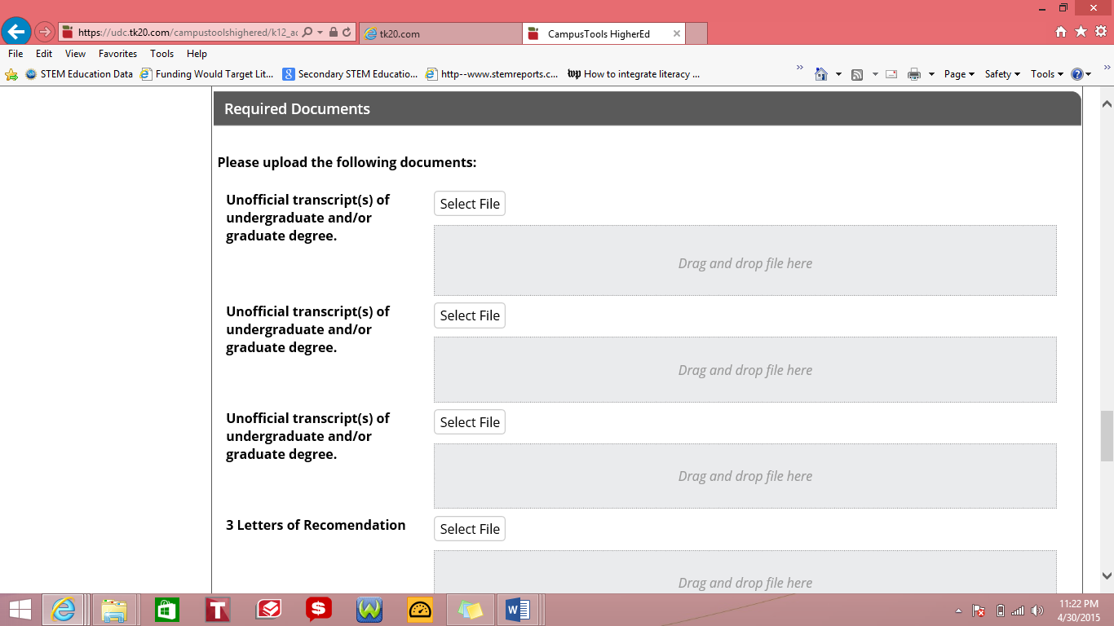
Step II: Choose the appropriate file from your saved documents and click open.

The name of your file will show in the application if it is successfully attached.

Step III: Click Save.
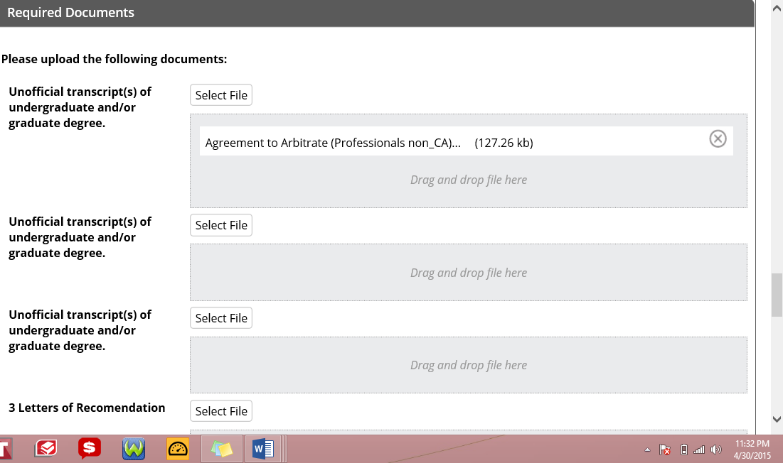

- Help Resources - Online Tutorials: Tk20 has step-by-step tutorials which can be accessed by clicking on Help located in the upper right corner of the screen (except the login page). Click on the role that best describes your responsibility. Clicking on a role allows you to view all resources.

21 credits are transferable to the MA degree, leaving only 15 additional credits to earn a graduate degree.
For teacher license renewal, 120 Professional Development hours or 8 credit hours of coursework are required every four years.
Please see Attachment I: UDC Adult Education Program and Admissions Requirements.
Please see Attachment II: UDC Schedule of Graduate Tuition and Fees – AY 2021-22.
Tk20 is an assessment, accountability, and management system used by the District of Columbia.
A practice model specific to propelling adults toward achieving specific learning outcomes, and promotes self-directed and deeper learning, as it places the learner at the center of the equation.
UDC Ph.D. Program in Urban Leadership and Entrepreneurship.

