

OSSE Adult Educator Scholarship Program – 2019 Offerings
Application Closing Date – Friday, June 7, 2019

- This Notification provides essential information about the Adult Educator Scholarships that the District of Columbia (DC) Office of the State Superintendent of Education, Adult and Family Education (OSSE AFE), proposes to offer in 2019. Funding permitting, this scholarship initiative is intended to assist eligible adult educators in the District of Columbia to meet the District’s State licensure qualifications. Provided below is relevant information on the initiative, the proposed scholarship opportunities, scholarship eligibility criteria, application and selection processes, and the timeline/critical dates.

- THE INITIATIVE: OSSE has forged a partnership with the University of the District of Columbia (UDC), to provide adult educators with the academic training necessary to meet the qualifications for state licensure and/or license renewal, as appropriate. UDC offers a Graduate Certificate in Adult Education (24 credit hours) and a Master of Arts (MA) in Adult Education (36 credit hours). The programs share core courses and design features, permitting the transfer of up to 21 credits earned in UDC’s Graduate Certificate program to the MA program. This OSSE/UDC partnership also offers 1-credit modules, workshops and seminars–many of which are aligned with the Graduate Certificate curriculum. Additionally, participation in these courses may meet professional development requirements for adult educators. Information about UDC’s program requirements is provided as Attachment I.

- SCHOLARSHIP OPPORTUNITIES: Depending on funding availability, in the 2019–20 academic year, OSSE plans to support, eligible adult educators to pursue academic opportunities that culminate in licensure and/or license renewal, as appropriate. OSSE will pay applicable tuition and fees, at UDC’s graduate resident rate, for:

- Up to 10 qualifying adult educators, who are admitted to UDC’s Graduate Certificate program, in Fall 2019, to pursue their education at a rate of 6 credit hours of coursework each semester (including summer sessions).

- Up to 10 qualifying adult educators, who are admitted to UDC’s Graduate Certificate program, in Fall 2019, to pursue their education at a rate of 3 credit hours of coursework each semester (including summer sessions) and/or at a rate of one thematic module (1 credit) per month.

- Up to 5 qualifying adult educators, with an earned Master’s degree, to have their transcripts analyzed to determine if they could meet the qualifications for licensure, as appropriate.

- Up to 30 adult educators (per session) to participate in professional development (PD) workshops/seminars provided under the partnership. For license renewal (every 4 years), adult educators are required to earn 120 Professional Development hours or eight credit hours of coursework.

- SCHOLARSHIP ELIGIBILITY CRITERIA: To be eligible for a scholarship, applicants must meet the following criteria:

A. Education:

- Hold an undergraduate degree from an accredited university.

- Meet UDC’s admissions requirements for the Graduate Certificate program.

- Adhere to the University’s requirement that students must pass Praxis Core (Math, Reading, and Writing) to participate in more than nine credit hours of coursework. Praxis Core is mandatory to advance beyond nine credit hours in the UDC teacher education programs; students are not allowed to continue their studies without a Praxis Core passing score. The program uses the cohort model whereby students move through all classes and phases together, and a new cohort is admitted to the program once each year. Failure to meet the Praxis Core requirement may result in a delay in the completion of the program and may cause a discontinuance of the scholarship.

- To retain the scholarship, students must comply with/exceed the university’s retention standard of a “B” or higher in each course (3.0 GPA or above).

B. Employment:

- For scholarships to credit-bearing Graduate Certificate and/or Professional Development Modules:

- priority will be given to adult educators employed in key positions in adult education programs funded by OSSE AFE, and if space is available, consideration will then be given to adult educators who work in other adult education programs in the District of Columbia.

- For OSSE AFE-sponsored professional development workshops/seminars (non-credit):

  - priority will be given to adult educators, volunteers, tutors and/or staff who work in adult education programs funded by OSSE AFE,

  - consideration will then be given to adult educators, volunteers and tutors and/or staff who work in other adult education programs in the District Columbia.

C. Residency.

- For scholarships to credit-bearing Graduate Certificate/Professional Development Modules:

  - priority will be given to adult educators who reside in the District of Columbia and who are employed in key positions in adult education programs funded by OSSE AFE,

  - priority will next be given to adult educators who are employed in key positions in adult education programs funded by OSSE AFE, but reside outside of the District of Columbia, and

  - if space is available, consideration will then be given to adult educators who reside within or outside of the District of Columbia and who work in other adult education programs in the District of Columbia.

- For OSSE AFE-sponsored professional development workshops/seminars (non-credit):

All adult educators working or volunteering in adult education programs in the District of Columbia are eligible to participate in professional development workshops/seminars regardless of residency. However,

  - priority will be given to adult educators, volunteers, tutors and/or staff who work in adult education programs funded by OSSE AFE,

  - consideration will then be given to adult educators, volunteers, tutors and/or staff who work in other adult education programs in the District Columbia, and

D. Commitment Agreement

- Recipients of a Scholarship to the Graduate Certificate program must commit to taking the necessary steps to become licensed within 6 months of successfully completing the necessary academic requirements.

- Recipients of a Scholarship, who matriculate for a Graduate Certificate in Adult Education, must additionally commit to working with adult learners in an OSSE AFE funded program or another adult education program in the District of Columbia for no less than two years after graduation.


SCHOLARSHIP APPLICATION PROCESS: To apply for a scholarship, eligible candidates must:

A. Complete a 2019 OSSE Scholarship Application online:

Please click here to access the application and follow the guidelines below. If you need assistance, please contact Ayanna Kelley (ayanna.kelley@udc.edu). Also, please see Attachment V for useful tips for navigating Tk20.
To Create an Admissions Account
- Once on the website, under Helpful Resources (located to the right of the split screen) click on the admissions tab.
- Create an account by clicking on the link. Click here to create your account.
- Complete the required fields (*) Name, Email, Address, Password, Security Question. (Note: Your password MUST contain 6-12 letters). Please be sure to save the password, which must be used for all future activities on Tk20.
- Complete the captcha (fill in the word) as directed; then click on Create My Account.
- Once you have created your account, your username will automatically populate in the field: Enter your password >.
- Click on Login.

To Complete an OSSE 2019 Scholarship Application
- After you login using your admission account username and password, then click on Create New Application.
- Click on the drop down menu and select “2019 OSSE Scholarship”.
- Click on Continue.
- You will see general information and, if applicable, any checklist items that are required. Click on Next to continue to the next page.
- Complete the Application. All fields with an asterisk (*) must be filled in before the system will let you submit. Click on Next when ready to proceed to the next page. See Attachment V for additional tips on navigating Tk20.
- On the last page, you will see > Submit Application Now. Please be sure to upload all required documents (listed below).

B. Attach all required documents: The following documents must accompany your completed OSSE Scholarship Application: Note: applications without these documents are classified as “incomplete” and will be considered only when all documents are received:

- A copy of your transcript(s)—for your undergraduate and graduate degree(s). Note: For your UDC Admissions package you will need--from every university you attended, whether a degree was awarded or not--an official transcript. To avoid admission delays, we recommend that you request your official transcripts now.

- An autobiographical and philosophical statement of 500 words or less about your academic and professional goals, research interests, relevant prior experience, motivation for graduate study in adult education, and any other information you believe will assist the consideration of your suitability for a scholarship and admission to a graduate program. Note: You may also submit this essay as part of your UDC Admissions package.

- Two Letters of Recommendation from professionals who can provide candid information relevant to your abilities to pursue graduate study in adult education. Guidelines for the Preparation of Letters of Recommendation are provided as Attachment IV. Note: You may also submit these letters as part of your UDC Admissions package.

- Employment Verification Form. See Attachment IV - OSSE Employment Verification Form.

- Current resume.

C. Apply To UDC For Admission: The award of an OSSE scholarship is predicated on the candidate’s admission to UDC. Potential scholarship recipients must complete and submit online a UDC Admissions application package, per steps detailed in Attachment I, Section B.

TIMELINE/CRITICAL DATES

- OSSE’s Scholarship application process closes on Friday, June 7, 2019. Please submit your complete scholarship application package on or before that date. Note: Applications will be reviewed in the order received., Application packages that are not fully completed will be relegated a lesser priority.

- Between June 10-20, 2019, applicants who have been selected as potential candidates may be interviewed by a Scholarship Selection Committee. By June 21, 2019, OSSE/UDC will inform successful candidates of the potential award of a Scholarship, predicated on their successful admission to UDC.

- By July 5, 2019, potential scholarship recipients must submit online to UDC a complete Admissions application package in order to be admitted to the Fall 2019 cohort. You are encouraged to submit your application to the university well in advance of this date to ensure that you are within its admission schedule.

Note: Applicants may plan ahead by requesting that all colleges attended send to UDC’s Admissions Office, their official transcript(s) that show all course work, grades and date(s) of graduation.

- Non-Scholarship Recipients may also follow the above schedule, should they wish to apply to be part of the UDC Fall 2019 cohort, paying their own tuition and fees. Please refer to Attachment II– UDC 2019 Tuition and Fees Schedule. Financial aid is available for the Graduate Certificate program, to which all applicants to the MA program are first admitted, and for which the GRE requirement is waived. (See Attachment I.)

ATTACHMENT I

UDC’s Adult Education Program offers a Graduate Certificate in Adult Education, a Master of Arts in Adult Education, and provides associated Adult Education Professional Development Training (graduate credit and PD hours) opportunities for adult educators in the District of Columbia.

SNAPSHOT OF UDC’S ADULT EDUCATION PROGRAM & REQUIREMENTS

A.  SNAPSHOT OF PROGRAM | PROGRAM | CORE | ELECTIVES | CAPSTONE | TOTAL
A.  SNAPSHOT OF PROGRAM | Graduate Certificate | 18 | 3 | 3 | 24
A.  SNAPSHOT OF PROGRAM | MA in Adult Education | 24 | 12 - 9 | 0 – 3 | 36
A.  SNAPSHOT OF PROGRAM | CORE COURSES |  |  | Certificate | Master’s
A.  SNAPSHOT OF PROGRAM | - Orientation to Adult & Continuing Education |  |  | 3 | 3
A.  SNAPSHOT OF PROGRAM | - Adult Learning, Motivation & Development |  |  | 3 | 3
A.  SNAPSHOT OF PROGRAM | - Communicating with the Adult Learner |  |  | 3 | 3
A.  SNAPSHOT OF PROGRAM | - Instructional Technology and Integration |  |  | 3 | 3
A.  SNAPSHOT OF PROGRAM | - Facilitating Learning in Adulthood |  |  | 3 | 3
A.  SNAPSHOT OF PROGRAM | - Transitioning Adults with Learning Differences |  |  | 3 | 3
A.  SNAPSHOT OF PROGRAM | - Culture, Context and Critical Pedagogy |  |  |  | 3
A.  SNAPSHOT OF PROGRAM | - Research and Assessment Methods |  |  |  | 3
A.  SNAPSHOT OF PROGRAM | Electives in Area of Concentration |  |  | 3 | 9 -12
A.  SNAPSHOT OF PROGRAM | CAPSTONE REQUIREMENT |  |  | 3 | 0 - 3
A.  SNAPSHOT OF PROGRAM | TOTAL CORE CREDIT HOURS REQUIRED |  |  | 24 | 36
A.  SNAPSHOT OF PROGRAM | - For certification by the DCPS Educational and Credentialing Office, students must have completed the professional education requirements specified by DCPS, prior to joining the program.  - The program follows a cohort model (students take most, if not all of their core courses sequentially, together): it accepts applications only in the Fall semester.  - All new and returning students are required to take Orientation to Adult & Continuing Education as the first required course of this new program of studies.  - To be certified, students who are without 1 year of fulltime or 2 years of part-time recognized adult education teaching experience are required to complete a 1-semester internship in an Adult Education service delivery program.
B.  Required for  Admission to the UDC/ Program | To receive an Admissions Decision, Applicants to the Graduate Certificate Program must:  - Hold an undergraduate degree from an accredited post-secondary institution, with a GPA of 2.8 or higher.  - Complete, on the university’s website, application for Non-Degree Applicants, if applying to the Graduate Certificate program. You will find full details on the Apply Now page on UDC’s website.  - Pay the non-refundable $50.00 application fee. If you do not pay your application fee by credit card when you submit your application, please download and mail an Application Fee Payment Form to the Admissions Office along with a check or money order payable to the University of the District of Columbia.  - Submit official college transcript(s) reflecting all course work, grades and date of graduation.  - Submit official GRE scores. Note: The GRE requirement is waived for new students entering the Graduate Certificate program. Completers of the Graduate Certificate program, who are transitioning into the Master’s program, must meet the GRE requirement, if they do not already hold a Graduate degree.  - Satisfy, for DCPS certification, the “Professional Education Requirements outlined in the License Requirements for the District of Columbia Public Schools (1993). UDC courses comparable to the DCPS requirements will be accepted.  - Submit a 500-word personal statement about your academic and professional goals, research interests, relevant prior experience, motivation for graduate study in the adult education program and any other information in support of your application for graduate admission. You may submit the same essay you provide to OSSE AFE with your 2019 Scholarship Application.  - Submit 2 letters of recommendation from individuals in a professional capacity, who can attest to your abilities to pursue graduate studies, written on their official letterhead, with contact information. You may submit with your UDC Admissions package the letters of recommendation you provide to OSSE AFE with your Scholarship Application.  - Submit proof of residency documentation. This is essential to ensure that the university does not charge you the difference between the tuition and fees that OSSE pays for scholarships awarded at the Resident or Metro Rate, and the much higher fees of the Non-resident rate--assigned, to all who do not provide proper documentation in a timely manner. Please see on UDC’s website, and/or check with the Admissions Office, the documents that evidence proof of residency.
C.  University Acceptance Process | - Approximately 2 weeks after submitting your application, you may check on its status, by logging into UDC’s application system with the same Login ID and Pin # used to create the application. If you forget your UDC ID or PIN #, please email the Admissions Office (UDCadmissions@udc.edu).  - The Admissions Office will review your credentials and transcripts to verify compliance with general and DCPS professional education requirements for certification in adult education. Note: UDC can only make an admission decision when it receives all required documents and your completed application.  - On completion of the review, the Admissions Office will notify you if you have been approved for admission to graduate studies at the university—a prerequisite that does not guarantee automatic acceptance into the Adult Education program.
D.  Program Acceptance and Continuation | - Submit Confirmation of Enrollment form to reserve space in the Fall 2019 cohort.  - A selection panel, convened by the Adult Education Program, will review your Graduate Application form, Official Transcript (s), letters of recommendation to determine your suitability for the adult education program.  - Candidates may be interviewed, required to write an onsite essay, and must demonstrate a suitable level of technology skills.  - All students are automatically charged health insurance at the time of registration, and the premium for this coverage is added to the student’s tuition bill. Note: OSSE scholarships do not pay for this coverage. Students who waive coverage with proof of comparable insurance coverage, by the waiver deadline, will see the premium removed from their account. Those who fail to execute a waiver by the firm deadline, are responsible for paying all insurance premiums charged to their account. You may opt out of the University’s sponsored health insurance plan by visiting www.firststudent.com before the deadline.  - All students admitted to the program must complete the Orientation to Adult and Continuing Education course before enrolling in other courses.  - Earn a “B” or better (GPA of 3.0 or higher) in all courses to remain in the program.  - Earn a qualifying score on the Praxis CORE Academic Skills examinations.  - Must have completed training for Tk20 Electronic Portfolio Assessment platform. Students are required to maintain electronic portfolios of all their work in the Certificate Program.  - Determination of acceptance into the Teacher Education Program will be made collectively by the Program Coordinator, the Technology Assessor, an Assistant Professor of Adult Education, and the Assistant Dean of the College of Arts and Sciences.
E.  Exit Requirements | - Must complete all required coursework (with a grade of “B” or better in each course, maintaining a GPA of 3.0 or higher), and all additional requirements, including internship requirement for students without relevant adult teaching experiences.  - Complete an Exit Survey.  - For State Licensing, obtain a passing score on Praxis CORE (English, Writing & Math), or OSSE equivalent.  - Complete and submit OSSE’s Application for Licensure Requirements Form, which requires a background check, and payment of an application fee.

ATTACHMENT II

UDC’S 2019 TUITION AND FEES SCHEDULE

Graduate Resident Tuition – Fall 2019
Credit Hours | Tuition | Fees ¹ | Total
1 | $500.00 | $430.00 | $930.00
2 | $1,000.00 | $430.00 | $1,430.00
3 | $1,500.00 | $430.00 | $1,930.00
4 | $2,000.00 | $430.00 | $2,430.00
5 | $2,500.00 | $430.00 | $2,930.00
6 | $3,000.00 | $430.00 | $3,430.00
7 | $3,500.00 | $430.00 | $3,930.00
8 | $4,000.00 | $430.00 | $4,430.00
9 or more | $4,500.00 | $430.00 | $4,930.00

Graduate Metro Tuition – Fall 2019
Credit Hours | Tuition | Fees ¹ | Total
1 | $562.00 | $430.00 | $992.00
2 | $1,124.00 | $430.00 | $1,554.00
3 | $1,686.00 | $430.00 | $2,116.00
4 | $2,248.00 | $430.00 | $2,678.00
5 | $2,810.00 | $430.00 | $3,240.00
6 | $3,372.00 | $430.00 | $3,802.00
7 | $3,934.00 | $430.00 | $4,364.00
8 | $4,496.00 | $430.00 | $4,926.00
9 or more | $5,058.00 | $430.00 | $5,488.00
Graduate Non-Resident Tuition – Fall 2019
Credit Hours | Tuition | Fees ¹ | Total
1 | $962.00 | $430.00 | $1,392.00
2 | $1,924.00 | $430.00 | $2,354.00
3 | $2,886.00 | $430.00 | $3,316.00
4 | $3,848.00 | $430.00 | $4,278.00
5 | $4,810.00 | $430.00 | $5,240.00
6 | $5,772.00 | $430.00 | $6,202.00
7 | $6,734.00 | $430.00 | $7,164.00
8 | $7,696.00 | $430.00 | $8,126.00
9 or more | $8,658.00 | $430.00 | $9,088.00

ATTACHMENT III

OSSE Adult Educator Scholarship Program
Guidelines for Letters of Recommendation

As part of your scholarship application package, OSSE requires you to provide two Letters of Recommendation from individuals who know you in a professional capacity and who can provide candid information relevant to your abilities to pursue graduate studies in adult education. You are required to upload into Tk20 two Letters of Recommendation when you submit your application for an OSSE Adult Educator Scholarship.

To be acceptable, Letters of Recommendation must:

- Be typed on the professional/agency’s letterhead of your personal reference provider.

- Include the name of the professional reference provider, his/her title, institution, department address, telephone and email address.

- Reference your name in the caption.

- State how long your referees have known you and in what capacity (e.g. supervisor, manager, teacher, etc.)

- Discuss your suitability for graduate studies in Adult Education, addressing specifically the following aspects of your competence:

- Your intellectual potential and ability to meet the high expectations of a rigorous program geared towards the development of scholar practitioners.
- Your ability to stay the course and complete the program within a specified timeframe.
- How they would describe you and your philosophy of adult education.
- How you demonstrate your ability, as an educator, to work with adults with varying learning needs.
- Your level of facility with oral, written and interpersonal communication skills.
- How you have displayed mature judgment.
- Your motivation and capability to engage in self-directed and active learning.
- Your ability to be a positive contributor and change agent in a vibrant cohort of adult educators.
ATTACHMENT IV

OSSE Adult Educator Scholarship Program
Employment Verification Form

Name: _________________________________________________________________

Mailing Address: _________________________________________________________

City: _________________________ State: ________________ Zip Code: _______

Phone: ______________________ (work) ___________________ (cell)

Email Address: _____________________________________________

Agency/Program Name: ___________________________________________________

Address: ________________________________________________________________

City: ____________________________ State: ________________ Zip Code: _______

Phone: ______________________ (work) _________________________ (cell)

Current title/position: _______________________________________________

Full-time _____ Part-Time _____ Volunteer _____ OSSE Funded position: Yes ___ No _____

How long have you been working in this position? ____________ (number of years/months)

Have you worked in other positions in the agency? Yes _____ No _____

If yes, please list the other positions that you have held: ____________________________________
___________________________________________ _____________________
Employee’s Signature Date

Supervisor’s Name: ______________________________________

Supervisor’s Phone Number: _________________ Email Address: __________________________

___________________________________________ _____________________
Supervisor’s Signature Date

Be sure to answer every question before signing.
ATTACHMENT V

SOME GENERAL HELPFUL TIPS FOR NAVIGATING Tk20

- Back will take you to the previous page.

- Save Changes and Exit: allows you to save your work and come back at a later time.

- Submit Application Now: submits your application for review.

- Cancel: deletes any work that had been started.

- If an application has a picture of a lock, it has already been submitted and will need to be recalled or re-opened for editing by an administrator.

- To Return to a Saved Application:
  - Login to your server. This will display a list of all application forms you have created.
  - Click on the name of the application you wish to edit.
  - When finished editing, click Save or Submit.

- To Upload Documents with your Application:

The following steps will assist you with uploading the required documents to Tk20.

Step I: Click on Select File under the required document section.

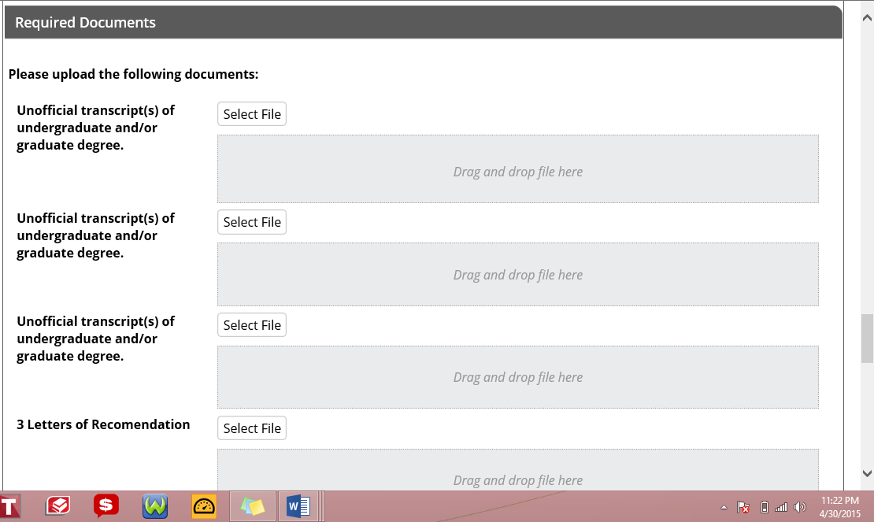

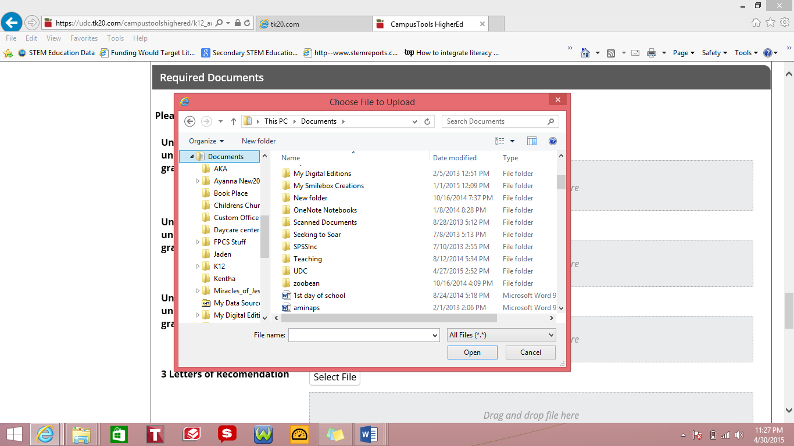
Step II: Choose the appropriate file from your saved documents and click open.

The name of your file will show in the application if it is successfully attached.

Step III: Click Save.
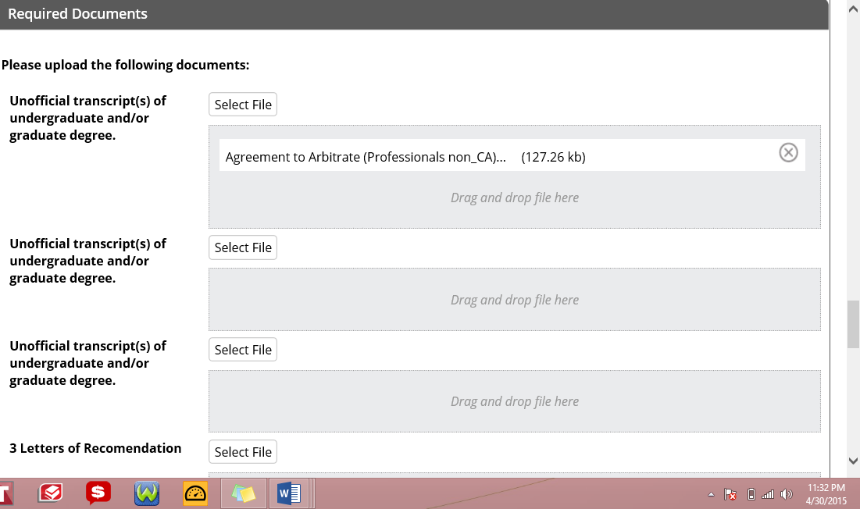

- Help Resources - Online Tutorials: Tk20 has step-by-step tutorials, which can be accessed by clicking on Help located in the upper right corner of the screen (except the login page). Click on the role that best describes your responsibility. Clicking on a role helps you view all resources.

Please see Attachment II: UDC’s 2019 Tuition and Fee Schedule for Graduate Resident and Metro Tuition Rates.
Please see Attachment I: UDC’s Adult Education Program and Admissions Requirements
www.udc.edu/admit/apply_now

