REQUEST FOR NAME CHANGE

Institutions that are currently approved by the Higher Education Licensure Commission that are requesting a name change must submit for approval the Request for Name Change Application. One individual (1) copy of the request should be submitted along with one (1) electronic version via flash drive. A check or money order in the amount of One Hundred Fifty dollars ($150) payable to the DC Treasurer must also be submitted with the application and delivered to:

Higher Education Licensure Commission
1050 First St. NE
Fifth Floor
Washington, DC 20002

The review and approval process takes 60-90 days depending on the timeframe the request is submitted as well as the completeness of the submission. Requests for name changes are acted on during the public meeting of the Commission.

An institution cannot begin advertising a new name until the Commission has approved the request for a new name.

DC HIGHER EDUCATION LICENSURE COMMISSION
Request for Name Change
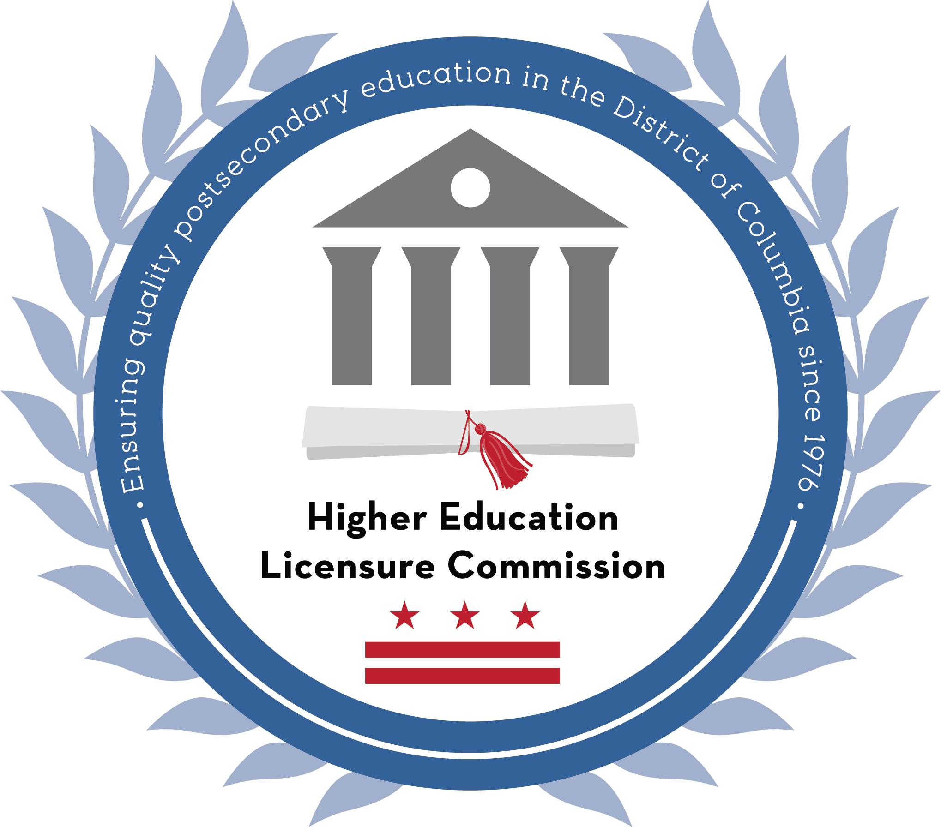
A. Institution Information

Current Approved Institution Name: Click here to enter text.

New Proposed Institution Name*: Click here to enter text.

Proposed Effective Date: Click here to enter text.

*If the name proposed contains any of the following words, the institution shall also complete a Request for Institution Name Good Cause Waiver form:
- United States | - State | - Government
- Federal | - Open | - Ward
- American | - District | - Washington
- National | - Columbia | - City
- Civil Service | - Municipal | - Metropolitan
- Public | - Commonwealth

Point of Contact (for this application)

Name and title: Click here to enter text.
E-mail: Click here to enter text. Direct Phone: Click here to enter text.
Address: Click here to enter text.
City: Click here to enter text. State: Click here to enter text. Zip code: Click here to enter text.
Phone: Click here to enter text. Website: Click here to enter text.

Name of Chief Executive (if different): Click here to enter text. E-mail: Click here to enter text.

B. Additional Information
- Please indicate reason for the name change?
Click here to enter text.

- If the institution is seeking to use “university” or “college” in its name, please indicate the rationale and justification including supporting documentation, keeping in mind that those specific terms are reserved solely for degree-granting institutions.
Click here to enter text.

- What effect will the name change have on current students, administrative staff, and faculty?
Click here to enter text.

- Has the institution’s accreditor(s) been notified of the name change? No ☐ Yes ☐ If yes, attach copy of accreditor(s) approval?

C. Required Supporting Documentation
- Certificate of Good Standing from the D.C. Department of Consumer and Regulatory Affairs and DC Tax & Revenue Office.

- Certificate of Trade Name Registration (if the institution is a business unit of a larger holding company)

- If the entity is a branch include the following documents from the state of origin:

  - Certificate of Good Standing from the business and tax offices
  - Copy of the educational license(s) or exemption(s).

D. Certification (must be signed by the Chief Administrator of the entity)

“I hereby affirm that the answers given in this application are true and accurate and complete. I understand that false information on this application may result in revocation and penalties. Further, I am authorized to sign this application on behalf of the entity named herein. I have read, and agree to comply with the District of Columbia’s laws and regulations governing corporations and educational entities regulated by the District of Columbia Higher Education Licensure Commission.”

Click here to enter text.

Type name and title Signature Date

REQUEST FOR INSTITUTION NAME GOOD CAUSE WAIVER

This form shall be completed by any institution whose name contains the following words:
- United States | - Public | - Columbia | - Ward
- Federal | - State | - Municipal | - Washington
- American | - Open | - Commonwealth | - City
- National | - District | - Government | - Metropolitan
- Civil Service

- Enter the full name of the institution: Click here to enter text.
- Is the institution a non-profit? No ☐ Yes ☐ (If yes, attach evidence of the non-profit status.)
- Does the institution operate exclusively in a foreign country? No ☐ Yes ☐ Click here to enter text. (name of country of operation)

- Non-governmental Affiliation Statement: In the following space, provide the text of the standardized language that is used by the institution to ensure that members of the public do not incorrectly presume an affiliation with the United States or District of Columbia governments as a result of the institution’s name.
Click here to enter text.

Required Supporting Documentation
Please attach to this Request for Good Cause Waiver the following documentary evidence:
- Evidence of 501(c)(3) status (if non-profit status claimed)
- Evidence of the original date of incorporation
- Evidence that the institution operates with the approval of the country of operation (if the institution seeks a waiver based solely on the fact that it operates exclusively in a foreign country)
- Evidence of accreditation granted to institution by an accrediting body recognized by the U.S. Department of Education
- Copies of publications, advertising, and student contracts employed by institution containing evidence of the above Non-governmental Affiliation Statement
Certification (must be signed by the Chief Administrator of the entity)
I solemnly swear or affirm that I have read this Request for Institution Name Good Cause Waiver and that the factual statements and assurances made herein are true to the best of my personal knowledge, information and belief under criminal penalties for the making of a false statement pursuant to D.C. Official Code § 22-2405, which includes 180 days in jail, a $1,000 fine or both.
Click here to enter text.

Type name and title Signature Date

This form need not be completed by any of the following institutions: Federal City College; Washington Technical Institute; University of the District of Columbia; District of Columbia School of Law of the University of the District of Columbia; Community College of the District of Columbia; or the American University.

