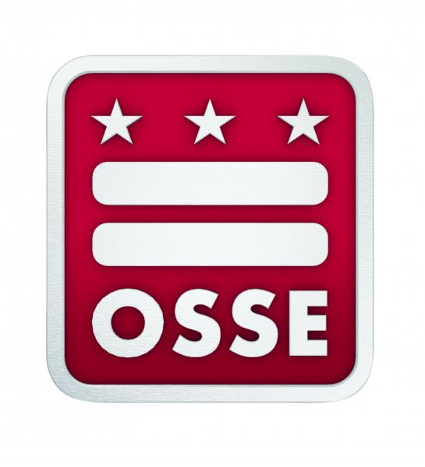

Discipline Data Collection Certification

2020-21

I CERTIFY that (1) my LEA / CBO has implemented a system of internal controls and taken any necessary corrective actions, to help ensure that all data included in the 2020-21 Discipline Data Collection, to the best of my knowledge, are valid and reliable; and (2) these data represent an accurate listing of all disciplinary incidents and actions that occurred during the prior school year.

AUTHORIZING OFFICIAL

DATE: _______________

LEA / CBO: _________________________________________________________________

HEAD OF SCHOOL NAME (PRINT): ____________________________________________

HEAD OF SCHOOL SIGNATURE: ______________________________________________

__________We have no students with discipline incidents to report for school year 2020-21

__________We have no in-school suspensions to report for school year 2020-21

