Instructions for Eligibility Based on Census Data

Step 1: Become familiar with the census data format

About the 2010 Census Block Group

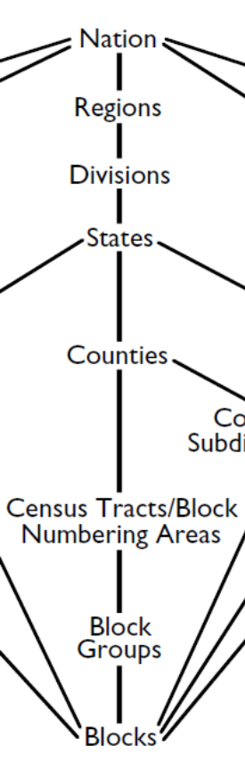
This file contains the 2010 Census Block Groups (CBG). Every 10 years the Census updates the area-based measures such as census tracts, blocks and block groups. This means that the income and CBG data released in 2003 should no longer be used.
01
001
020100
1

The ideal size of a CBG is around 1500 homes but vary by region and area characteristics. Contrary to the name, CBGs are not usually shaped like rectangles; rather they can take any shape. The graphic on the left shows the relationship of CBGs to other geographical areas and the components of the GEOID.

Every CBG in the country is numerated, meaning it has a unique number assigned to it. This number is called the GEOID.

What information is in the GEOID?

The GEOID contains 12 digits. Each position in the GEOID signifies a different level of geographical area. Every digit is important, even the first zero. This is important to remember when importing these data, because some programs drop the first zero. There is more information below about how to import the data correctly.

Here is an example of a GEOID from Autauga County, Alabama:

010010201001
- STATE: The first 2characters are the State code
- COUNTY: The next 3-characters are the county code
- TRACT: The next 6-characters are the census tract code
- BLOCK GROUP: The last character is the census block group code

The latest census data files can be found in folders here: https://www.partnerweb.usda.gov/communities/cndpolicy2/CND%20Resources/Forms/1.aspx?RootFolder=%2fcommunities%2fcndpolicy2%2fCND%20Resources%2fCensus%20Area%20Eligibility&FolderCTID=&View=%7b90D2EEBE-3FBB-4235-9583-F432F7D8FE6A%7d
Step 2: Determine eligibility

Below are instructions for two options to determine eligibility. State agencies, sponsoring organizations and individuals can use either tool.

- The Food Research and Action Center (FRAC) Map. This map includes an address search that will return eligibility information as well as other demographics. This map also includes zoom capabilities and map comparison for identifying areas of need. There is one map for CACFP and one for SFSP but remember both maps will return the correct information as eligibility in one program applies to both.
- The Census Bureau tools. These tools provide another method of identifying eligibility.

Step 2, Option 1: How to determine eligibility using the FRAC map

- Go to either FRAC map:
  - CACFP http://216.55.182.132/FairData/CACFP/map.asp?command=scope&map=0
  - SFSP http://216.55.182.132/FairData/SummerFood/map.asp?command=scope&map=0
- To find by address, click on “Find” and enter the address.
- In resulting map, the highlighted color indicates eligibility as indicated in the map layer key.
- If an address falls on a border between an eligible and ineligible CBG, click on the blue star and then INFO and scroll in the “2010 Block Group Information” window to “Eligible? (Yes or No).
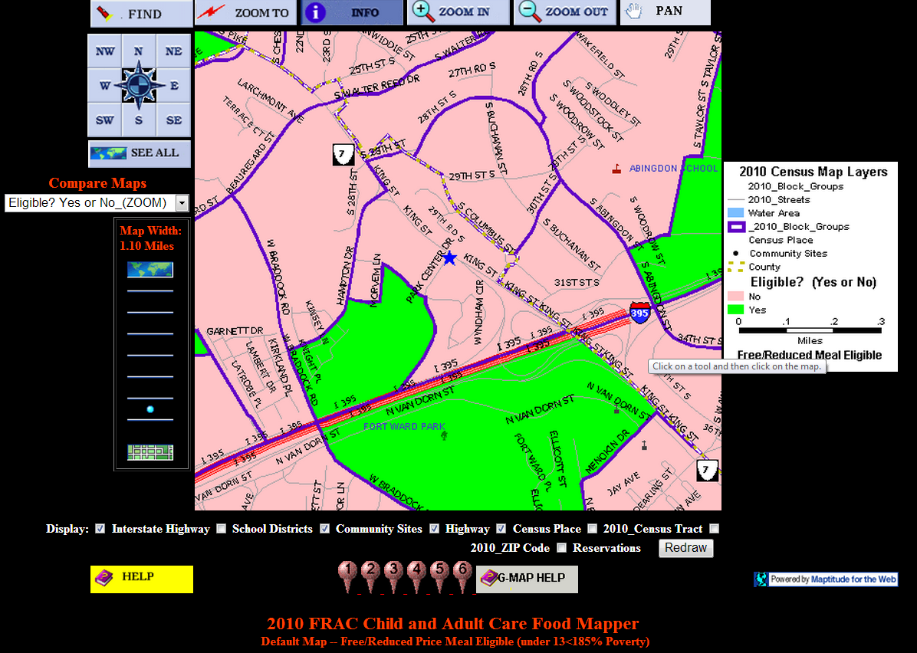
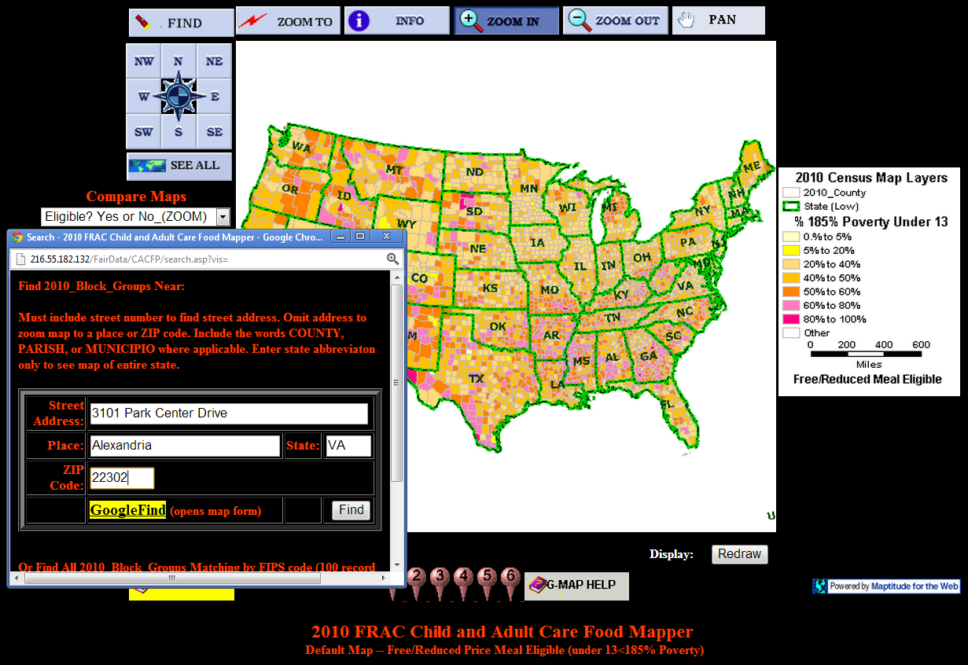

Step 2, Option 2: How to determine eligibility using Excel and Census.gov

Each State file contains the GEOID, the County Name, State Name, if the CBG is Eligible for SFSP and CACFP, and percentages of CACFP and SFSP children eligible for free and reduced priced school meals in that CBG. Finally, we have separated each GEOID into its geographical components in the last four columns: State, County, Tract, and Block Group.

GEOID | County Name | State Name | Eligible? (Yes or No) | SFSP: Percent 0-18 year olds eligible for free and reduced price meals (%) | CACFP: Percent 0-12 year olds eligible for free and reduced price meals (%) | State Code | County Code | Tract Code | Block Group Code
010010201001 | Autauga County | Alabama | No | 14.3 | 17.6 | 01 | 001 | 020100 | 1
010010201002 | Autauga County | Alabama | No | 22.1 | 26.2 | 01 | 001 | 020100 | 2
010010202001 | Autauga County | Alabama | No | 31.1 | 23.3 | 01 | 001 | 020200 | 1
010010202002 | Autauga County | Alabama | No | 42.4 | 48 | 01 | 001 | 020200 | 2

Things to be aware of when opening the State file(s):

If you open the file in a program other than Excel, make sure when importing that all fields are formatted as ‘Text’ at the import step. If the fields are formatted as ‘numeric’ or ‘general,’ then the first zero(s) of the 12 digit GEOID may be deleted automatically. In the last data release, it was reported that some non-Excel programs truncated zeros at the end of the number. Please ensure you have the expected number of digits in each column.

Also, if you have Excel 2003 or earlier versions, most files will open without incident, but large files may be truncated. If you think this may have occurred, please verify the file with a text editor. If the last CBG in the Excel file and text editor are the same, the Excel file is complete. If the last CBGs are not the same, the Excel file may truncated.

If you open the file in a word processing software but are having trouble aligning the columns, change the font to ‘Courier New’ or similar fixed width font.

Look up a GEOID using a map
- Go to http://tigerweb.geo.census.gov/TIGERweb2010/ *this website requires Microsoft Silverlight (5.0)
- When the window opens, a ‘Map Content’ box will be showing. Check the ‘Transportation’ box and then close the window by clicking on the ‘X’ in the upper right corner.
- Next, using the Zoom Tool, zoom in to approximately where you’d like to look up, as near as possible to the address. If you do not know where the address is, you can use an online mapping website, like Google Maps. You can zoom by using the Zoom tool on the left side of the map or by using your mouse’s scroll wheel.
- Once you have zoomed in, select the Query button.
- In the top of the Query window, click on the blue/yellow box with binoculars, this is a ‘Spatial Query.’
- Next, in the ‘Select Map’ pull down menu, chose ‘Census Tracts and Blocks.’
- In the field called ‘Select Layer’ highlight ‘Census Block Groups.’
- Click on the gray box with the blue circle, and click the map, as close as possible to the address.
- A GEOID will appear in the second query box and you should search for this number in the Excel when determining eligibility. If the address seems near to the highlighted CBG boundary, you can check for accuracy in the next step.
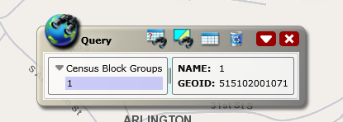
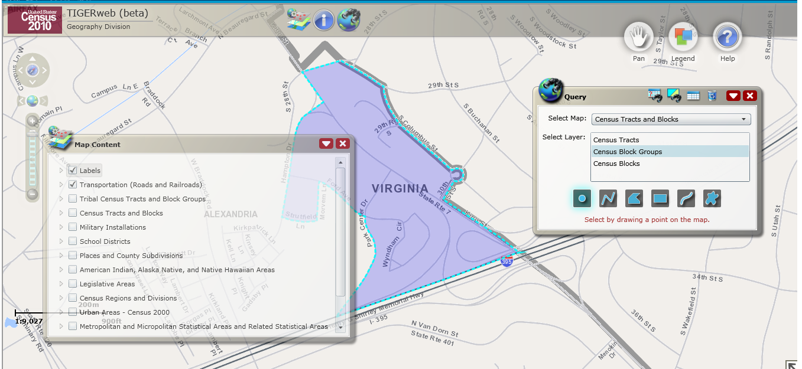
Zoom (Step 3)
Step 2
Query (Step 4)
Step 5
Step 6
Step 7
Step 8
Step 9
Look up a GEOID using American Fact Finder 2

Step A: Find the State and County codes for the GEOID.
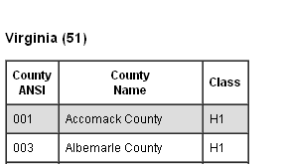
Step 3 State
- Go to http://www.census.gov/geo/www/ansi/countylookup.html.
- Pick the State of interest and choose ‘Go.’
- Above the right column, you’ll see the State name and two numbers in parentheses, this is the State Code, the first two numbers of the GEOID. Include the first zero, if applicable.
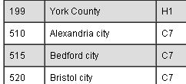
- Next, find the County of interest and find the three digit number to the right, this is the County Code, digits 3-5 of the GEOID. If you don’t know the county, open a second browser window and go to Step B. The name of the county will appear in the ‘Geography Name’ Column, under Geography Type ‘County’ (not shown).
Step 4 County

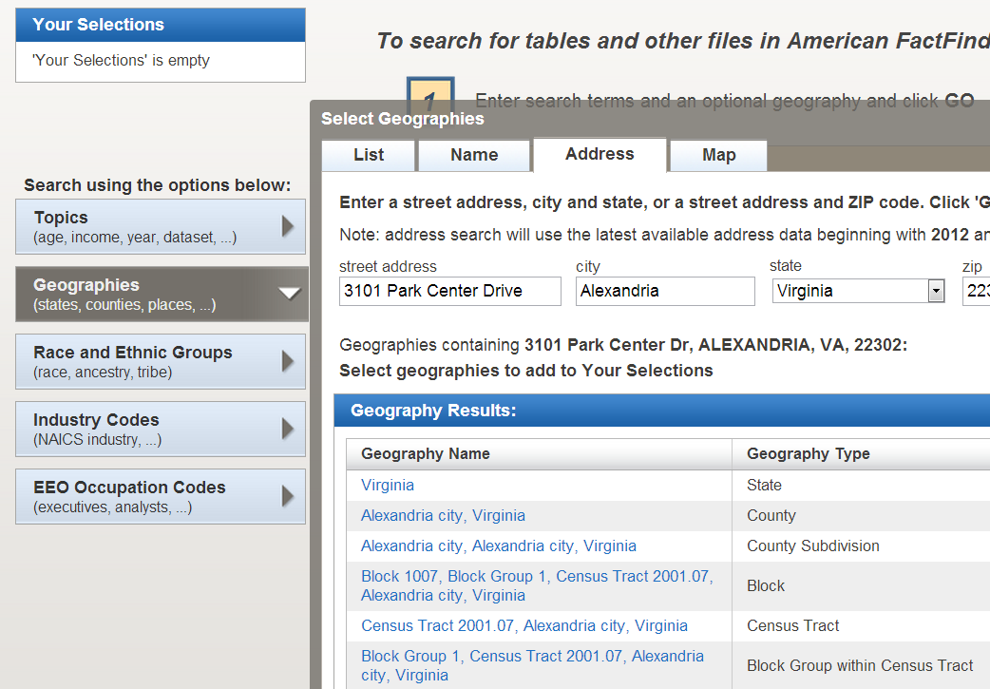
Step B: Find the Census Tract and Block Group codes for the GEOID.
- Go to http://factfinder2.census.gov/main.html.
- Click on “Advanced Search” and “show me all.”
- Click on ‘Geographies’ from the left menu.
- Click on ‘Address’ from the menu bar and enter the address and click ‘Go.’
Step 3
- Under the Geography Name results look for the Census Tract and Block Group information. The Census Tract may or may not have a decimal, but do not use the decimal when constructing the GEOID. The Block Group number is the last number of the GEOID. The Census Tract will be digits 6-11 of the GEOID. In this example, that would look like STCTY2001071
Step 5
- If you did not know the county for Step A, that is also listed in the Geography Results box.
Step C: Putting it all together.
- Combine the State Code, County Code, Census Tract, and Block Group into one 12-digit GEOID and search in the State eligibility files.
How to map a Census Block Group using GEOID
- Go to http://tigerweb.geo.census.gov/tigerweb/default.htm *this website requires Microsoft Silverlight (5.0)
- When the window opens a ‘Map Content’ box will be showing, check the ‘Transportation’ box and then close the window by clicking on the ‘X’ in the upper right corner.
- Select the Query button which looks like a globe with binoculars.
- Next, in the ‘Select Map’ pull down menu, chose ‘Census Tracts and Blocks.’
- In the field called ‘Select Layer,’ highlight ‘Census Block Groups.’
- Copy and paste the GEOID from the State eligibility file column labeled ‘GEOID’ into the field labeled ‘GEOID.’
- Click ‘Submit Query.’
Query (Step 3)
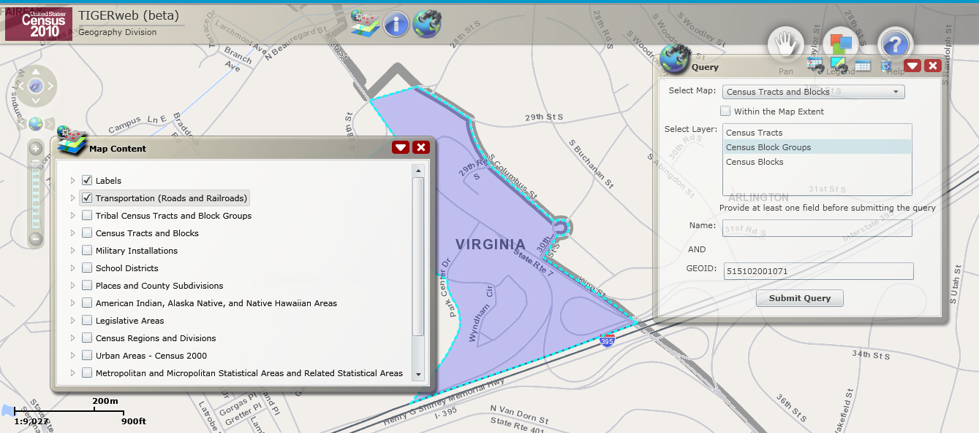
Step 2
Step 4
Step 6
Step 5
Step 7

