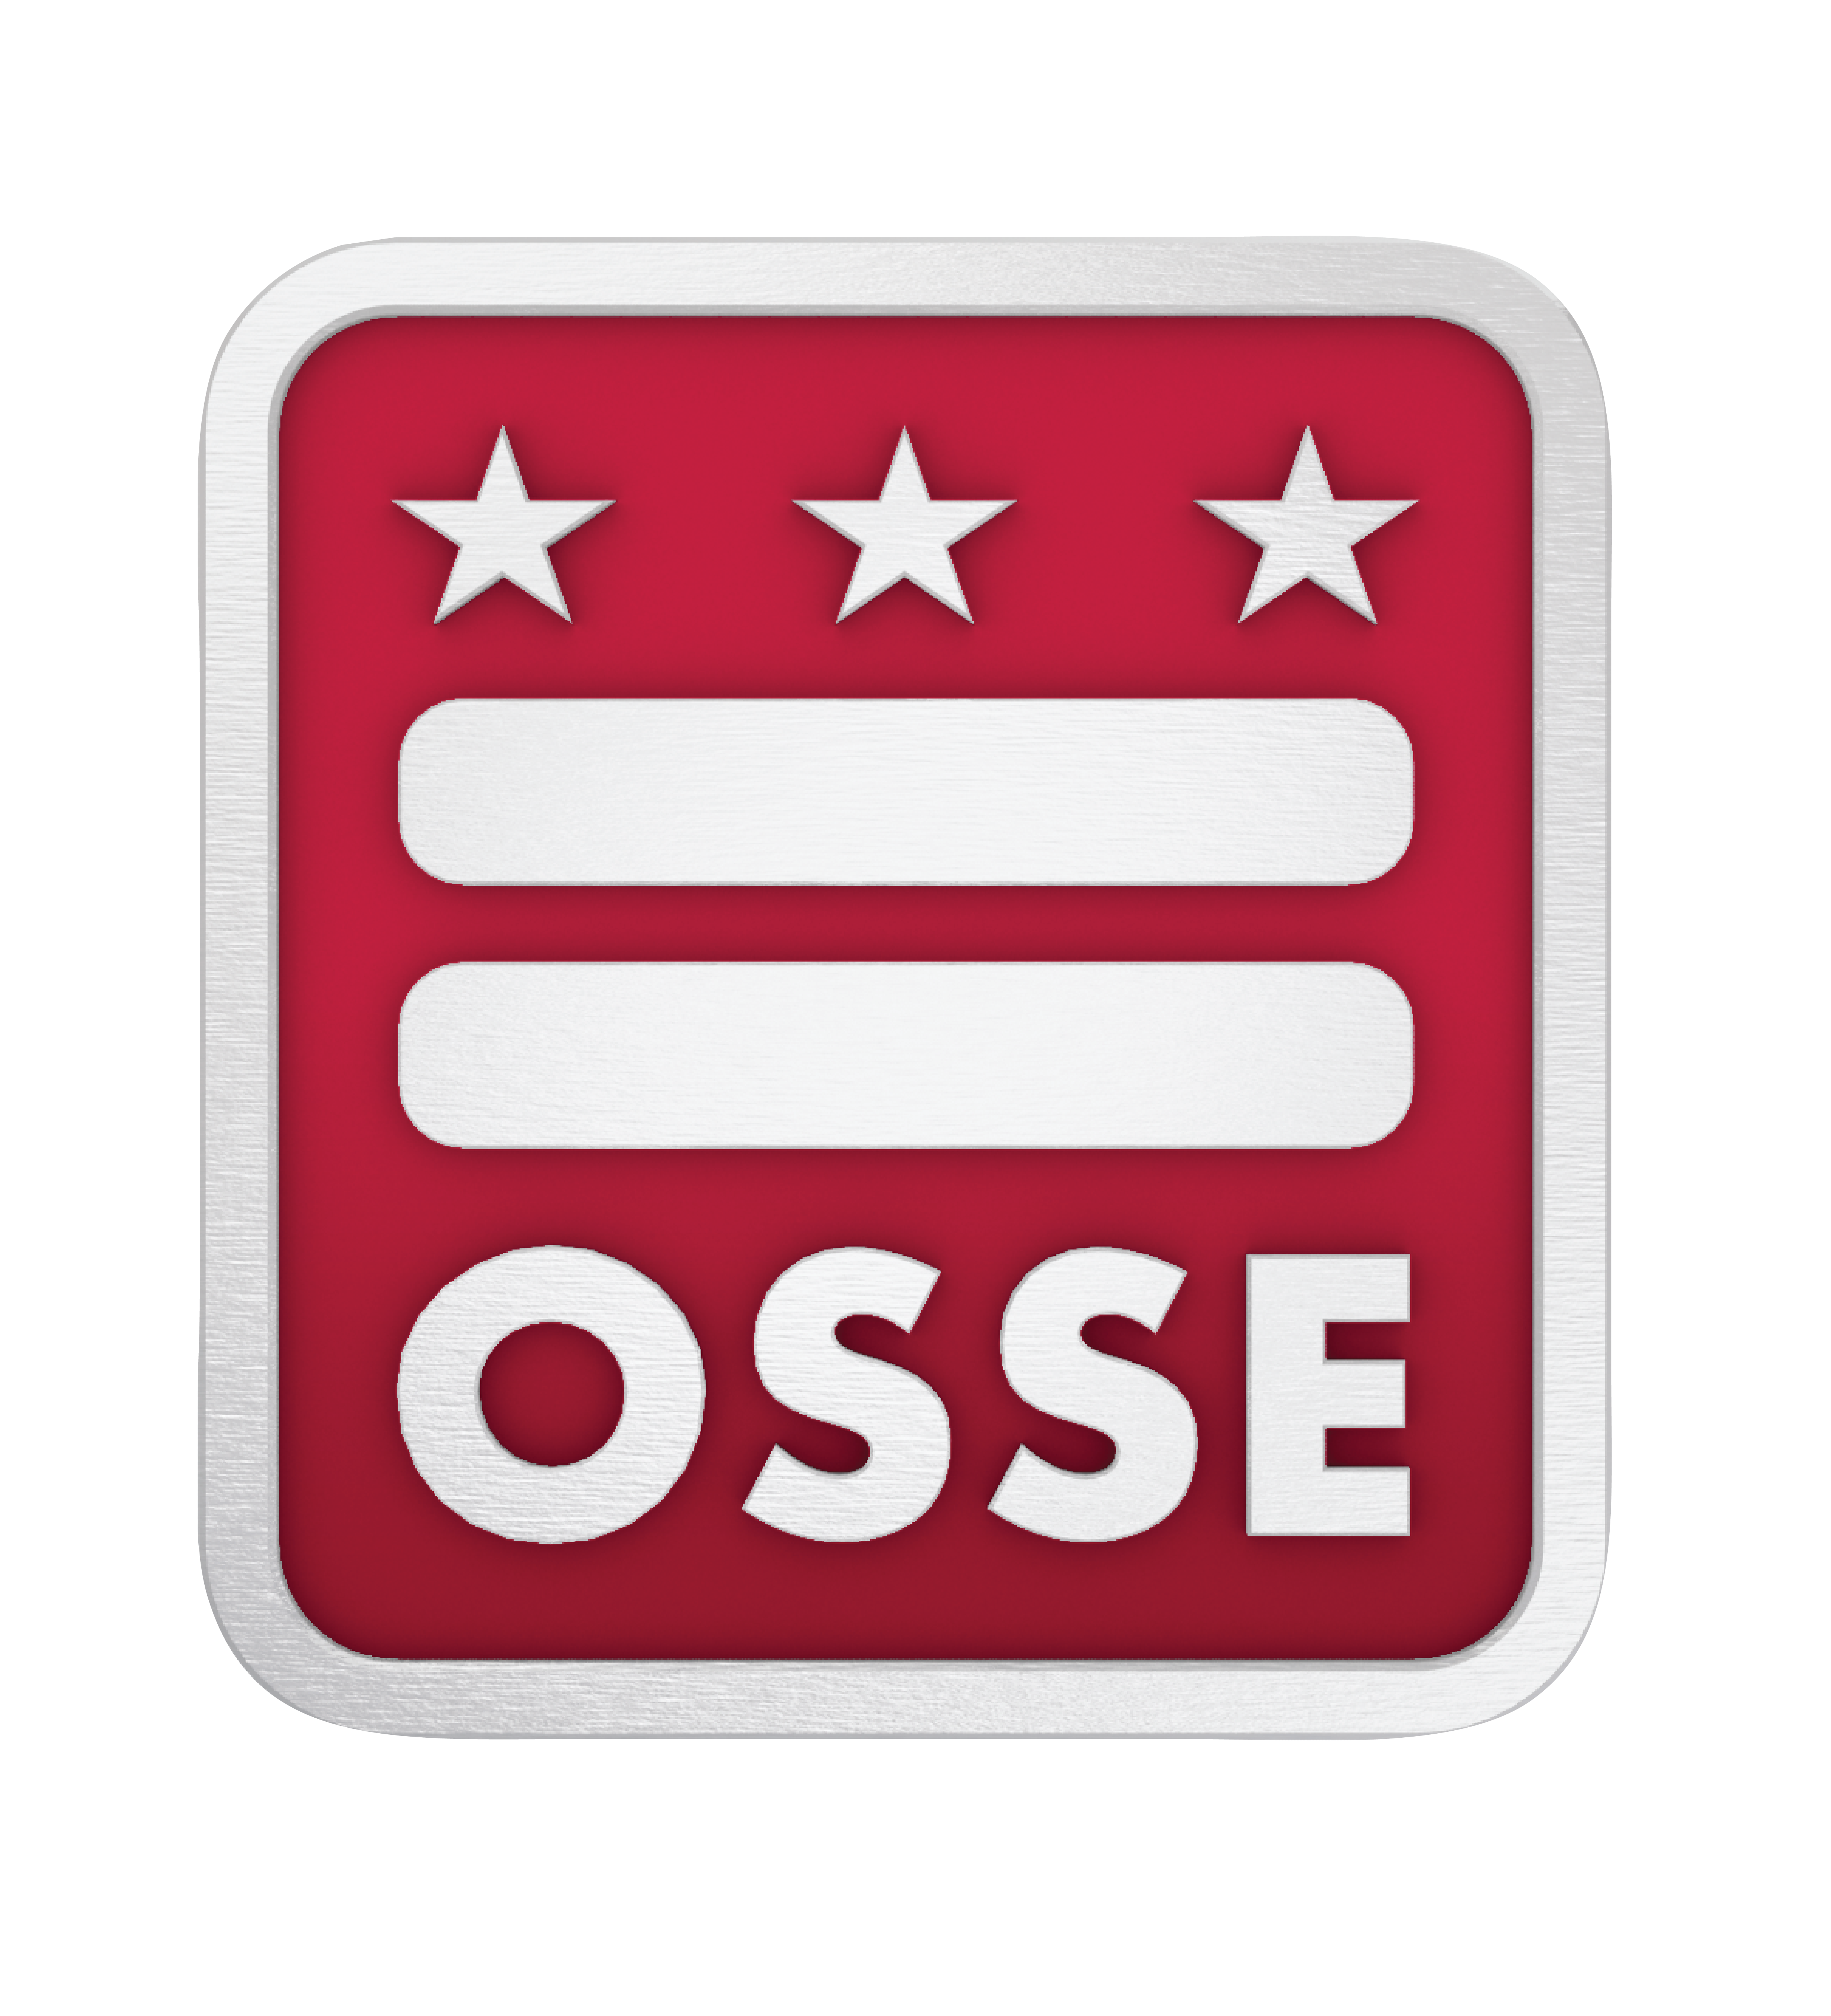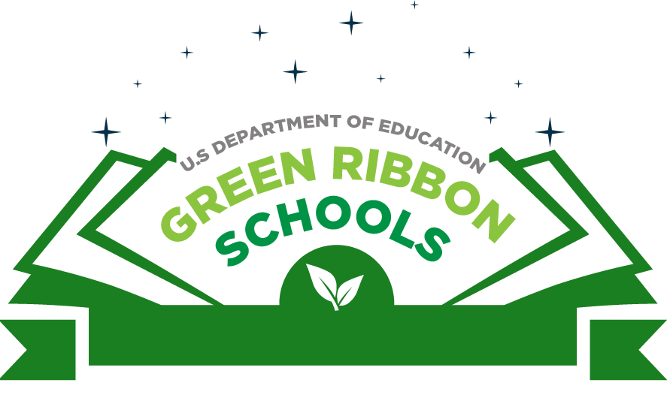
2024 Application Form

Thank you for your interest in completing the District of Columbia application for nomination to the US Department of Education Green Ribbon Schools (ED-GRS), District Sustainability Award, or Postsecondary Sustainability Award. ED-GRS recognizes schools, districts, and postsecondary institutions taking a comprehensive approach to sustainability, incorporating environmental learning with improving environmental and health impacts.
Becoming a US Department of Education Green Ribbon School is a multi-step process. The first step is to complete and submit this application form to be selected as a nominee by the OSSE. If selected as a nominee for ED-GRS, the second step of the process requires signatures certifying compliance with all applicable civil rights, Federal Student Aid, health, safety, and environmental statutory and regulatory requirements. You may view the certifications you will be asked to make in the Nomination Presentation Forms here. Finally, OSSE will send the nomination materials, including the signed Nominee Presentation Form, documentation of progress in all areas of the award, and several photographs, to the US Department of Education (ED). ED notifies national selectees in the spring and organizes a recognition ceremony.
Each year, OSSE may nominate up to five pre-K-12 schools or districts (local education agencies), one of which may be a private or independent school, and one college or university for ED-GRS. Selection is based on documentation of the nominee’s progress and high achievement in all three of the ED-GRS Pillars:
Pillar I: Reduced environmental impact and costs.
Pillar II: Improved the health and wellness of students and staff.
Pillar III: Effective environmental and sustainability education.

Schools, districts, and postsecondary institutions demonstrating progress in every area will receive highest scores. It may help to assemble a team with expertise across these areas to complete the application. This team might include: facilities manager, physical education director, food services director, curriculum director, finance department representatives, teachers and/or students. You may also wish to consult Green Strides programs related to each Pillar.
A network of District agencies and organizations are available to support you through this process. In order to receive support, please send a brief email indicating your intent to apply to Grace Manubay, Environmental Literacy Coordinator at Grace.Manubay@dc.gov by Dec. 15, 2023. Failure to do this will limit the ability of District agencies to support you, but will not disqualify your school from applying.
The questions in this application will help you demonstrate your high achievement in the three Pillars. Space is provided for you to include pertinent documentation.

Applications are due by Jan. 10, 2024. Please submit applications to Grace.Manubay@dc.gov.
PART I – NOMINEE INFORMATION

School, District (LEA), or Postsecondary Institution Name:
Category of Nomination (School, District, or Postsecondary):

Address: City: State: Zip:
Twitter: Facebook:

Top Official (School=Principal; District=Chancellor/CEO; Postsecondary Institution=President)
Title (Mr./Ms./Mrs./ Dr.): First Name: Last Name:
Position/Role (Principal/ Chancellor/ CEO/ President):
Email: Phone:

Lead Applicant (if different)
Title (Mr./Ms./Mrs./ Dr.): First Name: Last Name:
Position or Role (e.g., Teacher/ Sustainability Director/ Facilities Director):
Email: Phone:

Check all that apply:

Early Learning
Elementary
Middle
High
Public
Charter

Magnet
Non-Public
Two-Year
Four-Year
Community College
Career and Technical

Provide percentages, if any are relevant to your school, district, or institution:

Pell Recipients:
Free and Reduced Price Lunch:
Minority:
Limited English Proficient:
Special Education:
Graduation Rate:
Attendance Rate:

Provide the following:

Total Enrolled: Number of Schools: Buildings: Campuses:

PART II – DOCUMENTATION OF SUSTAINABILITY ACHIEVEMENT
Narrative for Pillar I: Your Efforts to Reduce Environmental Impact and Costs
Use 1-4 pages to describe how your school, district, or postsecondary institution is reducing environmental impact and costs by reducing or eliminating greenhouse gas emissions; improving water quality, efficiency, and conservation; reducing waste production; and using alternative transportation. Identify your energy-efficient facilities and practices, ecologically and educationally beneficial uses of grounds, and methods of disposal for solid and hazardous wastes. Use supporting data and reference participation in pertinent benchmarking programs to demonstrate progress where possible.

Narrative for Pillar 2: Your Efforts to Improve the Health and Wellness of Students and Staff
Use 1-4 pages to describe how your school, district, or postsecondary institution improves the health and wellness of students and staff by integrating an environmental health program and promoting sound health and wellness practices. You should discuss cleaning and maintenance; mold and moisture; chemical and environmental contaminants; ventilation; pests and pesticide, as well as nutrition and outdoors physical activity. Other components you may include are health education, health services, counseling, psychological and social services, sun safety, staff health promotion, and family and community involvement. Incorporate metrics and include program participation where possible.

Narrative for Pillar 3: Your Efforts to Ensure Effective Environmental and Sustainability Education
Use 1-4 pages to describe how your school, district, or postsecondary institution ensures effective environmental and sustainability education throughout the curriculum. Provide examples of interdisciplinary learning about the key relationships between dynamic environmental, energy, and human systems. Demonstrate how your institution uses the environment and sustainability to develop STEM content, knowledge, and thinking skills, and teach all subjects in context. You should discuss how your school, district, or postsecondary institution develops and applies civic knowledge and skills to environmental and sustainability education. All STEM and civics work should be described as it relates to environmental and sustainability learning. Detail any environmental or sustainability literacy standards, show how these concepts are integrated into assessments, and describe environmental and sustainability literacy professional development. Include co-curricular opportunities such as field trips, study abroad, clubs, and service learning. This section should describe hands-on, place-based, project-based, authentic learning across the curriculum, not limited to one subject, such as science courses.

PART III – SUMMARY NARRATIVE
Use one page to provide a summary narrative describing your school, district, or postsecondary institution’s efforts to reduce environmental impact and costs; improve student and staff health and wellness; and provide effective environmental and sustainability education. This overarching summary should highlight the best of your work in every ED-GRS Pillar and Element. You view examples of summary narratives in past Highlights Reports. The summary that you submit should be what you would like to see appear in a future Highlights Report, if your institution is selected. Be sure to include concrete sustainability achievements, supporting data, unique partnerships, program participation, awards, and certifications. It may be helpful to pull from your previous three narratives to write the summary.

PART IV – PHOTOS
Please submit 5-10 photographs with brief descriptions including who, what, when, and where. Photos should be action shots, not posed. By sending these photos, you are giving OSSE and the US Department of Education permission to use them in our newsletters and social media.

