[INSERT SCHOOL NAME AND/OR LOGO HERE]

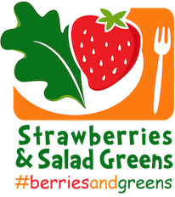
Dear Parent/Caregiver,
On Wednesday, June 6, 2018, our school will be participating in a District-wide event called Strawberries & Salad Greens Day sponsored by the Office of the State Superintendent of Education (OSSE). This day is a celebration of locally-grown fruits and vegetables where students will learn about where their food comes from, how it grows and why fruits and vegetables are healthy for them to eat.
As part of this celebration, we will be serving locally-grown strawberries and salad greens as part of the school lunch. We encourage all students to eat school lunch on June 6, 2018, so that he/she can taste how delicious these locally-grown items taste! The berries and greens will be purchased from farms in the surrounding area. We will also be promoting this event through an “education station” in the cafeteria and activities in your child’s classroom.
Healthy eating leads to healthy educational outcomes, so we encourage you to talk to your children before and after this special day about what they have learned! You can also do activities together at home, like planting spinach or lettuce in a pot on your windowsill or tasting strawberries as a part of a healthy snack. Let us know what you do as a family to celebrate Strawberries & Salad Greens Day by posting on twitter, facebook or instagram using the hashtag #berriesandgreens.
For more information, you can visit the OSSE website at http://osse.dc.gov/service/strawberries-salad-greens-day or contact Elysia DiCamillo, Program Specialist, at Elysia.DiCamillo@dc.gov or (202) 403-4556.
Thank you,
[Principal Name]

