2015 DC PARCC Performance Based Assessment (PBA) Close-Out Checklist:
Computer-Based Tests
After the final test unit is complete…
- Verify and log on the tracking form that all secure materials, including all student test tickets and used scrap paper have been returned to the School Test Coordinator.
- Ensure that all student tests are in the status “complete” or “marked complete”, and all test sessions have been closed in Pearson Access Next. Only test attempts in complete or marked complete status will be scored. For demonstrations of how to mark complete, see pages 10-11 of the guidance here: http://avocet.pearson.com/PARCC/Home#7431
  - Note: For students who did not take the last unit in the test as their final unit (who tested out of order as part of make-up testing), marking complete is the only way to submit tests.
  - If it is the end of your testing window, any unfinished tests containing student answers should be marked complete.
  - To check that all tests in sessions are complete or marked complete, you have several options.
    - Under TestingStudents in Sessions, filter tests by student test status to see if any tests are in statuses other than “complete” or “marked complete.” You may choose multiple statuses. See below. When you have that list, be sure any test records with student responses within them are marked complete.
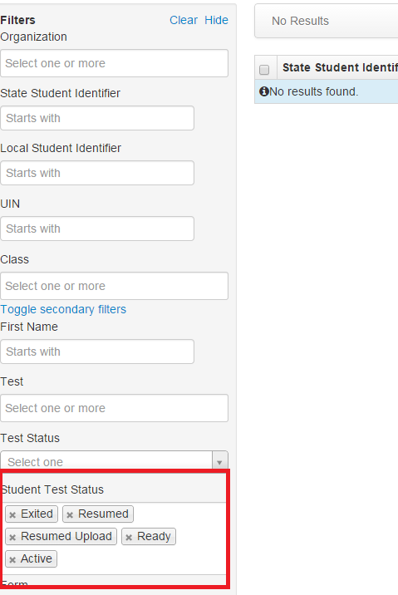
- Under ReportsOnline Testing, choose Session Roster to generate a report of all tests in sessions and their current status. Use this report to filter for test statuses other than marked complete or complete.
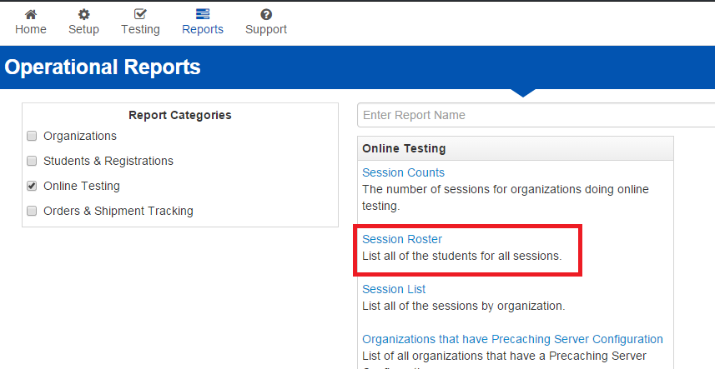
- Once you have verified that all tests with student answers in them have been complete or parked completed, purge cached test content. See instructions here: https://support.assessment.pearson.com/display/TN/Use+ProctorCache
Within one week of final test unit…
- Securely destroy (preferably via shredding and recycling), all used scrap paper, student testing tickets, and printed seal codes.
- Package and ship all used and unused paper PBA test materials according to vendor instructions.
- Keep all records related to test administration and test security in your school’s security file.
- Keep all physical manuals on hand as these should be re-used for EOY.
- LEA Test integrity Coordinators and School Test Monitors must sign and submit DC Test integrity Affidavits available here within 15 days after the conclusion of the PBA: http://osse.dc.gov/sites/default/files/dc/sites/osse/publication/attachments/2015%20Affidavit%20Appendix%20G.pdf
Paper-Based Tests
After the final test unit is complete…
- Verify and log on the Chain of Custody form that all secure materials, including all test booklets and used scrap paper have been returned to the School Test Coordinator, and that all make up test sessions have been completed. Make sure all used booklets either have a student ID sticker affixed to them, or all demographic information gridded in.
- Complete the form to report contaminated, damaged or missing materials as needed (available in the Test Coordinator Manual).
- Verify that you have all the necessary materials to return your materials, including boxes, header sheets, and shipping labels, according to pages 48-56 of the Test Coordinator Manual. If you are missing anything, order it via Pearson Access Next as soon as possible.
Within one week of final test unit…
- Organize and Return Test Booklets:
  - Complete the Used Test Booklet Return header for each course and band together used booklets using the PARCC supplied paper bands.
  - Assemble, seal and label boxes for return shipment, as explained in pages 48-56 of the Test Coordinator Manual. Note: Scorable and non-scorable materials should be packed and mailed separately, as they go to different locations.
  - Scrap paper, math reference sheets and test manuals should NOT be returned to the vendor. See instructions below.
  - Contact UPS to schedule materials return pickup.
- Securely destroy (preferably via shredding and recycling), all used scrap paper and paper math reference sheets.
- Keep all records related to test administration and test security in your school’s security file.
- Keep all manuals on hand as these should be re-used for EOY.
- LEA Test integrity Coordinators and School Test Monitors must sign and submit DC Test integrity Affidavits available here within 15 days after the conclusion of the PBA: http://osse.dc.gov/sites/default/files/dc/sites/osse/publication/attachments/2015%20Affidavit%20Appendix%20G.pdf

Questions? We are here to help!
- Email osse.assessment@dc.gov or call 240-270-2598 to speak with the OSSE assessments team.
- For live technical support, call PARCC Customer Support at 1-888-493-9888, or email PARCC@support.pearson.com.

