Local Literacy Plan Template
Introduction: The District of Columbia Office of the State Superintendent of Education (OSSE) is committed to closing the achievement gap and ensuring all students are prepared to succeed in school and in life. This success depends on ALL students’ ability to read well. In fall 2020, OSSE, together with community stakeholders, conducted a needs assessment to identify current practices in literacy instruction across the city and across all age groups, from birth through grade 12.
OSSE is now focused on writing a statewide comprehensive literacy plan (CLP) to establish guiding principles for literacy instruction that are rooted in evidence-based strategies. This state plan will serve as a blueprint and a roadmap for schools, local education agencies (LEAs) and child development facilities to build their own local literacy plan (LLP).
Purpose of a Literacy Plan: A plan sets the vision for an organization’s literacy program and serves as a roadmap to achieve implementation of the plan and its performance goals. A comprehensive literacy plan for an organization should:
- Be informed by a comprehensive literacy self-assessment;
- Be aligned with DC’s Statewide Comprehensive Literacy Plan;
- Include interventions and practices that are ideally supported by moderate or strong evidence or, in the case where limited research is available, the intervention and practices are supported by promising evidence;
- Include a plan for professional learning; and
- Include a plan to track learner outcomes.
Purpose of this Document: This document serves as a template and guidance for organizations who wish to create their own LLP. This LLP template can be used and adapted by organizations serving children birth to age 5, and by organizations serving students in grades K-12.
Technical Assistance Series: The main sections of this document correspond with the content discussed during the four-part webinar series, Creating Your Local Literacy Plan, hosted by the OSSE in March and April 2021 (recordings available soon on the OSSE website). Register at bit.ly/LocalLiteracyPlans
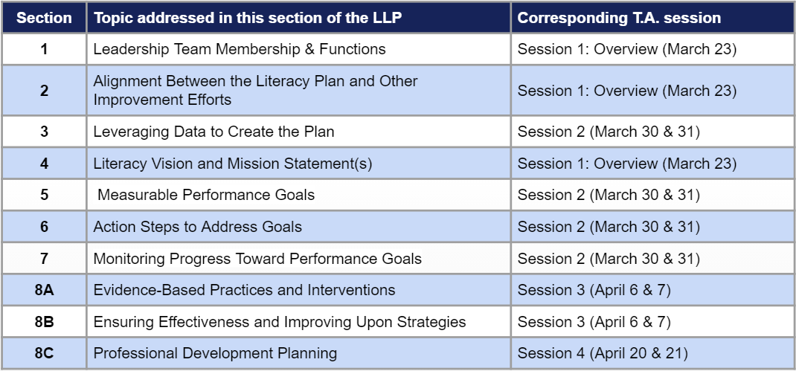
Birth to Age 5 Optional Consortium Approach: Smaller scale early care and education programs serving children birth to age 5 may wish to work together with other facilities (including potentially larger facilities) or organizations to create a more robust LLP, with accompanying professional learning opportunities. By working together with other birth to age 5 organizations, leadership and staff from smaller-sized facilities, programs and schools will have the opportunity to interact with a broader group of early childhood experts, share strategies and resources, engage in root cause analysis, plan joint professional learning experiences, and celebrate growth in literacy achievement together. This type of collaboration can have a broader catalytic impact at the individual, community, and system levels than may be possible from individual programs working alone.
Consortium Interest Form: Approaching your LLP development as part of a consortium is completely optional. If interested, organizations are encouraged to complete this LLP Consortium Interest Form. OSSE seeks to facilitate forming consortia among organizations interested in this option by collecting and sharing the information using this interest form.
Questions: For questions about this LLP template, contact: OSSE.CLSD@dc.gov.
Section 1: Leadership Sets the Vision
Part A: Leadership Team Membership
Guidance and Considerations:
The organization’s leadership team develops the LLP. A leadership team should include members to inform literacy instruction and improvement in the district or program, such as support staff, reading intervention specialists, educators from various grade levels and curriculum directors.
Members of the leadership team should include individuals with key positions at various levels of the organization. These individuals may include, but are not limited to:
- Head of School/CEO/lead administrator/director;
- Campus/Building-level administrators;
- Teacher leaders from various content areas, grade/age levels, buildings and specialized instructional areas;
- Program directors and supervisors (special education, English learners (EL), curriculum, and early childhood); and
- Family and community engagement team members
Take Action:
Insert a list of all leadership team members, roles and contact information. For a consortium literacy plan, ensure each participating facility or organization has a representative on the leadership team.

Part B: Developing, Monitoring and Communicating the Local Literacy Plan
Guidance and Considerations:
Functions of the leadership team include:
- Setting performance targets aligned with LEA or program goals;
- Monitoring performance against the targets; building a foundation for data-driven decision-making on a systemwide basis;
- Designing system planning and focused improvement strategies, structures and processes; facilitating the development and use of collaborative structures;
- Brokering or facilitating high-quality professional learning consistent with goals for instruction and achievement; and
- Allocating system resources toward instructional improvement.
Take Action:
Describe how the leadership team developed the plan, how the team will monitor the plan and how the team will communicate the plan.
Section 2: Alignment Between the Literacy Plan and Other Improvement Efforts
Guidance and Considerations:
Community collaboration, networking and alignment play a large role in OSSE’s plan to raise student achievement. If relevant, utilize this section to share how the leadership team collaborated with community members.
Information for the LLP must be aligned to other LEA, school, facility and program improvement initiatives to ensure a cohesive improvement structure. Applicants may use information from existing needs assessments, data analyses and improvement plans. Information may come from, but is not limited to:
- DC School Report Card results;
- Classroom data gathered and analyzed;
- Other school or student level classroom data;
- Data collected from authentic assessment and child observations;
- Data collected from Capital Quality, the District’s Quality Rating and Improvement System (QRIS);
- Data collected from Quality Improvement Network (QIN);)
- Data collected from Pre-K Enhancement and Expansion Program;
- Data collected or analyzed as per Head Start Performance Standards
Take Action:
Describe how the LLP aligns to other improvement plans or initiatives focused on literacy outcomes. For a consortium literacy plan, describe how the consortium has aligned each member’s individual LLP as a collective and collaborative plan, and ask, "How will a consortium enable partners to leverage commonalities, shared strengths, and resources to achieve progress on shared goals?"

Section 3: Leveraging Data to Create the Plan
Part A: Analysis of Learner Performance Data
Guidance and Considerations:
Birth to Age 5: Early care and education programs should analyze child learning and development and program performance data from authentic assessments, classroom observations, and other tools the program uses to collect data to inform teaching and learning or track children’s development and learning. Programs should be analyzing data over several years to understand trends in the data.
K-12: LEAs and schools should analyze student performance data from the PARCC English language arts assessments (grades 3-8 and high school) and reading diagnostics. In addition to these sources, LEAs/schools may analyze other relevant data sources, such as curriculum-based measures and other progress monitoring tools. LEAs and schools should be analyzing these data over several years to understand trends in the data.
Data Sources: The following are data sources a child development facility, school or LEA may include, but are not limited to:
- Infant risk factors;
- Authentic assessments or other tools the program uses to monitor progress towards developmental milestones (e.g., Teaching Strategies GOLD®)
- PARCC Assessment in English Language Arts (grades 3-8 and high school);
- Reading diagnostics assessments;
- High school end-of-course tests;
- ACCESS for ELs;
- Multi-State Alternative Assessment (MSAA); and
- Any other assessments, as applicable (curriculum-based measures).
Consortium Approach: Birth to age 5 organizations (early care and education programs and/or LEAs serving ages 3-5 years), with similar needs may choose to participate in a consortium-based literacy plan to enhance their capacity to drive improvement efforts. The data from the consortium members’ individual self-assessments should inform membership in a consortium. The data analysis completed by the consortium should identify common themes across consortium members, and the themes should guide the remainder of the consortium literacy plan.
Take Action:
List the child- or student-level data sources available to your organization. For a consortium literacy plan, focus on common data elements and themes.
Insert an overall analysis of language and literacy performance data, based on the age/grade ranges served by the organization(s) and age/grade ranges impacted by the plan.
Part B: Analysis of Factors Contributing to Underachievement in Literacy
Guidance and Considerations:
Early care and education programs, schools and LEAs should analyze factors that are contributing to low reading achievement in their communities. Such factors may include, but are not limited to, data related to social economic status, English proficiency of families served, graduation rates, employment rates, median income levels, literacy levels and at-risk status. Additionally, there are in-school/in-program factors which may be present such as teacher quality and effectiveness and implementation fidelity. This analysis also may include a root cause analysis.
In this section you are presenting facts about why an LLP is needed for the children attending your program, so make connections between reading readiness and academic, social and economic successes or challenges to illustrate the need.
Self-Assessment Tool: Each individual program or school should complete the Comprehensive Self-Assessment Tool, prior to completing this section of the plan. The Self-Assessment Tool is a rubric-based reflection tool that should be used by programs and schools to investigate the current state of literacy in your organization and to identify strengths and gaps in building a comprehensive literacy program. For a consortium literacy plan, it is essential that each consortium member complete the self-assessment tool individually, before coming together as a consortium to develop this section of the consortium literacy plan.
- Download a copy of the K-12 Comprehensive Literacy Self-Assessment Tool
- Download a copy of the Birth to Age 5 Comprehensive Literacy Self-Assessment Tool
Take Action:
Insert an analysis of additional factors believed to contribute to underachievement in literacy in the community served. For a consortium literacy plan, focus on common factors and themes.

Section 4: Literacy Vision and Mission Statement(s)
Guidance and Considerations:
The DC Comprehensive Literacy State Plan includes a vision and commitments (guiding principles) to support that vision (summarized below). When developing an LLP, early care and education programs and LEAs/schools should consider how their vision is aligned to the state’s vision and how their local plan incorporates the state’s guiding principles.
Consortium Approach: Individual members of the consortium should develop their own literacy mission/vision statements. Then, together the consortium should examine each member's mission/vision and develop a collective mission/vision for the consortium.
DC’s Literacy Vision
In the District of Columbia, all learners ages birth through grade 12 will have access to high-quality literacy instruction and early literacy experiences.
Guiding Principles: The principles below provide guidance on the implementation of DC’s Literacy Vision Statement. To achieve this vision, the following conditions must be in place:
- All learners should have access to an equitable, culturally and linguistically responsive, high-quality literacy curriculum and learning environment.
- High-quality literacy instruction must be accompanied by a comprehensive, standards-aligned formative and summative assessment system that is accessible to all learners, including students with disabilities and English learners.
- Using a multi-tiered framework, LEAs, schools, and early care and educational settings will provide proactive, data-driven systems and structures that support early identification and literacy interventions to support all learners, including students with disabilities and English learners.
- Early care and education professionals, educators, administration and school/program staff must have access to on-going and embedded professional learning opportunities aligned to evidence- and research-based practices and adult learning theory to improve literacy outcomes for all students, including students with disabilities and English learners specifically.
Take Action:
Describe the literacy mission and/or vision of the organization. You may want to state how the literacy vision is aligned to DC’s Vision for Literacy outlined in DCs Comprehensive Literacy Plan. For a consortium literacy plan, describe the collective mission and/or vision statement of the consortium.

Section 5: Measurable Performance Goals
Guidance and Considerations:
SMART(IE) GOALS: This section should address the goals this literacy plan is designed to support. The measurable performance goals should be Specific, Measurable, Ambitious, Realistic and Time bound. The goals also should be Inclusive and Equitable.
Goals tied to measurable learner outcomes should address child/student success and be directly related to the learner performance data analysis done in Section 3A. Here is an example learner performance goal and subgoal:
- Overarching Goal: Increase the percentage of learners meeting or exceeding third grade proficiency standards from ___ % to ___% by spring 2025, as measured by the PARCC ELA Assessment.
- Subgoal: Increase the percentage of kindergarten learners meeting or exceeding targets for phonemic awareness from ___% to ___% by spring 2022, as measured by (insert reliable and valid universal screening assessment for phonemic awareness measure).
Goals can also address educator/staff outcomes, program-level outcomes, or factors contributing to literacy underachievement identified in Section 3B.
Goals should tie back to areas for growth and improvement identified through any needs assessment process, including the self-assessment tool. Goals already established as part of other ongoing improvement efforts (discussed in Section 2) can also be used here in this literacy plan.
Take Action:
Describe the measurable performance goals (based on the analysis completed in Section 3) that the local literacy plan (or consortium literacy plan) is designed to support progress toward. The plan may have an overarching goal, as well as subgoals. For a consortium literacy plan, ask: “How can the consortium ensure each member’s individual goals are reflected in the overall consortium goals? How can the consortium create goals that are measurable for all participating organizations?”

Section 6: Action Steps to Address Goals
Guidance and Considerations:
This portion of the LLP will describe how implementation will take place for each specific literacy goal the plan is designed to address. Applicants should create a list of specific action steps for each subgoal they have created in order to accomplish the overarching goals of Section 5. The action steps must tie back to the analysis of data and factors contributing to underachievement in literacy (Section 3).
The combination of all the action steps for each subgoal in this section will provide a robust blueprint for the early childhood education program or LEA/school in achieving the measurable performance goals stated in Section 5.
Take Action:
Describe the main action steps associated with each subgoal listed in Section 5. These steps should create a blueprint to achieving the overall goals. Add as many subgoal action steps as necessary to accomplish the overall goals.

Section 7: Plan for Monitoring Progress Toward Performance Goals
Guidance and Considerations:
This section should specify what evidence is being collected, at what specific times, and by whom — to monitor the extent to which programs/schools are implementing the action steps and measuring progress toward the performance goals. In addition, this section should identify what will be done to facilitate improvement where the data being collected shows that learners are not progressing toward the performance goals.
Stated another way, what, how and when will you measure your progress toward meeting the goal? What ways do you have to collect data that will allow you to monitor progress toward success? Is it something you are already doing or collecting, or will you need to create or collect something new?
Take Action:
Describe how progress toward each performance goal will be monitored, measured and reported. For a consortium, describe how the consortium lead will monitor progress toward the consortium goal(s). How will the goal(s) be monitored, measured and reported?

Privacy Considerations: Describe how any collection of learner (child/student) data will remain consistent with all applicable child- or student-level data privacy requirements.

Section 8: Evidence-Based Practices and Professional Learning
Part A: Evidence-Based Practices and Interventions to Support Learners
Guidance and Considerations:
To increase the likelihood that an evidence-based practice will lead to improved student outcomes, LEAs/schools and programs should intentionally aim to leverage evidence-based activities, strategies and interventions that are:
  - Aligned with the LEA/school/early care and education program specific needs and context;
  - Part of a cohesive improvement plan; and
  - Implemented with fidelity.
The Every Student Succeeds Act (ESSA, Section 8002) and the US Department of Education’s Non-Regulatory Guidance: Using Evidence to Strengthen Education Investments outline four tiers of evidence based on the design and outcomes of the research studies carried out to evaluate an intervention.
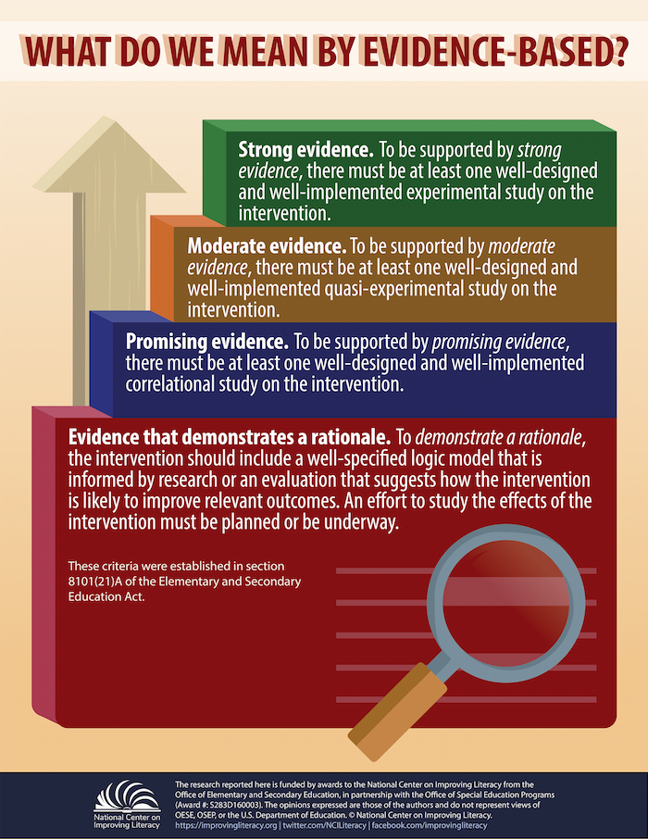
National Center on Improving Literacy (2018). What do we mean by evidence-based?. Washington, DC: U.S. Department of Education, Office of Elementary and Secondary Education, Office of Special Education Programs, National Center on Improving Literacy. Retrieved from improvingliteracy.org.
The importance of context and fit: Across all levels, a critical consideration in defining “evidence-based” is alignment with local needs and context. For example, researchers may evaluate an intervention for use at the high school level and find that it positively affects a student outcome in the context of those grade levels. However, the intervention has never been evaluated for impact on that same student outcome at the kindergarten level. In this case, this is not an appropriate evidence-based intervention for an entity to choose if the entity is focused on improving student outcomes at the kindergarten level.
Before identifying evidence-based interventions, policymakers, administrators and educators should always first carefully consider the need they are trying to meet and the specific context in which they are addressing that need.
For the purpose of the LLP, LEAs/schools/early care and education programs should identify evidence-based practices supported by Level 1 (“Strong”), Level 2 (“Moderate”) or Level 3 (“Promising), where evidence is applicable and available. If LEAs/schools/early care and education programs identify evidence-based practices supported by Level 4 (“Demonstrating a Rationale”), they should include a description of the research-base that supports the practice, a logic model linking the intervention to improved student outcomes, and a description of the organization’s plan to evaluate the efficacy of the practice or intervention.
Take Action:
- Describe the specific evidence-based practices and interventions that will be used to improve language and literacy development. This description should include evidence-based practices supporting core literacy instruction, as well as evidence-based interventions.
- For each evidence-based practice and intervention, identify the ESSA level of evidence associated with that practice or intervention, and describe how the leadership team made that determination.
- Describe how the proposed evidence-based practices and interventions support specific learner needs, as identified in Section 3.
- Describe how the evidence-based practices and interventions support children with developmental delays, disabilities, English learners and below grade-level reading proficiency.

Part B: Ensuring Effectiveness and Improving Upon Strategies
Guidance and Considerations:
Early care and education programs/LEAs/schools are encouraged to describe how the evidence-based practices and interventions identified will support a multi-tiered system of support (MTSS), Universal Design for Learning (UDL) and/or data-based decision-making. Ask yourselves these questions:
- How will educators be supported in implementing the evidence-based practices and interventions?
- How will adult implementation be measured and monitored?
- What mechanisms will be in place to ensure fidelity of adult implementation?
Take Action:
- Describe how the leadership team will offer and provide support for implementation of the identified evidence-based practices and interventions (for example, professional learning or coaching).
- Describe how the program/LEA/school will ensure proposed evidence-based strategies in Section 8, Part A will be effective, show progress and improve upon strategies utilized during the two prior consecutive years (i.e., fidelity of adult implementation).

Part C: Professional Learning Plan
Guidance and Considerations:
A comprehensive professional learning plan includes:
- Implementation of all instructional materials, reading programs and evidence-based strategies;
- Implementation in the use and interpretation of screening, diagnostic and curriculum-based progress monitoring assessments;
- Job-embedded opportunities, such as modeling in the classroom, book studies and data analysis; and
- Individualized and differentiated opportunities for professional growth.
Refer to the Self-Assessment Tool: When considering professional learning, organizations should complete a self-assessment of their professional learning needs for staff to promote and sustain high-quality instructional delivery and improved student academic achievement. Refer to your reflections and evidence listed in Domain One: Teaching and Instructional Support of the Comprehensive Literacy Self-Assessment Tool.
Promising Professional Learning Practices:
- Focus on teachers and early childhood education professionals as central to student learning yet include all other members of the school community;
- Focus on individual, collegial and organizational improvement;
- Respect and nurture the intellectual and leadership capacities of teachers and early childhood education professionals, administrators and others in the school community;
- Reflect the best available evidence-based research and practice in teaching, learning and leadership;
- Enable teachers and early childhood education professionals to develop further expertise in subject content, teaching strategies, uses of technologies and other essential elements in teaching to high standards;
- Promote continuous inquiry and improvement in the daily life of schools and programs;
- Are planned collaboratively by those who will participate in and facilitate that development;
- Require substantial time and other resources;
- Are driven by a coherent and long-term plan that includes a continual needs assessment; and
- Ultimately are evaluated on the basis of their impact on teacher effectiveness and student learning and guide subsequent professional learning efforts.
Take Action:
Create a professional learning plan that supports the evidence-based strategies proposed in the local literacy plan and clearly identifies the staff involved in the professional development.
Professional Learning Plan Template: OSSE has developed a Professional Learning Plan Template. LEAs/schools/early care and education programs are encouraged to use this template to complete Section 8, Part C of the LLP. (The template will be shared during the Session 4 of the LLP Series on April 20, 2021, and it will be added to this LLP Series resource folder.)

