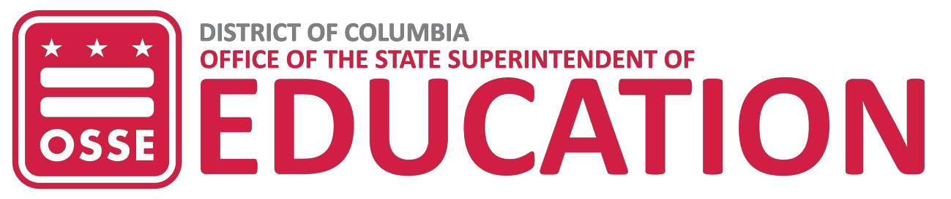

NOTIFICATION OF INTENT TO APPLY
Deadline: Friday, Aug. 23, 2019 at 5 p.m.
FY 2020 EARLY LITERACY INTERVENTION INITIATIVE GRANT (ELII2020)

TO: Angela Awonaike
Division of Teaching and Learning
Office of the State Superintendent of Education 1050 First St. NE
Washington, DC 20002
Telephone: (202) 481-3870
Email: Angela.Awonaike@dc.gov

Please accept this notification that the following eligible organization intends to apply for consideration of funding under FY 2020 EARLY LITERACY INTERVENTION INITIATIVE GRANT (ELII2020).

- ELII2020: Early Literacy Intervention Initiative Grant

Applicant Name (Official Name of Organization)
Applicant Address
Applicant Contact Person
Telephone |  | Fax
Authorized Representative Name and Title
Signature |  | Date

- I will attend the Friday, Aug. 30, 2019 pre-application webinar 10-11 a.m.

1050 First St. NE, Washington, DC 20002 • Phone: (202) 727-6436 TTY: 711 • osse.dc.gov

