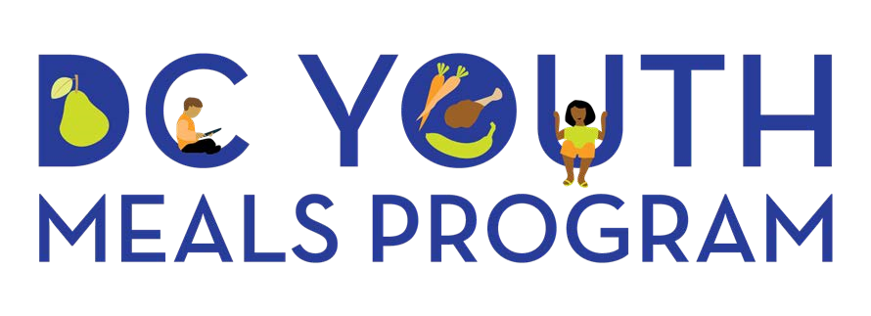
Summer Meals Promotion Kit
FY21

DC Youth Meals Summer Blurb:
The DC Youth Meals Program recognizes that healthy bodies and minds are the foundation of academic success. The Program provides breakfast, lunch, dinner and snacks to youth during the summer months. All youth in DC are welcome to grab a quick and healthy meal at any of the more than 200 participating locations across the city. Find a DC Summer Meals site near you. Call 1-866-348-6479. Visit www.fns.usda.gov/meals4kids. Text FOOD to 877-877.

Logo:
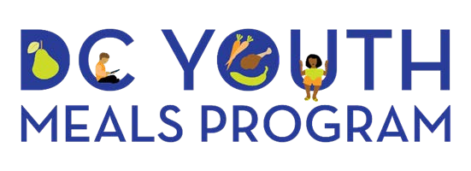

Summer FY21 Flyer:
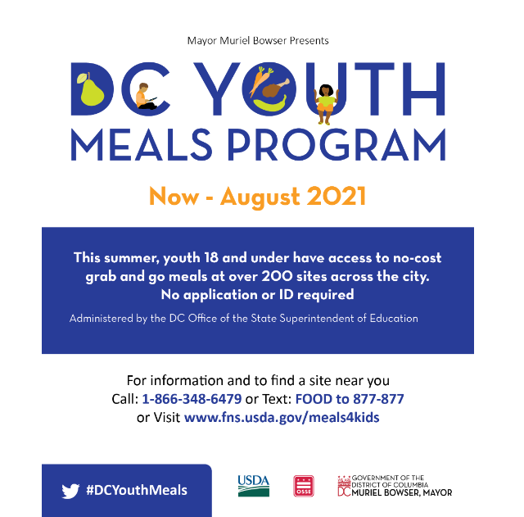

Tweets & Primary hashtag –
#DCYouthMeals
- School’s out, and #DCYouthMeals is in! Visit any open meal site to receive healthy, no cost meals for your children, no questions asked.

- Have growing kids? No worries, #DCYouthMeals can help! Visit an open site today and receive healthy, no-cost meals on the spot, no questions asked.
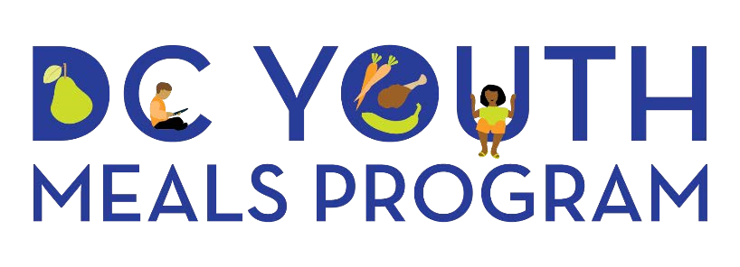

- We listened to your feedback DC, and the DC Free Summer Meals Program has a new name and logo. We are now the DC Youth Meals Program. Check out our new design!
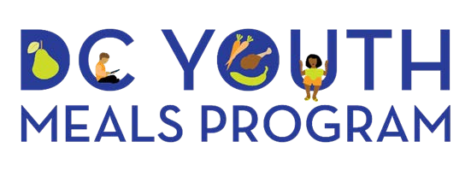

Meal Site Location Phone Numbers & Websites
- Phone Numbers: 1-866-348-6479
- Text: Text FOOD to 877-877
- Meal Access Websites: 1. www.fns.usda.gov/meals4kids
2. coronavirus.dc.gov/food

DC OSSE SFSP Program Contact Information:
Shaneka Nicole King – Program Coordinator
Email: Shaneka.King1@dc.gov
Phone: (202) 531-1739
Program Website: osse.dc.gov/dcsummermeals

