District of Columbia
Office of the State Superintendent of Education
Division of Early Learning

Emergency Response Plan (ERP) for
Center-based Child Care Providers

APPENDIX

TABLE OF APPENDIX

Appendix A: Applicable 2012 International Fire Code Sections
Appendix B: Agreements
Appendix C: Emergency Procedures Quick Sheets
Appendix D: Evacuation & Assembly Area Maps
Appendix E: Supply List for Centralized & Transportable First Aid Kit; Shelter-in-Place Kits
Appendix F: Bomb Threat Form
Appendix G: Staff & Volunteer Training Record
Appendix H: Record of Emergency Drills & Exercises
Appendix I: Medical Emergency & Unusual Incident Report (UIR) Forms
Appendix J: Staff and Family Emergency Contact Lists

Appendix A:

Applicable 2012 International Fire Code Sections

International Fire Code Sections, 2012

SECTION 401: GENERAL
401.3 Emergency responder notification. Notification of emergency responders shall be in accordance with Sections 401.3.1 through 401.3.3.
- Fire events. In the event an unwanted fire occurs on a property, the owner or occupant shall immediately report such condition to the fire department.
- Alarm activations. Upon activation of a fire alarm signal, employees or staff shall immediately notify the fire department.
- Delayed notification. A person shall not, by verbal or written directive, require any delay in the reporting of a fire to the fire department.
401.4 Required Plan Implementation. In the event an unwanted fire is detected in a building or a fire alarm activates, the emergency plan shall be implemented.
401.7 Unplanned Evacuations. Evacuations made necessary by the unplanned activation of a fire alarm system or by any other emergency shall not be substituted for a required evacuation drills.

SECTION 404: FIRE SAFETY AND EVACUATION PLANS
404.3.1 Fire Evacuation Plans. Fire evacuation plans shall include the following:
- Emergency egress or escape routes and whether evacuation of the building is to be completed or, where approved, by selected floors or areas only.
- Procedures for employees who must remain to operate critical equipment before evacuating.
- Procedures for assisted rescue for persons unable to use the general means of egress unassisted.
- Procedures to account for employees and occupants after evacuation has been completed.
- Identification and assignment of personnel responsibility for rescue or emergency medical aid.
- The preferred and any alternative means of notifying occupants of a fire or emergency.
- The preferred and any alternative means of reporting fires and other emergencies to the fire department or designated emergency response organization.
- Identification and assignment of personnel who can be contacted for further information or explanation of duties under the plan.
- A description of the emergency voice/alarm communication system alert tone and preprogrammed voice messages, where provided.
404.3.2 First Safety Plans. Fire safety plans shall include the following:
- The procedure for reporting a fire or other emergency.
- The life safety strategy and procedures for notifying, relocating, and evacuating occupants, including occupants who need assistance.
- Site plans indicating the following:
3.1 The occupancy assembly point.
3.2 The locations of fire hydrants.
3.3 The normal routes of fire department vehicles access.
- Floor plans identifying the locations of the following:
4.1 Exits.
4.2 Primary evacuation routes.
4.3 Secondary evacuation routes.
4.4 Accessible egress routes.
4.5 Areas of refuge.
4.6 Exterior areas for assisted rescue.
4.7 Manual fire alarm boxes.
4.8 Portable fire extinguishers.
4.9 Occupant-use hose stations.
4.10 Fire alarm annunciators and controls.
- A list of major fire hazards associated with the normal use and occupancy of the premises, including maintenance and housekeeping procedures.
- Identification and assignment of personnel responsible for maintenance of systems and equipment installed to prevent or control fires.
- Identification and assignment of personnel responsible for maintenance, housekeeping and controlling fuel hazard sources.

404.3.3 Lockdown plans. Where facilities develop a lockdown plan, the lockdown plan shall be in accordance with Sections 404.3.3.1 through 404.3.3.3.
3.3.1 Lockdown plan contents. Lockdown plans shall be approved by the fire code official and shall include the following:
  - Initiation. The plan shall include instructions for reporting an emergency that requires a lockdown.
  - Accountability. The plan shall include accountability procedures for staff to report the presence or absence of occupants.
  - Recall. The plan shall include a prearranged signal for returning to normal activity.
  - Communication and coordination. The plan shall include an approved means of two-way communication between a central location and each secured area.

3.3.2 Training frequency. The training frequency shall be included in the lockdown plan. The lockdown drills shall not substitute for any of the fire and evacuation drills required in Section 405.2.
3.3.3 Lockdown notification. The method of notifying building occupants of a lockdown shall be included in the plan. The method of notification shall be separate and distinct from the fire alarm signal.
404.4 Maintenance. Fire safety and evacuation plans shall be reviewed or updated annually or as necessitated by changes in staff assignment occupancy, or the physical arrangement of the building.
404.5 Availability. Fire safety and evacuation plans shall be available in the workplace for reference and review by employees, and copies shall be furnished to the fire code official for review upon request.
5.1 Distribution. The fire safety and evacuation plans shall be distributed to the tenants and building service employees by the owner or owner’s agent. Tenants shall distribute to their employees applicable parts of the fire safety plan affecting the employees’ actions in the event of a fire or other emergency.

SECTION 405: EMERGENCY EVACUATION DRILLS
405.1 General. Emergency evacuation drill complying with the provisions of this section shall be conducted at least annually in the occupancies listed in Section 404.2 or when required by the fire code officials. Drills shall be designed in cooperation with the local authorities.
405.2 Frequency. Required emergency evacuation drills shall be held at the intervals specified in Table 405.2 or more frequently where necessary to familiarize all occupants with the drill procedure.

TABLE 405.2 - FIRE EVACUATION DRILL FREQUENCY AND PARTICIPATION
Group or Occupancy | Frequency | Participation
Group – E: Daycare | Annually | Staff/Employees
Group – E: Daycare | Monthly | All Occupants

405.3 Leadership. Responsibility for the planning and conduct of drills shall be assigned to competent persons designated to exercise leadership.
405.4 Time. Drills shall be held at unexpected times and under varying conditions to simulate the unusual conditions that occur in case of fire.
405.5 Record keeping. Records shall be maintained of required emergency evacuation drills and include the following information:
- Identity of the person conducting the drill.
- Date and time of the drill.
- Notification method used.
- Staff members on duty and participating.
- Number of occupants evacuated.
- Special conditions simulated.
- Problems encountered.
- Weather conditions when occupants were evacuated.
- Time required to accomplish complete evacuation.

405.6 Notification. Where required by the fire code official, prior notification or emergency evacuation drills shall be given to the fire code official.
405.7 Initiation. Where a fire alarm system is provided, emergency evacuation drills shall be initiated by activating the fire alarm system.
405.8 Accountability. As building occupants arrive at the assembly point, efforts shall be made to determine if all occupants have been successfully evacuated or have been accounted for.
405.9 Recall and reentry. An electrically or mechanically operated signal used to recall occupants after an evacuation shall be separate and distinct from the signal used to initiate the evacuation. The recall signal initiation shall be manually operated and under the control of the person in charge of the premises or the official in charge of the incident. No one shall reenter the premises until authorized to do so by the official in charge.

SECTION 406: EMPLOYEE TRAINING AND RESPONSE PROCEDURES
406.1 General. Staff/Employees in the occupancies listed in Table 405.2 shall be trained in the fire emergency procedures described in their fire evacuation and fire safety plans. Training shall be based on these plans and as described in Section 404.3.
406.2 Frequency. Staff/Employees shall receive training in the contents of fire safety and evacuation plans and their duties as part of new employee orientation and at least annually thereafter. Records shall be kept and made available to the fire code official upon request.
406.3 Employee training program. Staff/Employees shall be trained in fire prevention, evacuation and fire safety in accordance with Sections 406.3.1 through 406.3.4.
3.1 Fire prevention training. Staff/Employees shall be apprised of the fire hazards of the materials and processes to which they are exposed. Each employee shall be instructed in the proper procedures for preventing fires in the conduct of their assigned duties.
3.3 Emergency lockdown training. Where a facility has a lockdown plan, staff/employees shall be trained on their assigned duties and procedures in the event of an emergency lockdown.
3.2 Evacuation training. Staff/Employees shall be familiarized with the fire alarm and evacuation signals, their assigned duties in the event of an alarm or emergency, evacuation routes, areas of refuge, exterior assembly areas, and procedures for evacuation.
3.4 Fire safety training. Staff/Employees assigned fire-fighting duties shall be trained to know the locations and proper use of portable fire extinguishers or other manual fire-fighting equipment and the protective clothing or equipment required for its safe and proper use.

Appendix B:

Agreements

INSTRUCTIONS: Insert FACILITY USE Agreement between Childcare Center and designated relocation site or local evacuation site. Also insert Agreement with COOP site if available with alternate site to continue operations, if Center is closed down for an extended period of time.

Appendix C:

Emergency Procedures Quick Sheets

Emergency Procedures for a Fire

Step 1. Call 9-1-1 and notify the Floor Captain / Zone Monitor & Center Director of the fire;
Step 2. Move staff & children away from the fire & towards the nearest exit;
Step 3. Sound the fire alarm using the pull station if it has not been activated;
Step 4. Fight the fire if it is small and you can do so without endangering yourself or children; use PASS method (Pull, Aim, Squeeze, Sweep);
Step 4. Attempt to extinguish the fire if the exit is blocked by fire or to extinguish a person on fire;
Step 5. Grab attendance roster and take with you to Assembly Area (AA);
Step 6. Direct staff, children and visitors towards the safest exit;
Step 7. Go to the designated AA and account for all children & staff;
Step 8. Notify parents of emergency, actions taken & reunification procedures;
Step 9. If anyone is missing, report to the Incident Commander immediately.

Emergency Evacuation Procedures

Step 1. Ask all children to form a line at the doorway; staff assist children;
Step 2. Lead Teacher in each room must take attendance roster;
Step 3. Account for children in line; if anyone is not present, notify Floor Captain / Zone Monitor & note in roster;
Step 4. Remind staff of the location of the Assembly Area (AA);
Step 5. Inform everyone to remain calm, stay together & meet at the AA;
Step 6. Lead children to the safest and nearest exit door;
Step 7. Sound the fire alarm using the pull station if it has not been activated;
Step 8. Help exiting children & follow last person in your group out of the building;
Step 9. After exiting the building, move quickly but carefully to the AA;
Step 10. Use attendance roster to account for all children and staff;
Step 11. Notify Incident Commander or Center Director that all children and staff are present or, if missing, provide name and last seen location.
Step 12. Notify parents of emergency, actions taken & reunification procedures

Lockdown Procedures

- Assemble all students in their classroom or nearest room if safer;
- Direct or guide any children or staff members in hallway to report to their classroom immediately;
- Lock the door and close all blinds, shades & cover window boxes; barricade the door if the door does not have a lock;
- Look for the “Safe Corner” of the room;
- Place students against the wall, so an intruder looking in the door cannot see them;
- Turn out lights and silence your cell phone; Teachers to hold onto attendance roster (in case evacuation is necessary);
- Keep students QUIET and calm;
- Administrators keep in contact with staff using text messaging;
- Notify parents of emergency, actions taken & reunification procedures
- Follow procedures until administrators or DC First Responders provide an “ALL CLEAR” announcement.

Shelter-in-Place Procedures

- Gather your attendance roster;
- Ask all children to form a line at the classroom door;
- Verify students in line. If anyone is not present, notify Floor Captain / Zone Monitor & note in roster;
- Notify students of Shelter-in-Place (SIP) location;
- Inform everyone to remain calm, stay together and move to SIP Room;
- Lead children to the designated stairwell;
- DO NOT ACTIVATE the ALARM SYSTEM;
- Monitor students into the stairwell, check to make sure you are last to leave room;
- Move carefully but quickly to the SIP Room;
- Use attendance roster to account for all children;
- Notify parents of emergency, actions taken & reunification procedures
- Notify Incident Commander or Center Director that all children are present or, if missing, provide name and last seen location.

Appendix D:

Evacuation & Assembly Area Maps

DIRECTIONS: On the following pages insert an evacuation map for each floor or separate area that the Childcare Center occupies. The maps must include a legend and an area map. The maps must show and label the following:

- Surrounding Street Names or North Nautical Legend & Area Map w/ AA & Cont. Site
- Primary Exit Routes (RED Arrows) Alternate Exit Route (BLUE Arrows)
- Exit Doors / Stairwells Fire Extinguishers / Pull Stations
- Area of Rescue ( symbol) Shelter-in-Place Room ( symbol)
- “You are Here” Marker (hallway Maps) Fire hydrants around or near the building

SAMPLE EVACUATION & AREA MAP
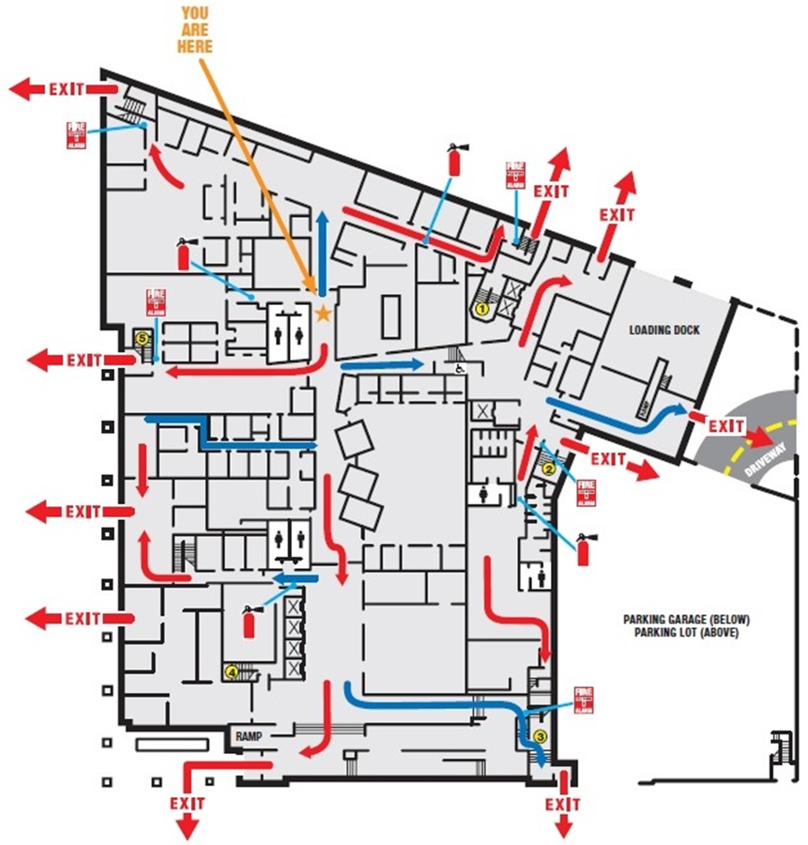
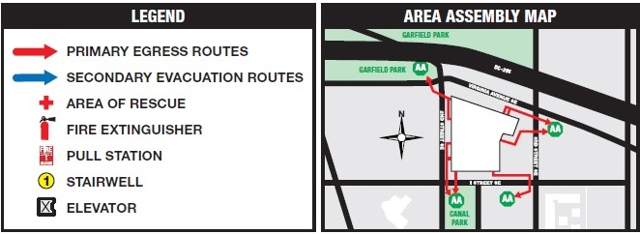
FIRE HYDRANT

Assembly Area Map: Create and include an area map showing the Center with the surrouding streets and the path that evacuees would take to reach the Assembly Area(s) and/or the Contingency Site.

SAMPLE LEGEND & AREA MAP

FIRE HYDRANT

Appendix E:

Supply List for
Centralized & Transportable First Aid Kit
Shelter-In-Place Kit

Centralized First Aid Kit Should Include:

☐ Current edition of the First Aid Guide published by the American Academy of Pediatrics, The American Red Cross, or an equivalent; | ☐ Telephone number(s) of the local Poison Control Center;
☐ One (1) roll of one-half (1/2) inch non-allergenic adhesive tape; | ☐ One (1) roll of two (2) inch gauze roller bandage;
☐ Ten (10) individually wrapped sterile gauze squares in assorted sizes; | ☐ Twenty-five (25) adhesive compresses, such as Band-Aids, in assorted sizes;
☐ Three (3) clean cotton towels or sheeting pieces, approximately 24 x 36 inches each; | ☐ One (1) measuring tablespoon or dosing spoon;
Safety pins in assorted sizes; | ☐ One (1) working flashlight;
☐ One (1) non-mercury, non-glass thermometer; | ☐ One (1) pair of scissors;
One (1) pair of tweezers; | ☐ Rubbing alcohol and alcohol swabs;
Cotton balls; | ☐ One (1) ice pack or gel pack
☐ Liquid sanitizer; | Sanitary soap;
☐ Disposable, nonabsorbent latex free or non-powdered latex free gloves (Nitrile); | ☐ One-third (1/3) cup of powdered milk for dental first aid (mx to make a liquid solution);
☐ All items needed for disposal of blood-borne pathogens; | ☐ One-way valves for infants (if served), young children, and adults;
☐ Pen or pencil and notepad; | ☐ Eye patch or dressing;
Whistle | Wipes;

Transportable First Aid Kits Should Include;

☐ Current edition of the First Aid Guide published by American Academy of Pediatrics, American Red Cross, or equivalent; | ☐ List of children in attendance, organized by the staff member they are assigned to, and each child’s emergency contact information;
☐ Disposable, nonabsorbent latex free or non-powdered latex free gloves (Nitrile); | ☐ One (1) roll of one-half (1/2) inch non-allergenic adhesive tape;
☐ Ten (10) individually wrapped sterile gauze squares in assorted sizes; | ☐ One (1) roll of two (2) inch gauze roller bandage;
☐ One (1) pair of scissors; | Safety pins in assorted sizes;
☐ One (1) working flashlight; | One (1) pair of tweezers;
☐ Rubbing alcohol and alcohol swabs; | Cotton balls;
☐ One (1) ice pack or gel pack | ☐ Liquid sanitizer;
☐ Pen or pencil and notepad; | Wipes;
Whistle; | ☐ Special care plans for children w/ a plan;
☐ Emergency medications or supplies as specified in the special care plan; | ☐ Written transportation policy and contingency plans.
☐ Twenty-five (25) adhesive compresses, such as Band-Aids, in assorted sizes; | ☐ One-way valves for infants (if served), young children, and adults;
☐ List of phone numbers for Poison Control Center, nearby hospitals, emergency care clinics & other community resource agencies;
A Licensee shall ensure a transportable First Aid Kit is taken along by facility staff on each outing, and when children under the care and supervision of the facility are being transported.

In addition to the First Aid Kits, a portable Shelter-in-Place (SIP) Kit should be created. The SIP Kit will allow you Center to shelter-in place within your facility or shelter at the relocation site for an extended period of time with the supplies you need to remain safe until the “All Clear” is given.

Shelter In Place (SIP) Kits Should Include:

☐ Transportable First Aid Kit; | ☐ Two (2) flashlights;
☐ Battery-powered or hand crank NOAA Weather Radio; | ☐ Whistle (to signal for help);
☐ Two (2) bullhorns to provide directions to fellow staff members and children; | ☐ Extra batteries in various sizes (for radio, flashlight, bullhorns, cell phones);
☐ At least three (3) gallons of water per person (1 gallon / person/ day = 3 days of water); | ☐ Canned food and can opener (enough for three (3) days, for each person);
☐ Two (2) rolls of duct tape (to cover gaps and opening around windows and doors); | ☐ Basic tools (hammer, nails, wrenches, pliers, pry bar, screwdrivers);
☐ Cell phone charging cables (if possible a battery powered cell phone charger) | ☐ Dust masks (enough for each person occupying SIP location) to filter contaminated air;
☐ Emergency thermal blankets (enough for each person); | ☐ Heavy-duty six-millimeter (6 mil.) plastic sheeting;
☐ paper towels & work gloves, for minor clean up activities; | ☐ Medication for children, i.e. (inhalers, Epipens, insulin, glucose testing supplies, etc.).
☐ Written instructions for deactivating the facility heating and air conditioning unit (HVAC), gas, electricity and water;

RECOMMENDATION for Childcare Staff:

Childcare Staff and regular volunteer personnel should be asked to create a personal Go-Kit for themselves that includes any prescription medications they take every day, a change of clothes appropriate for the season, and a copy of vital documents on a flash drive or in hard copy . They may also want to keep prescribed medical devices and supplies such as glucose and blood pressure monitoring equipment.

Appendix F:

Bomb Threat Form

BOMB THREAT FORM

If a Bomb Threat is received by telephone: KEEP CALM – DO NOT GET EXCITED OR EXCITE OTHERS

Time Call Received: ___________AM / PM Call terminated _____________AM / PM

EXACT WORDS OF THE CALLER:
_______________________________________________________________________________________________________________________________________________________________________________________________________________________________________________________________
DELAY: ASK THE CALLER TO REPEAT:
Questions you should ask:
- Time the bomb is set to explode?___________________________________________________
- Where is the bomb located? Floor_________________________ Area_____________________
- Kind of bomb?__________________________________________________________________
- Description ____________________________________________________________________
- Why kill/harm innocent people?____________________________________________________
______________________________________________________________________________

Voice Description:
_____ Female _____ Calm _____ Young _____ Rough
_____ Male _____ Anxious _____ Mature _____ Refined
_____ Foreign/Accent _____ Irritated _____ High-Pitched

Unusual phrases?_______________________________________________________________
Recognized voice? Who?_________________________________________________________

Background noises:
_____ Music _____ Horns _____ Television _____ Whistles
_____ Aircraft _____ Machinery _____ Traffic _____ Bells
_____ Other voices _____ Running Motor (type) _________________________
_____ Other distinctive sounds_____________________________ _____ Tape recorder

Additional Information:
- Did the caller indicate knowledge of the building? If so, how? In what way?
______________________________________________________________________
- What line did the call come in on?___________________________________________
- Did the number appear on a caller ID? _____ Yes #____________________ ___ No
- Any other identification? __________________________________________________
(Private, unknown caller, out of area)

Call-taker’s signature:_____________________________________ Date_____________

Appendix G:

Staff & Volunteer Training Record

CHILD CARE STAFF / VOLUNTEER TRAINING RECORD

Staff/Employee Name: _______________________ Position:________________________

New Employee Orientation Annual Staff Training Volunteer Training

Required Trainings | Completion Date
Child abuse and neglect, prevention, detection and reporting;
Emergency preparation and response planning for emergencies resulting from a natural disaster or a human-caused event;
Prevention of sudden infant death syndrome and use of safe sleep practices;
Prevention of shaken baby syndrome and abusive head trauma;
First aid and CPR;
Prevention and control of infectious diseases, including immunization;
Administration of medication, consistent with standards for parental or guardian consent;
Prevention of and response to emergencies due to food and allergic reactions;
Building and physical premises safety, including identification of and protection from hazards that can cause bodily injury such as electrical hazards, water, and vehicular traffic;
Handling and storage of hazardous materials and the appropriate disposal of bio contaminants;
Identifying, approaching and referring students showing signs of psychological distress to appropriate support services.

Employee Signature:________________________________ Date:_____________

Instructor/
Supervisor Signature:_______________________________ Date:_____________

Appendix H:

Record of Emergency Drills & Exercises

EMERGENCY DRILL / EXERCISE RECORD FORM
DIRECTIONS: Use the table below to record any drills (e.g. Fire Drills) and exercises that you conduct during the term of your license. Record the date, time and type of exercise (Use the following labels)
FIRE = Fire Drill SIP = Shelter-In-Place Lock = Lockdown ME = Medical Emergency
Drill / Exercise Date | Drill / Exercise Time | Type of Drill / Exercise | Authorized Signature

AFTER DRILL / EXERCISE REPORT

Notification method used: ___________________________________________________________

Time it took for all to reach SIP Room or Evacuate the building:______________________________
Special conditions simulated: _________________________________________________________
_________________________________________________________________________________
What went right / well? ____________________________________________________________
_________________________________________________________________________________
_________________________________________________________________________________
_________________________________________________________________________________
Problems encountered: _____________________________________________________________
_________________________________________________________________________________
_________________________________________________________________________________
_________________________________________________________________________________
Plan of correction (include what to correct, who is assigned responsibility, completion timeframe)
_________________________________________________________________________________
_________________________________________________________________________________
_________________________________________________________________________________
_________________________________________________________________________________
_________________________________________________________________________________
_________________________________________________________________________________
Other Information: _________________________________________________________________
_________________________________________________________________________________
_________________________________________________________________________________

Completed by: ____________________________________________ Date _____________

Appendix I:

Medical Emergency & Unusual Incident Report (UIR) Forms

Medical Emergency Reporting Form |  |  | Facility Name:
Facility Address: |  | Facility Phone Number: |  | Type of Facility (Check One):
 |  |  |  | Center Home Extended Home
Date Of Incident: | Time Incident Occurred: | Today’s Date: | IF CHILD ABUSE OR NEGLECT IS IDENTIFIED, CALL:  24 Hour Child Abuse and Neglect Hotline: 202-671-SAFE
Name of Reporter: |  | Reporter’s Title/ Position: |  | Reporter’s Contact Info:
Name of Student: |  |  |  | Age of Student: |  |  | Sex of Student | (Check One)  M F
Type of Medical Emergency:
Details of Medical Emergency:
Details of Actions Taken by Staff:
Additional Information:

DIVISION OF EARLY LEARNING

INSTRUCTIONS FOR COMPLETING
THE UNUSUAL INCIDENT REPORT (UIR) FORM

Completed forms should be faxed to the Compliance and Integrity Division (CID) at 202-727-7295.
Unusual incidents can also be reported via the dedicated hotline at 202-727-2993 or emailed to OSSE.ChildcareComplaints@dc.gov

Definition: An “Unusual Incident” is any event that is not ordinary to the regular operations or established procedure that may adversely affect the health, safety or well-being of any child or children in the child care facility.

Examples include, but are not limited to: accident or injury; physical, sexual, or verbal abuse of a child by staff or other child(ren); staff negligence; communicable disease occurrence; facility / property issues, including building security, theft, arson, bomb, fire threats, false alarms; and request for information or access to the participation from the press, attorneys, government officials outside OSSE/ECE; or persons other than those authorized by the parent.

UIR Forms must be filled out completely and accurately.

PART I – REPORTING INDIVIDUAL - Enter required information

PART II – INCIDENT INFORMATION - Enter required information
NOTE: Upon completion of item #7, if there are no other persons involved and no witnesses, skip to PART III and complete the details of the incident.

PART III – DESCRIPTION AND DETAILS OF INCIDENT
Enter complete information on who was involved, what occurred, where the incident occurred and how it occurred. List first and last names of everyone involved.

PART IV – WHAT ACTIONS WERE TAKEN AND BY WHOM
Enter any actions that were taken in response to the incident, such as police or family notified, medical treatment provided, etc. Also indicate corrective measures taken to prevent reoccurrence, including administrative, managerial or disciplinary actions taken and by whom.

SIGNATURE REQUIREMENT
The reporting person’s signature and date of signing is required.

 | COMPLIANCE AND INTEGRITY DIVISION PHONE: (202) 727-2993  FAX: (202) 727-7295 | UNUSUAL INCIDENT REPORT FORM | MAILING ADDRESS:  810 First Street, NE 4th Floor  Washington, DC 20002

PART I - REPORTED BY
1. PERSON REPORTING INCIDENT TO CID |  |  | FACILITY NAME:
TITLE / POSITION |  |  | ADDRESS
Home Telephone Number (with area code): |  |  | DIRECTOR/ OWNER
DATE REPORTED | TIME REPORTED |  | OFFICE # |  | CELL #
PART II -INCIDENT INFORMATION
2. Date of Incident: |  | 3. Time of Incident: |  | 4. Date of Report:
5. Type of Incident:
(accident, injury or unusual occurrence)

6. Incident Location Address:

7. Person Involved (Adult Child ) Age _  NAME: _  Last First Middle | 8. Person Involved (Adult Child ) Age  NAME: ________  Last First Middle
Home Telephone Number (with area code): | Home Telephone Number (with area code):
9. Person Involved (Adult Child )  NAME:  Last First Middle | 10. Person Involved (Adult Child )  NAME:  Last First Middle
Home Telephone Number (with area code): | Home Telephone Number (with area code):
Additional persons involved attach a separate sheet.
11. Witness 1:  NAME:  Last First Middle | 12. Witness 2:  NAME:  Last First Middle
11a. Home Telephone Number (with area code): | 12a. Home Telephone Number (with area code):
13. Witness 3:  NAME:  Last First Middle | 14. Witness 4:  NAME:  Last First Middle
13a. Home Telephone Number (with area code): | 14a. Home Telephone Number (with area code):
Additional witnesses attach a separate sheet.

PART III -DESCRIPTION AND DETAILS OF INCIDENT
15. Who, What, Where and How: (If necessary, attach a separate sheet for additional information)

PART IV - WHAT ACTIONS WERE TAKEN AND BY WHOM

Signature

Appendix J:

Staff and Family Emergency Contact Lists

Childcare Center Personnel Emergency Contact List
Name | Title / Position | Cell Phone | E-mail

Emergency Contact Information for Children

Child Name | Emergency Contact | Cell Phone | E-mail
KJ Kidd | 1. John Doe--Father | (202) 123-4567 | emergencycontact@gmail.com
 | 2. Jane Kidd--Mother | (202) 987-6543 | safetyfirst@anyemail.com

