

Request for Applications (RFA)

Competitive funding under

**McKinney-Vento Homeless Assistance Act**

*for Education of Homeless Children and Youths Program*

**RFA #MKV041015**



**Community Learning and School Support (CLASS)**

Office of Transitory Services

Office of the State Superintendent of Education (OSSE)

Division of Elementary and Secondary Education

District of Columbia

**Announcement Date: April 17, 2015**

**RFA Release Date: May 18, 2015**

**Application Deadline: June 26, 2015**

Incomplete or late applications **will not** be forwarded to the application review panel.

For more information, please contact Nicole Lee-Mwandha at (202) 654-6123 or

Email: [transitory.services@dc.gov](mailto:transitory.services@dc.gov)

**This page is intentionally left blank**



**McKinney-Vento Homeless Assistance Act**

*for Education of Homeless Children and Youths Program*

**Pre-Application Conferences**



**PRE-APPLICATION CONFERENCES**

*(Applicants are strongly encouraged to attend at least one pre-application conference)*

May 26, 2015 - 11:00 a.m. to 12:00 p.m. (webinar)

June 3, 2015 - 3:00 p.m. to 4:30 p.m. (on-site at OSSE)

June 10, 2015 - 3:00 p.m. to 4:00 p.m. (webinar)

**Please contact Nicole Lee-Mwandha at** [**nicole.lee-mwandha@dc.gov**](mailto:nicole.lee-mwandha@dc.gov)

**to pre-register for the on-site conference, as space is limited. To**

**participate in a webinar, please register at the following link:** <https://attendee.gotowebinar.com/register/4685402041388472833>

|  |  |
| --- | --- |
| **INDEX** | **PAGE(S)** |
| Pre-Application Technical Assistance Sessions | 3 |
| **Section I: Program Information** | **6-7** |
| * Overview | 6 |
| * Purpose | 6 |
| * Eligibility | 6 |
| * Allowable Uses of Funds | 6 |
| * Program Quality | 7 |
| **Section II: Project Requirements** | **8** |
| * General Requirements | 8 |
| * Performance Reports | 8 |
| * Evaluation | 8 |
| **Section III: Award Information** | **8-9** |
| * Amount of Funding | 8 |
| * Anticipated Number of Awards | 8 |
| * Award Period | 9 |
| * Grant Award Payments | 9 |
| **Section IV: Application and Submission Overview** | **9-14** |
| * Overview of the Enterprise Grants Management System (EGMS) Application | 9 |
| 1. Application Overview | 9 |
| 1. Contact Information | 9 |
| 1. Needs Assessment | 9 |
| 1. Project Narrative | 9 |
| 1. Implementation Plan (Includes Goals and Budget) | 10 |
| 1. Detailed Planning Expenditures (The Budget) | 10 |
| 1. Assurances | 10 |
| * Application Scoring Overview | 10 |
| * Application Due Date | 14 |
| * Submission Process | 14 |
| **Section V: Review Panel and Selection Process** | **14** |
| * Review Panel Criteria | 14 |
| * Review and Selection Process | 14 |

|  |  |
| --- | --- |
| **Section VI: Award Administration** | **14-15** |
| * Award Notices | 14 |
| * Overview of Payment Process | 15 |
| **Section VII: Terms and Conditions** | **15-16** |
| * Audits | 15 |
| * Equipment | 15 |
| * Document Retention | 15 |
| * Supplement, not Supplant | 15 |
| * Reporting Requirements | 15 |
| * Nondiscrimination in the Delivery of Services | 16 |
| * Family Educational Rights and Privacy | 16 |
| * Federal Funding Accountability and Transparency | 16 |
| * Additional Terms and Conditions | 16 |
| **Section VIII: OSSE Program Contact Information** | **17** |
| * Technical Assistance Questions | 17 |
| * OSSE Program Contact Information | 17 |
| **Section IX: Resources** | **18-35** |
| * Resources | 18 |
| * Definition of Terms | 18 |
| * Attachment A: EGMS On-line Tool – Visual Overview | 21-31 |
| * Attachment B: Reviewer Scoring Information | 32-34 |
| * Attachment C: Reviewer Scoring Information – Reviewer Summary Sheet | 35 |

**SECTION I: Program Information**

**Overview:** The District of Columbia Office of the State Superintendent of Education (OSSE) invites local educational agencies (LEAs) to apply for federal funding for the Education for Homeless Children and Grant Program via a Request for Applications (RFA). This funding is authorized by Section 726 of Title VII Subtitle B of the McKinney-Vento Homeless Assistance Act, as amended by Public Law 107-110.

Detailed information regarding the McKinney-Vento statute is available at:

<http://www2.ed.gov/programs/homeless/legislation.html>.

**All LEAs, with or without this funding, must ensure that children and youth who are homeless have equal access to the same free, appropriate public education as provided to all other children and youth**.

**Purpose of the Funding:** The intent of the grant is to facilitate the enrollment, attendance, and success in school of homeless children and youth.

**Eligibility:** LEAs within the District of Columbia are eligible to apply. OSSE will prioritize LEAs with a high number of identified homeless children and youth when distributing funding.

**Allowable Uses of Funds:** Each eligible entity that receives an award may use the award funds to carry out the following activities:

1. The provision of tutoring, supplemental instruction and enriched educational services that are linked to the achievement of the same challenging District academic content standards and student academic achievement standards that the District establishes for other children and youth;
2. The provision of expedited evaluations of the strengths and needs of homeless children and youth, including needs and eligibility for programs and services such as, but not limited to:

* educational programs for gifted and talented students, children with disabilities, and students with limited English proficiency;
* services provided under Title I of the Elementary and Secondary Education (ESEA) Act of 1965; or
* other District or local programs, such as programs in vocational and technical education, and school nutrition programs;

1. Professional development and other activities for educators and pupil services personnel that are designed to heighten the understanding and sensitivity of such personnel to the needs of homeless children and youth, the rights of such children and youth under this subtitle, and the specific educational needs of runaway and homeless youth;
2. The provision of referral services to homeless children and youth for medical, dental, mental, and other health services;
3. The provision of assistance to defray the excess cost of transportation for eligible students, not otherwise provided through Federal, District, or local funding, where necessary to enable students to attend the school of origin;
4. The provision of developmentally appropriate early childhood education programs, not otherwise provided through Federal, District, or local funding, for preschool-aged homeless children;
5. The provision of services and assistance to attract, engage, and retain homeless children and youth and unaccompanied youth in public school programs and services provided to non-homeless children and youth;
6. The provision for homeless children and youth of before- and after-school, mentoring, and summer programs in which a teacher or other qualified individual provides tutoring, homework assistance, and supervision of educational activities;
7. If necessary, the payment of fees and other costs associated with tracking, obtaining, and transferring records necessary to enroll homeless children and youth in school, including birth certificates, immunization or medical records, academic records, guardianship records, and evaluations for special programs or services;
8. The provision of education and training to the parents of homeless children and youth about the rights of, and resources available to, such children and youth;
9. The development of coordination between schools and agencies providing services to eligible homeless children and youth;
10. The provision of pupil services (including violence prevention counseling) and referrals for such services;
11. Activities to address the particular needs of homeless children and youth that may arise from domestic violence;
12. The adaptation of space and purchase of supplies for any non-school facilities made available under subsection to provide services supported by this program. See section 723 (a)(2) of the McKinney-Vento Homeless Education Assistance Act of 2001 for detailed criteria;
13. The provision of school supplies, including those supplies to be distributed at shelters or temporary housing facilities, or other appropriate locations; and
14. The provision of other extraordinary or emergency assistance needed to enable homeless children and youth to attend school.

**Program Quality:** The Education of Homeless Children and Youth Program is based on sound principles of effectiveness that will guide local grantees to identify and implement programs and activities that can directly enhance homeless student’s academic equity and achievement. In assessing the quality of applications under paragraph, OSSE will consider:

* The applicant's needs assessment under subsection and the likelihood that the program presented in the application will meet such needs;
* The types, intensity, and coordination of the services to be provided under the program;
* The involvement of parents or guardians of homeless children or youth in the education of their children;
* The extent to which homeless children and youth will be integrated within the regular education program;
* The quality of the applicant's evaluation plan for the program; and
* The extent to which services provided under this subtitle will be coordinated with other services available to homeless children and youth and their families.

**SECTION II: Project Requirements**

**General Requirements:** Sub-grantees are responsible for reviewing and revising policies that may act as barriers to the enrollment and retention of homeless children and youth. See use of funds section for further detail. Lastly, the application must include a preliminary plan for continuation of services after Federal funding ends.

**Performance and Census Reports:** Sub-grantees must submit annual performance and census reports requested by the OSSE in order to assess the educational needs of homeless children and youth and to distribute available resources equitably. Successful applicants will receive further detail regarding these reporting responsibilities.

**Evaluation:** Sub-grantees must implement an evaluation plan to ensure that program goals are met. Sample templates and evaluation plans are readily available in the U. S. Department of Education’s non-regulatory guidance manual, found at

<http://www2.ed.gov/programs/homeless/guidance.pdf>.

**SECTION III: Award Information**

**Amount of Funding:** The total estimated amount of available funds is 75% of the amount awarded for FY15 and FY16, as follows:

|  |  |
| --- | --- |
| Estimated Award to DC | $190,269.00 |
| 25% for State Activities | -47,567.25 |
| 75% Available for Sub-grants | 142,701.75 |
| Reserved for Continuation Awards | -69,550.00 |
| **Available Amount for FY15/FY16 Competition** | **$ 73,151.75** |

**Anticipated Number of Awards:** FY15 awards ranged from $600 to $48,000. OSSE reserves the right to fund applicants at a lesser amount than requested if it is deemed that the project can be implemented with less funding than requested or if federal funding is not sufficient to fully fund all applications that merit award. Awards *may* be extended for two additional years if the sub-grantee’s program remains in compliance with all grant requirements. Programs are renewed from year-to-year and a modified continuation application will be required to extend funding beyond the initial award year. Continuing awards are subject to the continuing availability of funding,

**Award Period:** The grant programmatic and fiscal implementation period will be from the date of the award, to September 30, 2016. Year one funds must be obligated by September 30, 2016. Projects that successfully demonstrate substantial progress and demonstrate programmatic and fiscal reporting compliance during the award period ***may*** be eligible to receive continuation awards for two (2) additional years if funds remain available. ***No more than 15% of the award may be carried over to the next program period.*** The program periods are:

Year 1: July 2015– September 2016 (original application)

Year 2: July 2016 – September 2017 (continuation)

Year 3: July 2017 – September 2018 (continuation)

**Grant Award Payments:** In accordance with section 80.21(d) of the Education Department General Administrative Regulations (EDGAR), OSSE has implemented a reimbursement process for all sub-grantees. Grant award payments are reimbursable on a monthly basis. Program costs must be paid by the sub-grantee to the payee prior to requesting reimbursement; it is not sufficient for costs merely to be incurred.  All awards will be reviewed annually for consideration of continued funding. Compliance with programmatic and fiscal implementation and reporting will be considered.  In order to receive federal education funds, sub-grantees must establish eligibility by submitting an application to the OSSE in accordance with the relevant program statute(s) and any additional rules established by the OSSE. Once OSSE has fully approved the application and issued an official Grant Award Notification, sub-grantees may then receive payment for allowable expenditures for which obligation was made during the grant period through the reimbursement request process. To receive reimbursement for grant program expenditures, OSSE sub-grantees must complete and submit the applicable reimbursement workbooks electronically via the Enterprise Grants Management System (EGMS).  Detailed policy and template instructions are available at [**http://osse.dc.gov/service/reimbursement-and-reporting-workbooks**](http://osse.dc.gov/service/reimbursement-and-reporting-workbooks).

**SECTION IV: Application and Submission Overview**

**Overview of Enterprise Grant Management System (EGMS) Application:** This section provides information on the required form and content of application submissions. This RFA includes the application template, also posted on the OSSE website at [www.osse.dc.gov](http://www.osse.dc.gov). The application must be completed in OSSE’s EGMS. To receive more information or to request a copy of this RFA, please see section VII of this RFA. The complete application form is located at the following link: <https://osse.mtwgms.org/>. The EGMS application includes the following components (see Attachment A for a visual display of EGMS):

1. Application Overview
2. Contact Information
3. Needs Assessment—a summary of the educational and related needs of homeless children and youth in the area served by the LEA/School (not to exceed 2,000 characters per text box).
4. Program Narrative (not to exceed 2,000 characters per text box) to include:
   1. Part 1: a brief narrative describing the following:
      1. The extent of the need for the proposed project;
      2. Goals, objectives and measurable indicators of success;
      3. Plan of operation, including policies and procedures that the LEA/School will undertake to ensure that its activities would not isolate or stigmatize homeless children and youth;
      4. Coordination of the project as it relates to Title I, Part A; and
      5. Evaluation and dissemination of plan(s).
   2. Part 2: a brief narrative describing the following:
      1. The management plan, including key personnel;
      2. Project timeline;
      3. Professional development awareness activities; and
      4. Future plans (ex: sustainability beyond this grant).

Implementation Plan: this section consists of four pages/tabs (or Parts 1, 2, 3, and 4). Each page consists of a series of check boxes with a list of activities. Please select all activities that pertain to your project. If the activities listed on the page do not apply to your project, please do not place a check in the box and move on to the next page. However, for activities that do apply to your project, please select them accordingly by placing a check in the box, entering the amount to be allocated for each selected activity and providing a description of each proposed activity (text boxes are limited to 2,000 characters).

Detailed Planning Expenditures (the Budget)

Assurances

McKinney-Vento Homeless Education Program Specific Assurances

General Agreement Assurances

**Application Scoring Overview:**

|  |
| --- |
| **CONTACT INFORMATION (* denotes required field)** |
| Description: Every application must identify a Point of Contact (POC) for proposed project. The following information must be provided in the contact information section:   * Application Approval/Disapproval Copy Email Addresses. Up to five (5) email addresses may be included to receive copies of automated approval/disapproval notices in addition to the Superintendent or Authorized Representative of applicant LEA/School. * Please note: the Superintendent or Authorized Representative will automatically receive notices. |
| Scoring Criteria:TheApplication cannot be submitted if this section is incomplete |
| **Met** |
| **NEEDS ASSESSMENT SUMMARY** |
| Description: A compelling proposal will clearly define an identified issue or problem that is supported by the proposed project, which must to be summarized within the application. The needs assessment must assess the educational and related needs of homeless children and youth in the LEA service area (which will also be undertaken as part of the needs assessments for other disadvantaged groups).  A needs assessment is a systemic review of information collected from a variety of sources, analyzed to determine strengths and weaknesses, and prioritized for action in the proposal. Access <http://center.serve.org/nche> and [http://www.icpny.org/PDF/reports/ICP_DistrictofColumbia_Brief.pdf](http://www.icpny.org/PDF/reports/ICP_DistrictofColumbia_Brief.pdf%20) for relevant resources and research.  Below are suggestions for the required needs assessment:   1. Summarize the methods used to complete the needs assessment. 2. Clearly state the educational and/or related academic needs facing the homeless children and youth in the LEA. 3. Select data sources used to perform the needs assessment and summarize how the specific data collected confirms the existence of the problem, issue and its source(s) or root cause. This may include information about the students, parents of the students and schools the proposed project will serve.   The following are suggestions of content that could be included in this section:   * Utilize multiple methods to document the issue, for example:   + The number of homeless shelters that serve families with school aged children,   + The population served,   + A breakdown of the homeless children and youth by grade level, survey, analysis of school records, previous studies, or focus groups. All are options. * Utilize local data to document the issue(s) in the service area. Include relevant demographic information and other statistics about the population which will potentially be served by the proposed project. * Identify the population primarily affected by the issue/problem. * Identify when and where the problem exists. * Document the factors contributing to the problem. * Document current or past efforts to address the issue and illustrate the reasons why those efforts were unsuccessful or inadequate to address the total need. * Provide the applicant’s history and expertise in dealing with the issue and past successes. If the entity does not have prior experience coordinating a homeless education program, provide reasons that the applicant can meet the issue with success. * Specify the consequences or the internal accountability factors that will result from not meeting the needs of the issue. |
| **Total Value: 15 points** |

|  |
| --- |
| **PROJECT NARRATIVE** |
| **Description**: The Project Narrative provides a description of the services and programs that the LEA will provide. This is an opportunity to convince readers that the proposed project is sound. Provide as much detail as possible. Clearly describe the policies and procedures that the LEA will undertake to ensure that its activities would not isolate or stigmatize homeless children and youth. Use the Appendices to include supplemental information that may be important for the reader but will not fit within the Project Narrative. For additional clarity, it is important to reference any supplemental information included in the appendices in the body of the proposal. Your narrative must address:   * + Extent of Need   + Goal, Objectives and Measurable Indicators of Success   + Plan of Operation   + Coordination with Title I Part A, including the provision of Title I, Part A services at non-Title I schools, if applicable   + Evaluation and Dissemination of Plan   + Management Plan including Key Personnel   + Project Timeline   + Professional Development and Awareness Activities   + Future Plans (Impact of Evaluation and sustainability plan)   **No required elements of the proposal can be submitted as appendices or attachments**. Be sure to:   1. Identify the plan of operation by specifying who will be responsible for each activity and for the implementation timeline. 2. Describe the plan to evaluate the project, disseminate the plan, and to use the evaluation results to improve future activities. 3. Describe any planned professional development and awareness activities. 4. Proofread the Project Narrative once it is completed. Check for style inconsistencies, redundancies, repetition, factual omissions, and unexplained assumptions.   When writing the Project Narrative, keep the following suggestions in mind:   * Be concise and clear. Readers need to quickly and easily understand the components of the proposed project and how it will address the stated needs. * Do not assume the reader is familiar with the proposed project; readers represent diverse backgrounds. Avoid jargon and define all acronyms.   **Evaluation:** Sub-grantees are required to submit annual evaluation reports. Your evaluation plan should be consistent with the goal(s) and objective(s) described earlier. Keep in mind that the evaluation will consider the entire project, beginning to end. The evaluation should not be viewed as what is done after the project’s completion, but as an integral element in the project’s design, planning, and implementation. A solid, ongoing plan that evaluates milestones quarterly will allow the project manager to make informed decisions regarding the modifications needed to ascertain the necessary results. Identify what the evaluation will seek to answer and what strategies will be used to determine the answers to the evaluation questions. See Appendix B (page 44) for a sample evaluation plan.  **Dissemination:** Provide details on the dissemination process for the proposed project; i.e., what types of media will be used to disseminate information. For example:   * Newsletters/Posters * Parent or School Community Events * Parent-teacher Conferences * Internet/Email * Community Outreach * Robocalls * Social Media   **Management Plan And Critical Personnel:** Provide a description of proposed project supervision and how the LEA will ensure the plan will be implemented. Describe how the program will cooperate and coordinate services with Title I programs, Head Start, Even Start, and other public education programs available locally for which homeless children and youth are eligible  **Professional Development:** Describe the methods through which the program will provide staff development or training on homeless student rights, best practices, statewide efforts and advocacy for students experiencing homelessness. |
| **Total Value: 20 points** |
| **PROGRAM IMPLEMENTATION PLAN** |
| **DESCRIPTION:** Activities are the specific steps taken to accomplish the project objectives and involve direct service to clients (students, teachers, parents). These events or activities may take place on a single date or over a period of time. The description should clearly indicate how funds will be used. Strategies are broad approaches (methods, procedures, techniques) employed to accomplish the evidenced outcomes. Provide a justification describing the strategies selected and how these strategies will assist in achieving the outcomes. |
| **Total Value: 15 points** |
| **ASSURANCES** |
| Description: Applicants must review and assure the OSSE of their intent to implement this program in accordance with all applicable statutes, regulations, program plans, and applications; |
| Scoring Criteria:Applications cannot be submitted if this section is incomplete. |
| **Met** |

**Application Due Date:** Applications are due no later than 11:59 p.m. on **June 26, 2015***.* OSSE will record receipt information for all applications. Applications submitted after 11:59 p.m. on **June 26, 2015** will not be forwarded to the review panel for funding consideration. Any additions or deletions to an application will not be accepted after the deadline—no exceptions can be made. Please submit all questions in writing to:

**Office of Transitory Services**

Community Learning and School Support (CLASS)

Office of the State Superintendent of Education (OSSE)

Division of Elementary, Secondary and Specialized Education

810 First Street, NE, 8th floor

Washington, DC 20002

[transitory.services@dc.gov](mailto:transitory.services@dc.gov)

**Submission Process:** To apply for grant funds, a McKinney-Vento Homeless Assistance grant application must be completed and submitted by the deadline using OSSE’s online EGMS. The EGMS system will automatically confirm receipt and time/date stamp all submissions. Applications submitted after 11:59 p.m. on **June 26, 2015** will not be accepted or forwarded to the review panel for consideration.

**SECTION V: Review Panel and Selection Process**

**Review Panel Criteria:** The review panel for this RFA will be comprised of a minimum of three neutral, qualified, professional individuals who will be been selected for their unique qualifications, knowledge and expertise in the objectives of the elementary, secondary and specialized education fields. The review panel is responsible for scoring and ranking applications and making recommendations for funding consideration. A copy of the review rubric is provided (see Attachment B).

Reviewers will not be expected to search the internet or other references/resources, make assumptions, or search beyond the section of the application under review for responses to and/or evidence of scoring criteria. It is imperative that responses to and/or evidence of the scoring criteria are located in the appropriate sections of the application.

**Review and Selection Process:** The recommendations of the review panel are advisory only and not binding on OSSE. The final decision on awards is vested solely with OSSE. The Agency reserves the right to accept or deny any or all applications if the Agency determines it is in the best interest of the Agency to do so. After reviewing the recommendations of the panel and any other information considered relevant, OSSE shall make the decisions regarding which applications will be awarded and the amounts to be funded. Upon approval, selected awardees will be notified through EGMS.

**SECTION VI: Award Administration**

**Award Notices:** Successful applicants will receive a letter of notification and a Grant Award Notice (GAN) that includes the terms and conditions that apply to the award, and any special conditions and performance standards that may apply.

**Overview of Payment Process:** In order to receive federal education funds sub-grantees must establish eligibility by submitting an application to the OSSE in accordance with relevant program statute(s), and any additional rules established by the OSSE. Once the OSSE has fully approved the application and issued an official GAN, sub-grantees may submit reimbursement requests (containing valid costs paid by the sub-grantees) monthly, every other month or quarterly to the OSSE for review and process. Payments are made on a reimbursement basis only. Accrual of accounting is not sufficient to seek reimbursement (see grant award payments).

To request reimbursement, sub grantees must submit completed Federal Grant Reimbursement Forms. Completed forms, including signature must be submitted electronically through OSSE’s EGMS system. For detailed guidance, review the grants administration guidance provided at <http://osse.dc.gov/>.

Sub-grantees are not required to submit any supporting documentation with the Federal Grant Reimbursement Forms (F1 and F2). *However, sub-grantees are required to maintain all necessary supporting documentation and to ensure such documentation is available to the OSSE, the U.S. Department of Education and other authorized entities for review, upon request (see EDGAR,* 76.730).

**SECTION VII: Terms and Conditions**

The following terms and conditions apply to all grants awarded by OSSE:

* **Audits:** At any time before final payment and five (5) years thereafter, OSSE may have the sub-grantee’s expenditure statements and source documentation audited.
* **Equipment:** The applicant must implement adequate controls to account for procurement, location, custody, and security of equipment purchased in accordance with EDGAR 80.32.
* **Document Retention:** Sub-recipients of these funds are required to maintain complete documentation of grant activities. This includes financial records, supporting documents, statistical records, and all other records pertinent to this award for a period of five years from end date of the program period. Sub-recipients must ensure that such documentation is available to the OSSE, the U.S. Department of Education and/or other authorized entities for review, upon request.
* **Supplement, not Supplant**: Sub-recipients must ensure that the award is used to supplement, not supplant, any other Federal, state, or local dollars available to support activities allowable under the McKinney-Vento program.
* **Reporting Requirements:** Sub-grantees are required to complete an Annual Performance Report (APR), complete reimbursement workbooks on at least a quarterly basis, submit periodic census reports and complete an annual evaluation of programmatic activities. Timely submission of reports is essential to ensure compliance with local and federal requirements. at

Further guidance will be provided to successful applicants.

* **Nondiscrimination in the Delivery of Services:** In accordance with Title VI of the Civil Rights Act of 1964 (Public Law 88-352), as amended, no person shall, on the grounds of race, color, religion, nationality, sex, or political opinion, be denied the benefits of, or be subjected to discrimination under, any program activity receiving McKinney-Vento Program grant funds.
* **Family Educational Rights and Privacy:** In accordance with the Family Educational Rights & Privacy Act, as amended (FERPA), successful applicants must protect the rights of parents and children as it pertains to confidentiality, disclosure of personally identifiable information and the right to inspect records.
* **Federal Funding Accountability and Transparency:** In accordance with the Federal Funding Accountability and Transparency Act of 2006, as amended (FFATA), information on federal awards (federal financial assistance and expenditures) must be made available to the public via a single, searchable website, which is [www.USASpending.gov](http://www.USASpending.gov).
* **Additional Terms and Conditions:** The following terms and conditions apply to this competition ONLY:
* Funding for this award is contingent on continued funding from the grantor. The RFA does not commit OSSE to make an award.
* OSSE reserves the right to accept or deny any or all applications if the OSSE determines it is in the best interest of the Agency to do so. OSSE shall notify the applicant if it rejects that applicant’s proposal. OSSE may suspend or terminate an outstanding RFA pursuant to its own grant-making rule(s) or any applicable federal regulation or requirement.
* OSSE reserves the right to issue addenda and/or amendments subsequent to the issuance of the RFA, or to rescind the RFA.
* OSSE shall not be liable for any costs incurred in the preparation of applications in response to the RFA. The applicant agrees that all costs incurred in developing the application are the applicant’s sole responsibility.
* OSSE may conduct pre-award on-site visits to verify information submitted in the application and to determine if the applicant’s facilities are appropriate for the services intended.
* OSSE may enter into negotiations with an applicant and adopt a firm funding amount or other revision of the applicant’s proposal that may result from negotiations.
* OSSE shall provide the citations to the statute and implementing regulations that authorize the grant or sub-grant; all applicable federal and District regulations, such as OMB Circulars A-87, A-102, A-122, A-133, 2 CFR 180, 2 CFR 225, 2CFR 220, and 2 CFR 215; payment provisions identifying how the grantee will be paid for performing under the award; reporting requirements, including programmatic, financial and any special reports required by the granting Agency; and compliance conditions that must be met by the grantee.
* If there are any conflicts between the terms and conditions of the RFA and any applicable federal or local law or regulation, or any ambiguity related thereto, then the provisions of the applicable law or regulation shall control and it shall be the responsibility of the applicant to ensure compliance.
* The applicant must disclose in a written statement, the truth of which is sworn or attested to by the applicant, whether the applicant, or where applicable, any of its officers, partners, principals, members, associates or key employees, within the last three (3) years prior to the date of the application, has: been indicted or had charges brought against them (if still pending) and/or been convicted of (a) any crime or offense arising directly or indirectly from the conduct of the applicant’s organization or (b) any crime or offense involving financial misconduct or fraud, or been the subject of legal proceedings arising directly from the provision of services by the organization If the response is in the affirmative, the applicant shall fully describe any such indictments, charges, convictions, or legal proceedings (and the status and disposition thereof) and surrounding circumstances in writing and provide documentation of the circumstances.

**SECTION VIII: OSSE Program Contact Information**

**Technical Assistance Questions:** Please email questions to [Transitory.Services@dc.gov](mailto:ashaki.goodall@dc.gov). Every effort will be made to respond to questions within two business days. Technical assistance questions and responses will be shared with all applicants who attend the pre-application conferences and who email their contact information as indicated above. Please include RFA #**-MKV041015** in the subject line of your email.

**Contact Persons:** For further information regarding this RFA competitive process, please contact:

|  |
| --- |
| **Sheryl Hamilton**  Director  Office of the State Superintendent of Education  810 First Street, NE, 8th floor  Washington, DC 20002  (202) 741-6404  [sheryl.hamilton@dc.gov](mailto:sheryl.hamilton@dc.gov) |
| **Nicole Lee-Mwandha**  Homeless Education State Coordinator  Office of the State Superintendent of Education  810 First Street, NE, 8th floor  Washington, DC 20002  (202) 654-6123  [nicole.lee-mwandha@dc.gov](mailto:nicole.lee-mwandha@dc.gov) |
| **Danielle C. Rollins**  Homeless Education Program Specialist  Office of the State Superintendent of Education  810 First Street, NE, 8th floor  Washington, DC 20002  (202) 741-0255  [danielle.rollins@dc.gov](mailto:danielle.rollins@dc.gov) |

**SECTION IX: Resources**

* **LEGISLATION:** [**http://www.ed.gov/programs/homeless/legislation.html**](http://www.ed.gov/programs/homeless/legislation.html)
* **GUIDANCE:** [**http://www2.ed.gov/programs/homeless/guidance.pdf**](http://www2.ed.gov/programs/homeless/guidance.pdf)
* **OSSE WEBSITE:** [**http://osse.dc.gov/**](http://osse.dc.gov/)
* **RESEARCH**

[**www.naehcy.org**](http://www.naehcy.org/)

* **Liaison Toolkit:** [**http://center.serve.org/nche/pr/liaison_toolkit.php**](http://center.serve.org/nche/pr/liaison_toolkit.php)

**Definitions of Terms Related to Homeless Children and Youth:**

The term **“homeless child and youth”** is defined as:

* Children and youth who lack a fixed, regular, and adequate nighttime residence;
* Children and youth who are sharing the housing of other persons due to loss of housing, economic hardship, or a similar reason;
* Children and youth who are residing in hotels, motels, trailer parks, or camping grounds due to lack of alternative adequate accommodations;
* Children and youth who are living in emergency or transitional shelter (including DC transitional housing)
* Children and youth who are abandoned in hospitals
* Children and youth who are awaiting foster care placement
* Children and youth who have a primary nighttime residence that is private or is a public place not designed for, or ordinarily used as a regular sleeping accommodation for human beings;
* Children and youth who are living in cars, parks, public spaces, abandoned buildings, substandard housing, bus or train stations, or similar settings;
* Migratory children who qualify as homeless because they are living in circumstances described above; and
* Unaccompanied youth, including youth who are not in the physical custody of a parent or guardian, and who qualify as homeless because they live in any of the aforementioned circumstances.

**Free and Appropriate Public Education:**  is defined as the educational programs and services that are provided to the children and youth of the State and that are consistent with State school attendance laws, to include special populations such as homeless children and youth. Additionally, the State educational agency, shall assure that each child of a homeless individual, and each homeless youth has equal access to a free, appropriate public education. If the homeless children and youth meet eligibility criteria they must be included in programs and services that include but are not limited to: transportation services, gifted and talented programs, and all Title I services provided. Title I services include local educational programs (e.g., Educational Services and extended day programs) , educational programs for students with disabilities, educational programs for students with limited English proficiency, programs in vocational education, and school meal programs.

**School Age Children:** According to the District of Compulsory School Attendance Amendment Act of 1990, all children of compulsory school age are required to attend school or receive an equivalent education approved by the local educational agency. Compulsory school attendance age is five (5) years to the eighteenth (18th) date of birth of the student. Children ages three (3) and above are eligible to attend pre-kindergarten programs. However, students identified and or determined to be in need of special education services are eligible for slightly extended school attendance ages. These students are eligible to attend school from ages three (3) until their twenty second (22nd) birth date.

**School of Origin:** is defined as the school that the child/youth attended when permanently housed or the school in which the child was last enrolled.

**Doubled Up:** describes children and youth who are sharing the housing of other persons due to loss of housing, economic hardship, or a similar reason. Families who are living in doubled up circumstances voluntarily for purposes of saving money are generally not considered homeless.

**Transient/Transitory:**  is defined as in a state of mobility and lacking a fixed, regular and adequate nighttime residence.

**Dispute Resolution Process:**  is the method used to determine a school placement decision that is in the best interest of the child or youth. This process may be required in cases when parents/guardians or an unaccompanied youth object to the initial determination made by school personnel regarding school selection or other school enrollment decision for the homeless child or youth.

**Local Lead Liaison:** is the staff person(s) designated by the administrators of the particular LEA. Each LEA in the state must as mandated by federal law -designate and submit the name of the designee to the state for purposes of carrying out the duties assigned to the local lead (homeless) liaison by the McKinney-Vento Homeless Assistance Act upon request or as required.

**School Based Liaison:** is the local school staff member appointed by the principal. This individual is generally a school counselor, clinician, or school psychologist who serves as the immediate on-site point of contact for children and families experiencing homelessness or transition.

**Awaiting Foster Care:** is defined as the time period that a child is removed from their home until entry into a permanent placement, designated by the Child and Family Services Agency (CFSA). If a child is legally adopted or placed into a permanent residence, then that child is no longer eligible for McKinney-Vento Homeless Assistance Act.

## Office of the State Superintendent of Education

In accordance with Title VI of the Civil Rights Act of 1964, Title IX of the Education Amendments of 1972, Section 504 of the Rehabilitation Act of 1973, the Age Discrimination Act of 1975, Title II of the Americans with Disabilities Act of 1990, and the D.C. Human Rights Act of 1977, the Office of the State Superintendent of Education does not discriminate on the basis of actual or perceived race, color, religion, national origin, sex, age, marital status, sexual orientation, gender identity or expression, personal appearance, familial status, family responsibilities, matriculation, political affiliation, genetic information, disability, source of income, or place of residence or business in its programs and activities. Sexual harassment is a form of sex discrimination, which is prohibited by the D.C. Human Rights Act. In addition, harassment based on any of the above-protected categories is prohibited. Discrimination in violation of the aforementioned laws will not be tolerated. Violators will be subject to disciplinary action.

**For further information on Federal non-discrimination regulations, contact the Office for Civil Rights at ocr.dc@ed.gov or call 1(800) 421-3481.**

For further information on the D.C. Human Rights Act of 1977, contact the D.C. Office of Human Rights at [**www.ohr.dc.gov**](http://www.ohr.dc.gov)or call (202) 727-45

**Attachment A**

**EGMS On-line Tool**

**Visual Overview**

1. **Central Data Form:** Central Data captures information that is common to the applicant’s organization across all grant programs. Each June, the applicant should complete or update the Central Data Collection for the upcoming fiscal year. The Central Data collection must be completed annually by any agency wishing to apply for a grant within the EGMS. Central Data should be completed and submitted to OSSE prior to completing the first funding application for the Fiscal Year. Failure to complete the Central Data collection will prevent users from completing and submitting Funding Applications.

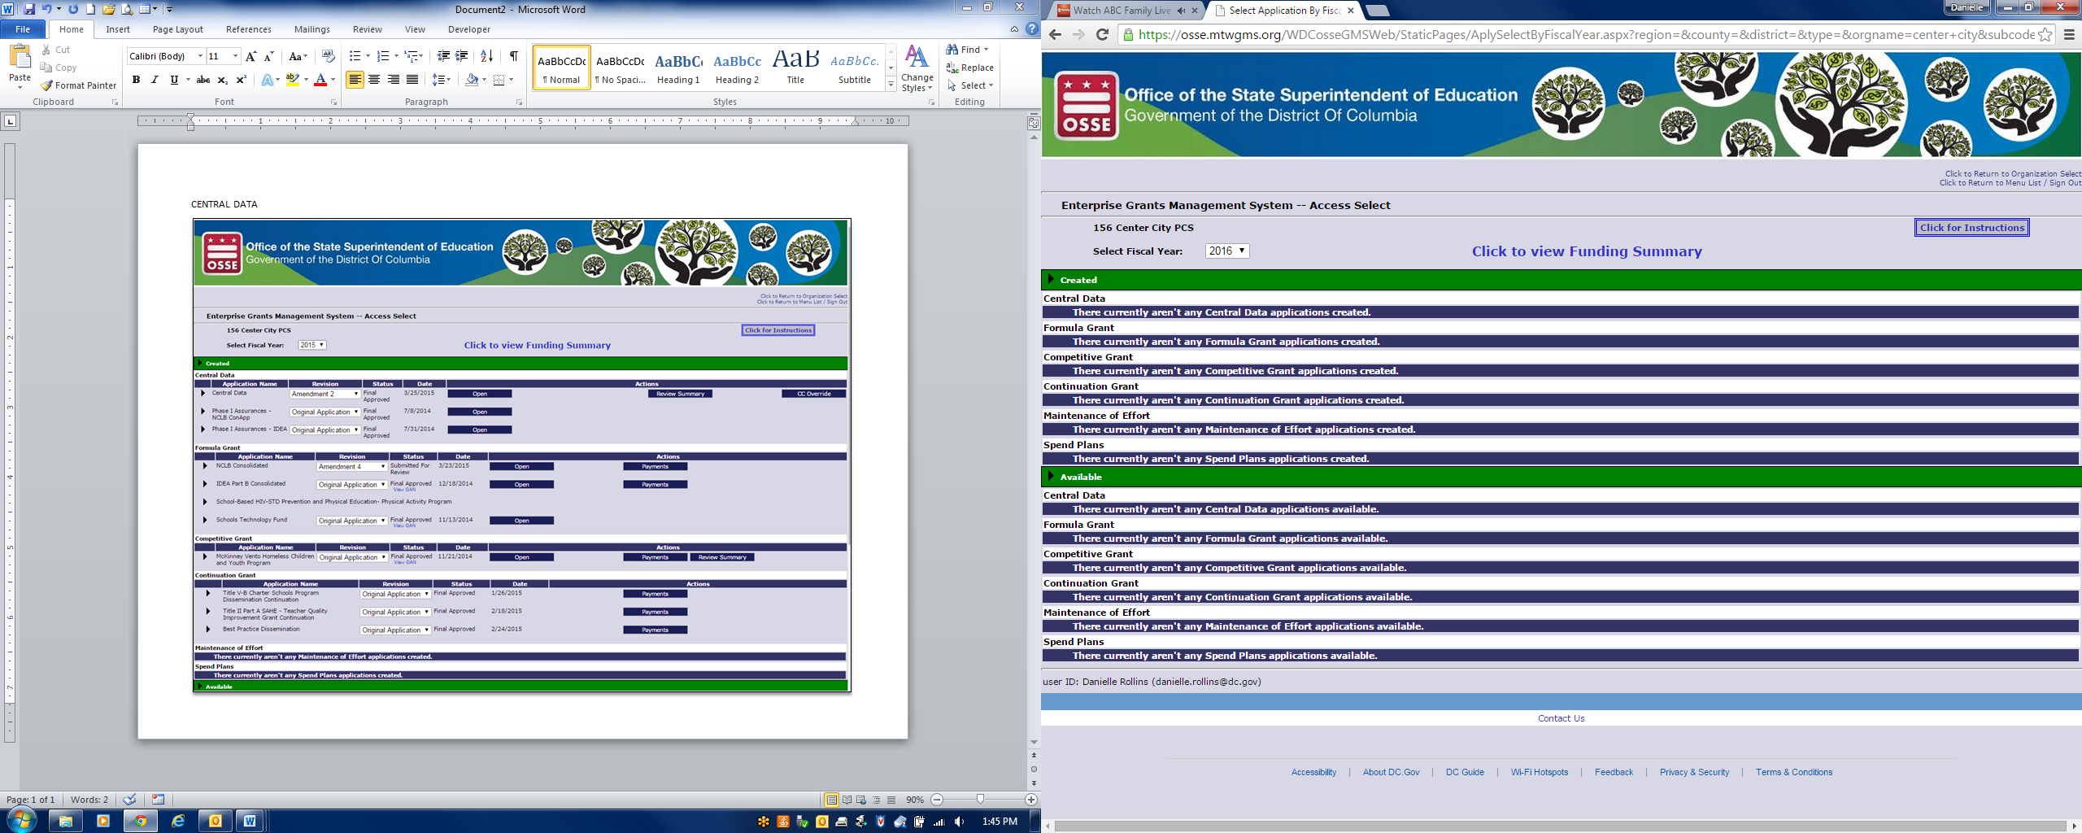

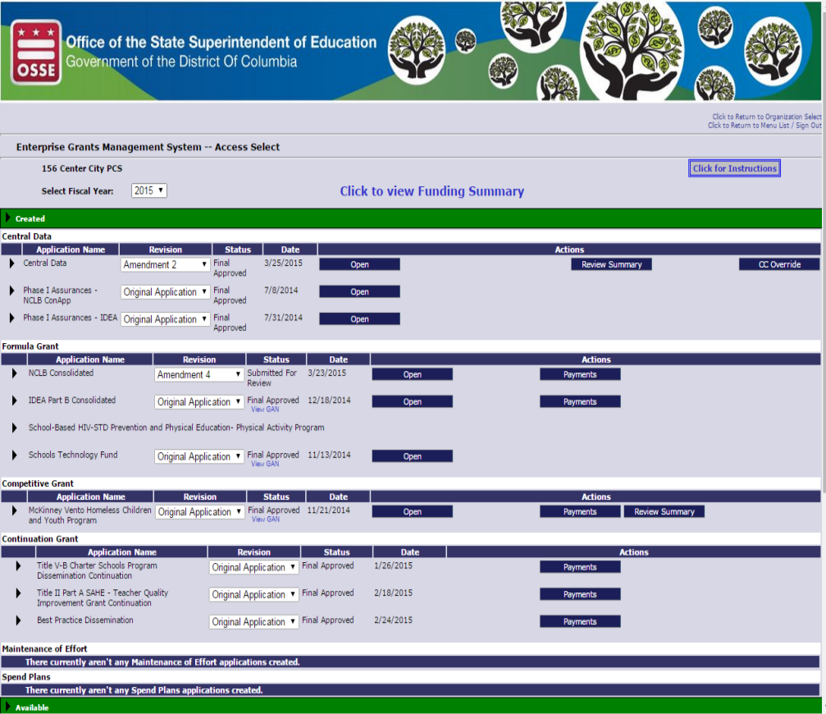

Applicant Information

1. **EGMS Log-on Page:**  The EGMS “Logon” Page is located at the following URL: <http://grants.osse.dc.gov>. If you do not have user credentials, click the “New User” link in the top right of the “Logon” Page.

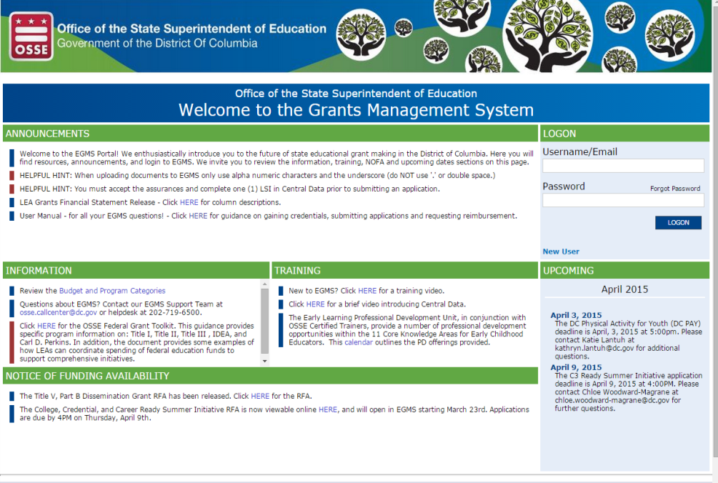

In the image above, the “Logon” page contains the following features/information:

* Ability to logon for users with existing credentials
* Ability to request credentials as a new user (which may be a new user at an existing vendor or a new user at a vendor new to OSSE)
* Ability for vendors to register
* Use of the public access feature to view allocations and payments of approved applications.
* Announcements from OSSE
* Other EGMS related information from OSSE
* Upcoming Events from OSSE
* Copies of Notices of Funding Availability from OSSE

Users with credentials to access the EGMS should enter their User ID (which will be their email address) and password and click the “Logon” button. As part of the first logon, users will be required to set a new password, and answer four (4) security questions that will be used in the case that the user needs to reset a password in the future.

1. **EGMS Menu List:** After successfully logging on, the EGMS will display the EGMS “Menu List” page (see below). The EGMS menu list shows options for each user based on authority they have been assigned. The hyperlink for “GMS Access/Select” will take users to the list of systems including:

* Central Data and Common Assurances
* Phase I Assurances
* Funding Applications
* Other Data Collections

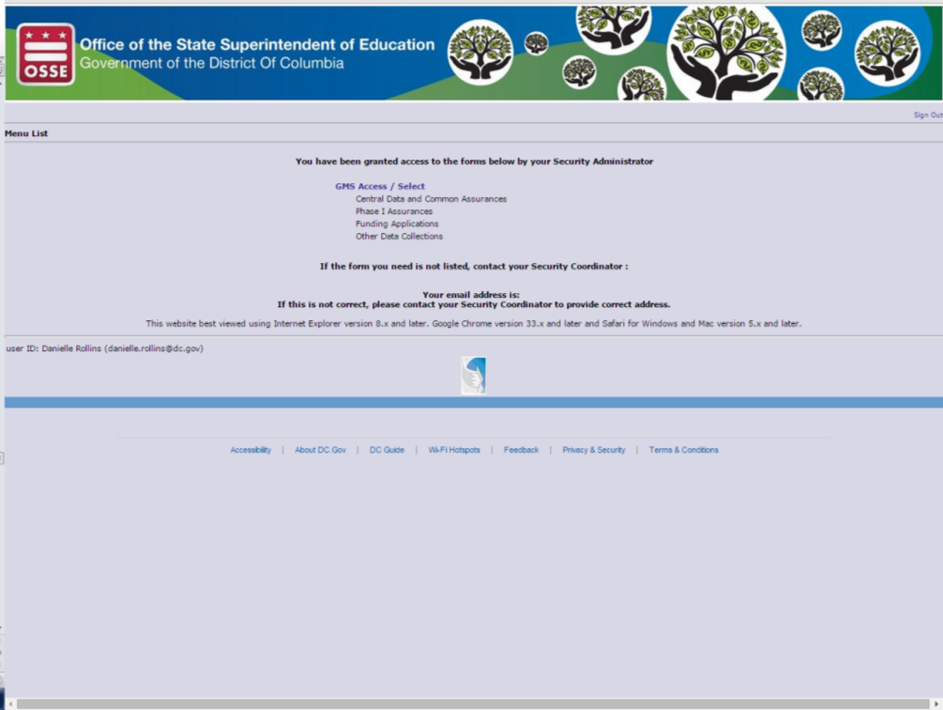

The list of “Security Coordinators” who can request additional users for your organization will display at the bottom of the page when users log in.

EGMS pages displayed after the “Menu List” contain hyperlinks in the top right corner. These hyperlinks include:

1. Sign Out of the EGMS,
2. Return to this Menu List Web page,
3. Return to the EGMS Access / Select Page, and
4. Display the Contents of the Web.
5. **Completing the Application:**

The McKinney-Vento Homeless Education Program is a stand-alone program, and sub-grants are awarded based on a competitive application process. Sub-grants are awarded based on the quality of the application and alignment of the proposed activities with the requirements of the McKinney-Vento Homeless Assistance Act of 1965. Applications will be reviewed by a team of subject matter experts and scored based on the quality of the application. The highest scoring applications will receive funding accordingly.  The following sections contain a visual illustration of each section included in the application:

1. Overview Web Page: The first page that displays upon opening the application is the “Overview” page (see below). This page contains information about the program(s) included in the application, relevant guidance, and OSSE contact information, should users have questions about completing the application. Due dates for the applications are also listed on this page.

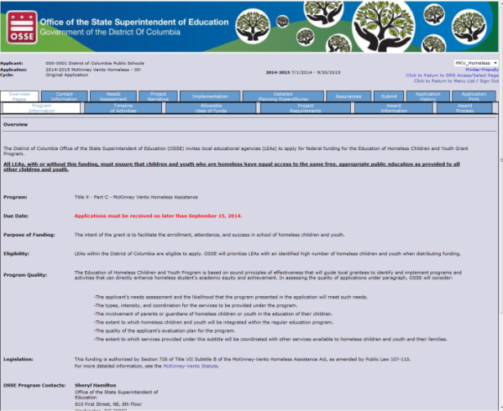

1. Contact Information: Every application must identify a Point of Contact (POC) for proposed project. Up to five (5) email addresses may be included to receive copies of automated approval/disapproval notices in addition to the Superintendent or Authorized Representative of applicant LEA.
   * + Please note: the Superintendent or Authorized Representative will automatically receive notices.

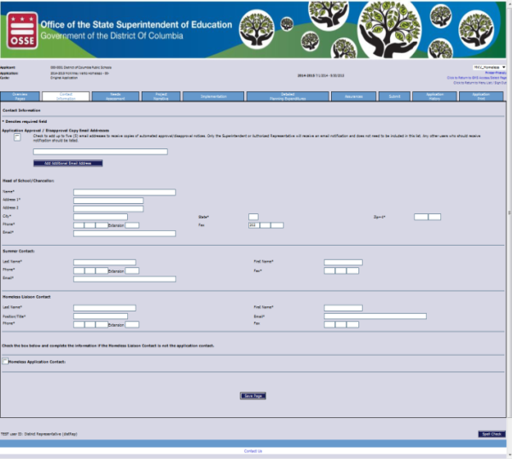

1. Needs Assessments: Each applicant must provide a summary of educational and related needs of homeless children and youth in the area served by the LEA (each text box is limited to 2,000 characters). The needs assessment must assess the educational and related needs of homeless children and youth within the LEA’s service area.

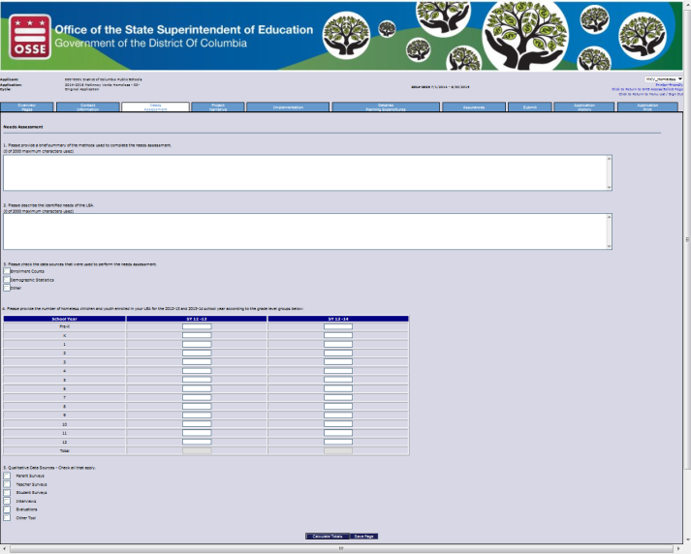

1. Program Narrative: Each applicant must complete the “Program Narrative” section, which should include a description of the services and programs that the applicant will provide with requested funds. This is an opportunity to convince readers that the proposed project is sound. Provide as much detail as possible (each text box has a 2,000 character limit).

Helpful hint: please clearly describe the policies and procedures the agency has in place to ensure that its activities do not isolate or stigmatize homeless children and youth.

The following is an image of the Program Narrative page.

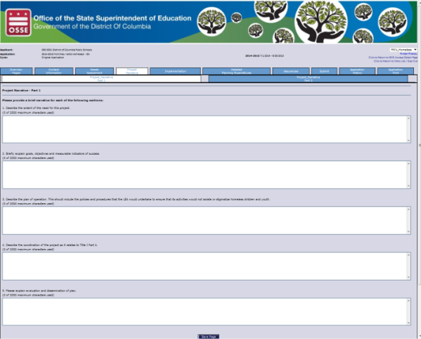

Where narrative information is required, the page includes validations to ensure the applicant has completed required fields correctly. If the applicant has entered any data in error, the EGMS will issue either “Warning” or “Error” messages. The EGMS is constructed to only issue a warning or error if data entry is incorrect or incomplete. If all data entered is complete and valid, when the user clicks “Save Page,” no confirmation message will display. Please note the following:

* In the case of warning messages, the data is saved to the EGMS database. Applicants must correct such conditions before they can submit the application.
* In the case of error messages, the data will not be saved to the database until the error is corrected. If the user clicks another tab on the tab strip before successfully resolving all error level messages that exist, the data entered will be discarded. Upon clicking off of a tab with errors, there are no messages to verify whether the user wishes to discard this data. Therefore, all errors should be resolved and the page re-saved until no error message displays at the top of the page.

1. Implementation:

Each applicant must complete this section by selecting activities that apply to the proposed program. Once an activity is selected by placing a check in the box next to the proposed activity, a series of boxes will appear requiring additional information. The following is an image of the “Implementation” page, which includes four (4) tabs.

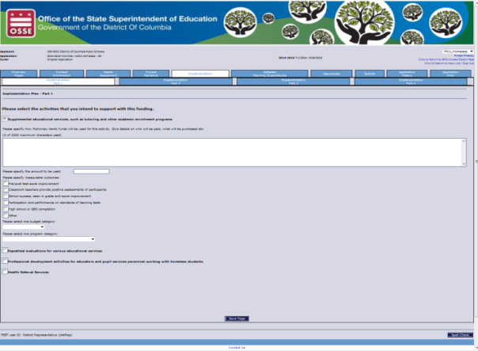

1. Detailed Planned Expenditures (Budgeting): Applicants must detail the proposed program budget in the “Proposed Expenditures” section. The sum of the proposed expenditures must match the total funds available.

There are multiple budget categories under which funds may be budgeted. each budget category has its own sub-tab under detailed planning expenditures. For example, the budget category salaries & benefits requires entry of the name of the person whose salary and benefits are to be paid. However, the budget category equipment does not need the name of the person, but rather the name of the item to be purchased. The following image shows the “Salaries and Benefits” tab.



1. Program-Specific and Common Assurances: This section contains assurances that are specific to the McKinney-Vento program. These assurances, along with the Assurances previously completed within central data section, must be agreed to prior to submitting the application.

**Only** users who have “Authorized Representative” credentials for their agency can agree to assurances. Assurances pages contain an affirmative statement at the top, along with a checkbox for the “Authorized Representative” to check. At the bottom of the page, the authorized representative must click “Save Page”, which constitutes agreement to those assurances. Where multiple assurances pages exist, an “Assurances Summary” page will redisplay the checkboxes. Users cannot modify the checkboxes on the “Assurances Summary” Web page. On this “Assurances Summary” page, the Authorized Representative must click “Legal Entity Agrees”. After this is complete, the EGMS designates assurances as complete and they are binding for the duration of that fiscal year.

The following images show the pages that outline the assurances to which the authorized representative must agree.

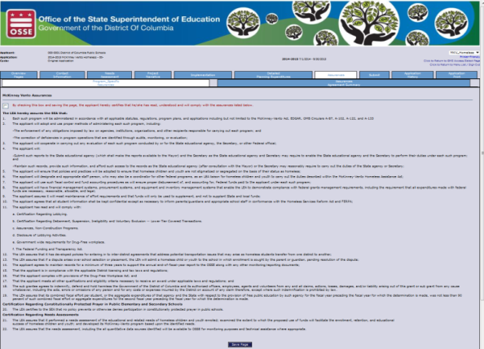

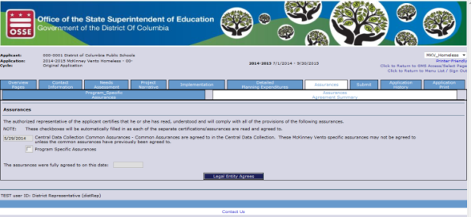

Please note: Assurances can only be completed after all other sections of the application have passed a consistency check. Once the check is passed, the organization’s “Authorized Representative” can complete the assurances and submit the application.

1. Submit:

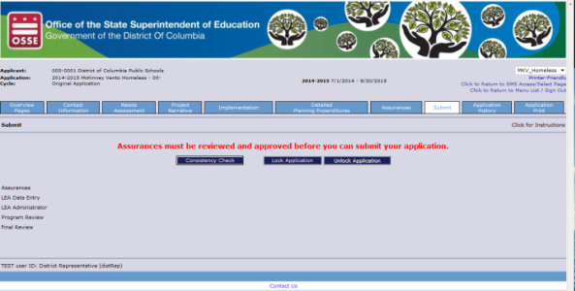

1. Additional Information - Continuation Grants: The grant programmatic and fiscal implementation period for this grant will be from the date of the award to September 30, 2016. All funds **must** be obligated by September 30, 2016. Projects that successfully demonstrate substantial progress and comply with programmatic and fiscal reporting requirements during the award period ***may*** be eligible to receive continuation awards for two (2) additional years if funds remain available. ***No more than 15% of the award may be carried over to the next program period.***

**Attachment B**

**MKV Program Scoring Rubric**

**RFA #041015**

**Date of Review:**

|  |  |  |  |  |  |  |  |
| --- | --- | --- | --- | --- | --- | --- | --- |
| **Applicant Name:** |  | | | | | | |
| **Application #:** |  | | | **Reviewer’s Initials:** | | |  |
| Section A: MANDATORY REQUIREMENTS (Met/Not Met) | | | | | | | |
| **CRITERIA** | **ACCEPTABLE SUBMISSION** | | | | | | **Met/Not Met** |
| Contact Information | All of the following information must be provided on the contact information page in order for the applicant to meet this requirement:   * Name of applicant/agency * Telephone number of the applicant/agency * Name of the contact person * Address of the contact person * Name of the local liaison for transitory services * Telephone and email address of contact person | | | | | | MET |
| ASSURANCES | All assurances must be accepted | | | | | | MET |
| *Applicants that have not completed the contact information page and/or the**assurances and that do not meet the criteria described above will not be* *considered for funding and will not be reviewed beyond this point.* | | | | | | | |
| Section B: EXTENT OF NEED (15 out of 50 points) | | | | | | | |
| Applicant provides a compelling proposal that clearly defines the issue(s) or problem(s) supported by a needs assessment. Applicant describes the needs assessment, including the sources from which the information was collected and the process used to analyzed the data. The way in which this analysis was used to determine strengths and weaknesses and prioritized action in the proposal, is clear. | | | | | | | |
| **Score 15** | | **Score 10** | **Score 5** | | | **Score 0** | |
| All required data is completed (assurances, data sources, etc.) and the description of the method for identifying homeless children and youth and of identified needs is thorough and reflects a clear understanding of the law. | | All required data is completed (assurances, data sources, etc.) and the description of the method for identifying homeless children and youth and of identified needs is clear. | All required data is not completed (ex: data sources, etc.) and/or the description of the method for identifying homeless children and youth and/or of identified needs is clear partial or vague on the method for identifying homeless children and youth. | | | All required data is not completed (assurances, data sources, etc.) and the applicant does not describe a method for identifying homeless children and youth and/or of identified needs. | |
| **Comments:** | | Strengths: | | | Weaknesses: | | |
| **Score:** | | | | | |  | |
| **Section C: NARRATIVE (20 out of 50 points)** | | | | | | | |
| The applicant creates clear and measurable goals, objectives, and milestones for all outcomes. Outcome statements are quantify the positive impact on the project’s target population will. Every outcome describes a change in a target population. | | | | | | | |
| **Score 20** | | **Score 15** | **Score 10** | | | **Score 5** | |
| The Narrative is thorough and clear and describes a program that is aligned with sections A and C and that:   * Is aligned with the needs assessment information provided in section A; * Identifies roles and responsibilities for implementation; * Includes coordination with the Title I, Part A, if applicable; * Includes measurable goals and outcomes, project milestones to help monitor progress, and a clear evaluation plan; * Includes professional development and awareness activities; * Demonstrates how the program will use evaluation data to improve future activities; and * Includes policies and procedures that the LEA will implement to ensure that its activities would not isolate or stigmatize homeless children and youth. | | The Narrative is clear and describes a program that is aligned with sections A and C and that:   * Is aligned with the needs assessment information provided in section A; * Identifies key roles; * Includes coordination with the Title I, Part A, if applicable; * Includes measurable goals and outcomes, project milestones to help monitor progress, and a clear evaluation plan; * Includes professional development and awareness activities; * Will use evaluation data to improve future activities Includes policies and procedures that the LEA would undertake to ensure that its activities would not isolate or stigmatize homeless children and youth; and * Includes policies and procedures that the LEA will implement to ensure that its activities would not isolate or stigmatize homeless children and youth. | The Narrative is vague or unclear and does not describe a program that includes all of the following:   * Is aligned with the needs assessment information provided in section A; * Identifies key roles; * Includes coordination with the Title I, Part A, if applicable; * Includes measurable goals and outcomes, project milestones to help monitor progress, and a clear evaluation plan; * Includes professional development and awareness activities; * Will use evaluation data to improve future activities; and * Includes policies and procedures that the LEA will implement to ensure that its activities would not isolate or stigmatize homeless children and youth. | | | The Narrative is vague and unclear and does not describe a program that includes any of the required elements | |
| **Comments:** | | Strengths: | | | Weaknesses: | | |
| **Score:** | | | | | |  | |

|  |  |  |  |  |  |
| --- | --- | --- | --- | --- | --- |
| **Section D: IMPLEMENTATION PLAN (15 out of 50 points)** | | | | | |
| The Plan of Operationdiscusses the strategies and activities that will be used to accomplish the project’s outcomes. For this section, the applicant provides detailed descriptions of how each of the McKinney-Vento Act policies and requirements will be addressed in planning, policy or practice of the local educational agency. | | | | | |
| **Score 15** | **Score 10** | **Score 5** | | | **Score 0** |
| * Activities for which funding is to be used is clearly identified; * The activity description clearly identifies how funds will be used (who will be paid, what will be purchased, structure of program, implementation timeline etc.); * The amount of funding is specified; * Goals and objectives are identified; and * An implementation timeline is specified. | * Activities for which funding is to be used is identified; * The activity description clearly identifies how funds will be used (who will be paid, what will be purchased, structure of program, implementation timeline etc.); * The amount of funding is specified; * Goals and Objectives are identified; and * An implementation timeline is specified. | One or more of the following elements is missing:   * Activities for which funding is to be used is identified; * The activity description clearly identifies how funds will be used (who will be paid, what will be purchased, structure of program, implementation timeline etc.); * The amount of funding is specified; * Goals and Objectives are identified; and * An implementation timeline is specified. | | | * Several required elements are missing. |
| **Comments:** | Strengths: | | Weaknesses: | | |
| **Score:** | | | |  | |

**Attachment C**

**MKV Program Scoring Rubric**

**Review Summary Sheet**

**RFA #041015**

**Date of Review:**

|  |  |  |  |  |  |  |  |
| --- | --- | --- | --- | --- | --- | --- | --- |
| **Applicant Name:** |  | | | | | | |
| **Application #:** |  | | | **Reviewer’s Initials:** | | |  |
| **Criteria** | | | | **Possible Score** | | | **Application**  **Score** |
| Contact Information | | | | MET | | |  |
| Assurances | | | | MET | | |  |
| Statement of Need | | | | 15 | | |  |
| Narrative | | | | 20 | | |  |
| Implementation Plan | | | | 15 | | |  |
| ***TOTAL*** | | | | ***50*** | | |  |
| **Reviewer’s Comments** | | | | | | | |
| Evaluate the quality of the application in its entirety. Aside from your general comments in the individual sections, consider how well (strengths/weaknesses) the whole application flowed and was logical in the spaces below. | | | | | | | |
| General Comments: | | | | | | | |
| Strengths: | | | Weaknesses: | | | | |
| Reviewer’s Signature: | |  | | | Date: |  | |